flag

|  |
| --- |
| **ChemBioOffice Enterprise 12.6.3** |
| **Installation Guide** |

|  |  |
| --- | --- |
| **Last Updated:** | February 02, 2017 |

**Table of Contents**

1. Introduction 4

2. System Components 4

3. System Requirements 4

4. Database Server Installation 4

4.1. Overview 4

4.2. Oracle Server Configuration 5

4.3. Oracle Cartridge Installation 7

5. Application Server System Configuration 8

5.1. Oracle Client Configuration 9

5.2. Internet Information Server Configuration 10

5.3. Enabling Secure Sockets Layer (SSL) and Installing SSL Certificate 11

6. Application Server Installation 19

6.1. Overview 19

6.2. Before Proceeding to Install 19

6.3. Configuration Verification for Windows Server 2012 20

6.4. Configuration Verification for IIS 23

6.5. Installing ChemBioOffice Enterprise 12.6.3 24

6.6. Installing ChemACX 29

6.7. Activate ChemDraw Professional 29

6.8. Activate ChemScript 30

7. Database Schema Creation 32

7.1. Overview 32

7.2. Database Schema Creation 33

8. Application Server Configuration 40

8.1. Overview 40

8.2. Configuration Files 41

8.3. Configuration Tool 42

8.4. Additional Configuration 53

9. Importing Application Configuration 55

9.1. Importing Chemical Registration Configuration 55

9.2. Updating invconfig.ini file for non C-Drive Installation 57

10. Client Workstation Installation 58

10.1. Installing ChemDraw ActiveX (CDAX) Enterprise Constant NA 15.1 58

10.2. InvLoader Installation 61

10.3. Configuration Settings for Inventory Reporting 64

11. Installing Datalytix 6.3.1 71

11.1. Installation Pre-requisites 71

11.2. Datalytix Installation 72

11.3. Deploying the Lead Discovery Package 72

11.4. Launching Datalytix from Spotfire 73

12. Upgrading CBOE 12.6.x to CBOE 12.6.3 75

12.1. Upgrading ChemBioOffice Enterprise Server 75

12.2. Activate ChemDraw and ChemScript 76

12.3. Upgrading CBOE Database Schemas 76

12.4. Running the Server Configuration Tool 85

12.5. Installing Datalytix 6.3.1 85

12.6. Upgrading Client 85

13. Troubleshooting 86

13.1. ‘Could not load file or assembly Oracle.DataAccess’ Error 86

13.2. ORA-00600 Error While Accessing Registration 86

13.3. Registering ASP.Net in IIS 87

13.4. .Net Framework Security 87

13.5. Oracle 11g or 12c Related Issues 88

13.6. Error in RLS Log File 'log_runRLSConfigurationTool.txt 88

13.7. Inventory Reporting Errors 88

13.8. ChemDraw for Excel Errors 89

13.9. Invalid Character Error in Japanese Environment while Importing Configuration 89

13.10. Error: ChemDraw Control Version is Not Supported in Server Side 89

13.11. Inventory Application Stops Working After Configuring Inventory Reporting 90

13.12. Strange Characters are Displayed When Logging into CBOE Manager 90

13.13. Receive Orders Window in Inventory Expiries after 20 Minutes despite the Session Timeout Settings of the System 92

13.14. Registration and Inventory Loading CDAX14 instead of CDAX15.1 when ChemBioDraw Ultra 14 is installed in the Client Machine 95

13.15. Degree and Period Symbols in S Sentences and P Precaution Sentence are not Displaying Properly 96

13.16. Unable to Browse Inventory Content after Changed Authentication from ORACLE to LDAP or vice versa Once the CBOE System is Setup 97

13.17. Unknown Error Displays when Trying to Search for a Query While Adding a New Component to a Mixture 98

13.18. Errors While Creating New User and Submitting Record to Registration Temp Table in an Oracle 12c Upgraded Machine 98

13.19. Fail to Publish Data Source and DataView to Spotfire 7.6 99

13.20. Invalid Objects in CBOE12.6.3 fresh Database 101

14. Appendix A: Inventory Enterprise INI Configuration Files 102

InvConfig.ini Configuration File 102

1. Introduction

This guide provides instructions for installing and configuring ChemBioOffice Enterprise 12.6.3. ChemBioOffice Enterprise 12.6.3 installer is also designed for upgrading your old version of ChemBioOffice Enterprise CBOE12.6.x to the most recent one, ChemBioOffice Enterprise 12.6.3. It provides integration support with the latest version of our flagship E-Notebook 2014 R7 and E-Notebook 12.1.10. It also works with Datalytix™, enabling a Spotfire™ analysis and visualization also with Lead Discovery™.

1. System Components

The ChemBioOffice Enterprise 12.6.3 distribution includes following application modules:

* COE Framework 12.6.3
* Registration Enterprise 12.6.3
* Inventory Manager Enterprise 12.6.3
* ChemACX Enterprise 12.6.3
* DataView Manager 12.6.3
* DataLoader 12.6.3
* InvLoader 12.6.3

The distribution package includes the following components:

* CSCartridge 15.1

In addition, the following components are also distributed with ChemBioOffice Enterprise 12.6.3 suite because they are required for the proper functioning of the above modules:

* ChemOffice Professional 15.1
* ChemScript 14.0
* ChemDraw ActiveX Enterprise Constant Non Admin 15.1

1. System Requirements

ChemBioOffice Enterprise 12.6.3 is deployed in 3 tiers using physical or virtual servers. Specific requirements for Database Server, Application Server and Client Workstation are mentioned in the “*CBOE12.6.3 Hardware Software Guide*” document.

1. Database Server Installation

## Overview

The only PerkinElmer component required on the database server tier is the CambridgeSoft (CS) Oracle Cartridge. The CS Oracle Cartridge implements an Oracle Domain Index that enables applications to perform chemical queries in the Oracle database server. The CSCartridge is therefore required by many PerkinElmer as well as third party applications. Detailed instructions for Cartridge Installation are provided in the “*Oracle Cartridge User’s Guide”* document. This section provides a brief description of the Cartridge installation process suitable for the most common scenarios encountered during a ChemBioOffice Suite installation.

Installation of the Oracle Cartridge on a host Oracle server consists of the following main steps:

1. Configuration of the Oracle host to support Domain Indexes.
2. Installation of the CSCartridge program on the host server.
3. Creation of a CSCartridge Oracle schema.

## Oracle Server Configuration

CSCartridge is a program written by PerkinElmer which cooperates with the Oracle server to provide chemical searching capabilities. Oracle interacts with such third party programs via a specialized Oracle client program referred to as the “external procedure agent” or “extproc” for short. Extproc differs from other Oracle client programs in that it gets executed in the Oracle server rather than on a remote client machine. Extproc, like any other Oracle client program, needs to know how to connect to the Oracle server. The extproc connection process is affected by configuration found in three Oracle files: listener.ora, tnsmanes.ora, and sqlnet.ora. These files are typically located on the server under:

ORACLE_HOME/network/admin

### Listener.ora

Listener.ora is the file used by the Oracle listener service to mediate connections between an Oracle client and the database server. It defines which client programs can connect to the server as well as details on the protocols used for that connection. Oracle listeners are highly configurable. For example, there may be multiple listeners associated to your database, and each listener can manage multiple types of service requests. This is a complex topic, the many variations of which are not covered in this document. Please refer to the "Oracle Database Net Services Administrator's Guide" for details about configuring your listeners. Furthermore, it is highly recommended that changes to this file be only performed under the supervision of an experienced Oracle DBA.

Below is a simple example which uses a single listener to manage connections from both remote Oracle clients and the local extproc. This file may be significantly different for every database instance.

|  |
| --- |
| SID_LIST_LISTENER =  (SID_LIST =  **(SID_DESC =**  **(SID_NAME = PLSExtProc)**  **(ORACLE_HOME = C:\app\Admin\product\11.2.0\dbhome_1)**  **(PROGRAM = extproc)**  **(ENVS="EXTPROC_DLLS=ANY")**  **)**  (SID_DESC =  (SID_NAME = ORADB)  (ORACLE_HOME = **C:\app\Admin\product\11.2.0\dbhome_1)**  (GLOBAL_NAME = ORADB)  )   LISTENER =  (DESCRIPTION_LIST =  (DESCRIPTION =  (ADDRESS = (PROTOCOL = TCP)(HOST = dgb2.camsoft.com)(PORT = 1521))  **(ADDRESS = (PROTOCOL = IPC)(KEY = EXTPROC0))**  )  ) |

The highlighted regions represent the entries required by Oracle to support the CSCartridge or any other program that depends on external libraries.

Below are some explanations of the entries in this section:

* + - 1. SID_LIST_LISTENER

This label begins a list of SIDs to be handled by the listener named LISTENER (the default listener name).

* + - 1. SID_LIST and SID_DESC

The example above defines two services, which are listed as two SID_DESC entries under the heading SID_LIST. The first in the list (PLSExtProc) handles extproc requests and the second (ORADB) handles remote client connections.

* + - 1. SID_NAME = PLSExtProc

This entry corresponds to the SID specified for the extproc in the file tnsnames.ora described below.

* + - 1. ORACLE_HOME

This entry defines the location of the Oracle Home for this service. The extproc program files load from a folder beneath this location. This path will differ for each installation but must correspond to the actual Oracle home location.

* + - 1. PROGRAM

This entry specifies the file name of the extproc executable file. This case-sensitive name might be extproc, extproc.exe, or extproc32, depending on the operating system type. The file is located in ORACLE_HOME/bin.

* + - 1. ENVS

This is a list of environment variables that the extproc uses when it runs. The list is colon-delimited. This list could include a definition of the environment variable EXTPROC_DLLS (see below) and possibly other environment variables that the extproc may use at runtime. For example, it may be desirable to include LD_LIBRARY_PATH on UNIX and Linux systems. LD_LIBRARY_PATH should typically include the location of the CSCartridge library.

* + - 1. EXTPROC_DLLS

This environment variable defines a list of libraries that the extproc can load and call functions from directly. The ANY keyword is used above to allow extproc to load any library within its path. The specific path to the CSCartridge library file (CSCartridge.dll, CSCartridge.so or CSCartridge.sl) could be specified instead to limit the code base accessible to extproc.

The list is colon-delimited. All paths must be absolute. There is no environment variable substitution. The optional keywords ANY and ONLY can be used to loosen or restrict the way the extproc uses library files. In many cases, neither keyword is needed.

* + - 1. KEY = EXTPROC0

The name in the example, EXTPROC0, links this listener with the corresponding service entry in the file tnsnames.ora. It distinguishes this listener from other IPC listeners that might be present on the same database server. The key can be any short name but must be the same in the files listener.ora and tnsnames.ora. The key is case sensitive.

### TNSNames.ora

The file tnsnames.ora contains a directory of known database services. This file can define services on the local database or on remote servers. One entry is specifically for use by the local database server to use interprocess communications (IPC) to send function calls to the extproc.

This entry is always labeled EXTPROC_CONNECTION_DATA.

Here is an example as it appears in the file tnsnames.ora. (Please note that this will probably not be the only entry in the file).

|  |
| --- |
| EXTPROC_CONNECTION_DATA =  (DESCRIPTION =  (ADDRESS_LIST =  (ADDRESS = (PROTOCOL = IPC)(Key = EXTPROC0))  )  (CONNECT_DATA =  (SID = PLSExtProc)  (PRESENTATION = RO)  )  ) |

* + - 1. EXTPROC_CONNECTION_DATA

This entry must always have the label EXTPROC_CONNECTION_DATA.

* + - 1. Key and SID

The two items in this entry that could be changed are the name of the key (EXTPROC0) and the SID (PLSExtProc). These items are used to link this entry to corresponding information in the listener.ora file. The key can be any short name but must be the same in both the listener.ora and tnsnames.ora files. These values are case sensitive. They are only used by the listener process, not by users or applications.

### SQLNet.ora

The SQLNet.ora file is not directly used by the extproc calling infrastructure; however, it may contain entries which affect the ability of the listener to reach the services described in the TNSNames.ora file. This section covers SQLNet.ora entries that can indirectly affect extproc operation.

In order for extproc to use the TNSNames.ora services, the SQLNet.ora file must contain the following entry:

NAMES.DIRECTORY_PATH= (TNSNAMES,ONAMES,HOSTNAME)

There may be additional items inside the parenthesis, but the TNSNAMES entry is required and should be the first entry in the list.

### Library Dependencies

The above .ora file configuration settings allow the extproc program to locate and call functions in the CSCartridge library. However, CSCartridge itself depends on other Oracle or operating system libraries. These dependent libraries must be present on the Oracle server system and accessible to the user that executes the extproc process. The list of dependent libraries differs for each of the platforms supported by the cartridge. A detailed table can be found in CS Cartridge User’s Guide.

For Unix systems, in addition to verifying the presence and access permissions for all dependent libraries, it is also necessary to ensure that path(s) to the library locations is present in environment path variables such as LD_LIBRARY_PATH, SHLIB_PATH, or LIBPATH. Please consult the Unix manuals for information on properly setting those environment variables.

## Oracle Cartridge Installation

The installation of the CSCartridge program and the creation of the CSCartridge Oracle schema are most easily accomplished by using the automated CSCartridge Installer utility. This is a Windows application specifically designed to simplify the deployment of the cartridge on all supported Oracle host platforms. The installer utility, however, introduces some requirements that may not be achievable in some production Oracle environments. A manual installation process described in the *CS Cartridge User’s Guide* can be used to circumvent some of the installer requirements. For all other cases, the automated installation process described below is recommended.

### Installer Requirements

The following prerequisites must be met in order to complete the installation of the CS Cartridge using the installation utility:

* Ensure that the Database Server system requirements have been met.
* Ensure that the Oracle server has been configured according to the guidelines provided in section Oracle Server Configuration above.
* The password for the Oracle SYS account must be known. The use of SYSTEM or other DBA privileged Oracle users is not sufficient.
* The target Oracle instance must have a tablespace named “USERS”. This tablespace is used as the default tablespace for schema owners created by the Cartridge installer utility during its automated testing process.
* A Windows system equipped with the Oracle client and capable of connecting to the target Oracle host must be available to run the installer utility.
* For Windows Oracle hosts, the Cartridge installer must be run on the server itself.

If any of the above requirements cannot be met, then a manual cartridge installation is recommended.

### Oracle Cartridge Installation (Fresh)

***Note****: Only CSCARTRIDGE 15.1 is supported.*

| **Step** | **User Input/Action** | **Expected Results** |
| --- | --- | --- |
| 1 | Locate and run the file SetupCartridge.exe | Installation window opens |
| 2 | Enter Service Name | Service Name entered |
| 3 | Enter the Sys Password | Password entered |
| 4 | Enter the Computer name or IP address | Computer name or IP address entered |
| 5 | Enter the User name with access rights to Oracle instance (not root) | User name entered |
| 6 | Enter the Password for the above User | Password entered |
| 7 | Select the install mode ("Full" for new install, "Partial" for upgrade) | Install mode selected |
| 8 | Enter the tablespace, or leave T_CsCartridge  ($ORACLE_HOME\Database\T_CSCartridge.DBF) as default | Tablespace name entered |
| 9 | Click 'OK' | A series of command will run as indicated in the status window.  When complete, an "Installation succeeded" window will open. |
| 10 | Click 'OK' | The Oracle cartridge user's guide will open |
| 11 | Close the Oracle cartridge test system. | Window closes. |
| 12 | When done reading, close the user's guide. | Window closes. |

***Note:*** *A full description of the Cartridge features and functions is in the User’s Guide which is part of the Cartridge installer package.*

***Note****: For Upgrade of Oracle Cartridge, refer to section* *12.3.11. Oracle Cartridge Upgrade*

1. Application Server System Configuration

This section describes the configuration and verification of non-PerkinElmer system components that the ChemBioOffice Enterprise products require. It assumes that the hardware and software prerequisites have been met. If any of the required configuration steps cannot be performed or verified, no PerkinElmer software should be installed until a remedy has been found.

## Oracle Client Configuration

The application server uses several Oracle client components to communicate with the database server. This section describes the steps necessary to configure and verify connectivity to the server. Note that some of the files and configuration tasks are similar to those performed on the Oracle Server itself, to support the CSCartridge connectivity. Make sure that steps described below are performed on the Application Server, not on the database server. Note, however, that if the Oracle Server and Application Server are installed on a single host system, then all configurations will take place on the single server.

### TNS Names Configuration

The application server must be able to resolve the address of, and connect to, the target database service. To test this connectivity:

1. Open a windows command prompt

2. Execute the command: tnsping <serviceName>

**Note**: <serviceName> must be substituted by the actual name of the target Oracle service.

The TNSPing utility will respond with connection details and success or failure messages.

3. If the connection is not successful, open the TNSNames.ora file located on the application server at: ORACLE_HOME\network\admin

The file should contain a section similar to:

<serviceName> = (DESCRIPTION =(ADDRESS_LIST = (ADDRESS = (PROTOCOL = TCP)(HOST = <host>)(PORT = 1521)) ) (CONNECT_DATA = (SERVICE_NAME = <SID>) ))

where:

<serviceName>, is a friendly name to designate the target Oracle Service.

<host>, is the name or IP address of the target Oracle Server host.

<SID>, is the unique service identifier for the target Oracle instance.

### SQLNet Configuration

Connections between the application server and the Oracle database use credentials supplied by the end user. The use of the Windows authentication is not supported for the Oracle client hosted by the application server. It is therefore recommended that the SQLNet.ora file be modified to prevent NTS authentication.

1. Edit the SQLNetOra file at: ORACLE_HOME\network\admin

2. Ensure the following entry is present in the file:

* SQLNET.AUTHENTICATION_SERVICES= (NONE)

The standard value for this entry (if present) is typically NTS. It should be changed to NONE.

Note that this change implies that “internal” connection descriptors, such as “connect / as sysdba” will not be supported by the client. If it becomes necessary to connect to the database from this client using windows authentication, then the above change will need to be temporarily reverted.

### ODBC Client Configuration

The Reporting service used by Inventory Manager requires the use of the Oracle ODBC Driver. To ensure proper functioning of the reporting features, two system data sources (DSNs) must be configured on the application server:

1. Open the ODBC Control Panel (Start > Administrative Tools > Data Sources (ODBC)
2. Select the System DSN tab.
3. Click Add.
4. Highlight Oracle ODBC Driver.
5. Click Finish.
6. Enter the following in the Oracle ODBC Driver Configuration dialog:
   * Data Source Name: Chem_Inv
   * Description: Chem_Inv
   * Service Name: <serviceName> for your target database.
   * User ID: should be left blank
7. Click the Test Connection button.
8. Enter a the User Name and Password for a user that is allowed to connect to the database (Ex. System/manager2)

A connection failure for either DSN may indicate problems with the Oracle client and/or ODBC driver installation. Consult the Oracle DBA or Consultant before attempting to use the Inventory module.

## Internet Information Server Configuration

ChemBioOffice Enterprise applications use a combination of Active Server Pages (asp), ASP.NET Web Services, and Visual Basic Web Services. Internet Information Server is a Windows Component that should be installed as part of the application server prerequisites. The IIS service and each application extension that supports the above service must be explicitly installed and allowed.

### Changing the Web Root Path for non C Drive Installation (Optional)

The ChemBioOffice Enterprise application installers deliver their asp and other web content files to a location relative to the default Web site’s local path. In a default IIS installation, the local path is set to “C:\Inetpub\wwwroot\”.

To change the default Web root path:

1. Start the IIS Manager console.
2. Expand the tree node corresponding to the local computer name.
3. Expand the Sites node.
4. Select Default Web Site, and click **Advanced Settings** from the right pane.
5. Edit the Physical Path entry as desired (For example, E:\inetpub\wwwroot).

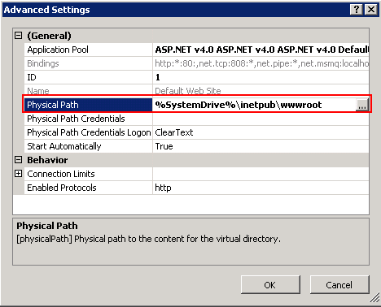

1. Click OK to accept the changes.
2. Copy the *inetpub* folder from the default location and paste it into the new drive as specified in the Physical Path.

In addition, the following process must be followed to ensure that the ChemBioOffice installers direct their output to the expected path:

1. Open the Registry Editor (Start > Run > RegEdit)
2. Expand the tree and navigate to:
   * HKEY_LOCAL_MACHINE\Software\Microsoft\InetStp (for 32-bit systems) OR
   * HKEY_LOCAL_MACHINE\Software\Wow6432Node\ Microsoft\InetStp (for 64-bit systems)
3. Right-click the PathWWWRoot value and click Modify.

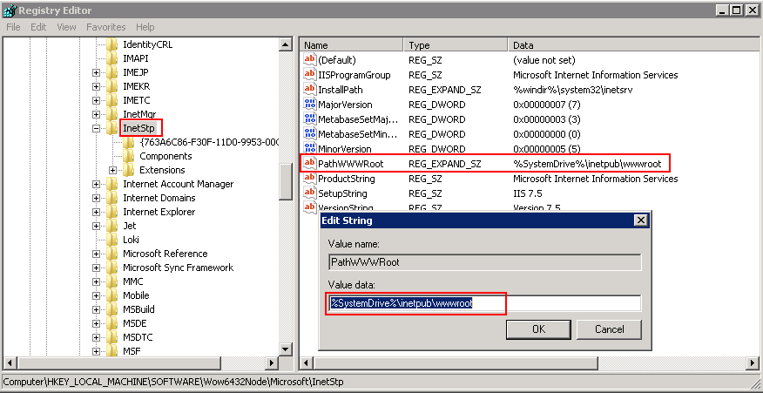

1. Enter the same value that was previously used for the Default Web Site local path.
2. Click **OK**.

## Enabling Secure Sockets Layer (SSL) and Installing SSL Certificate

Secure Sockets Layer is a protocol that provides secure communications on the Internet while exchanging sensitive information. If you enable SSL connections, ChemBioOffice application will force HTTPS (Hypertext Transfer Protocol Secure) when you access the ChemBioOffice application.

To configure SSL in IIS on a Windows machine, follow the steps mentioned below.

### Creating SSL Certificate in IIS

To create an SSL Certificate in IIS:

| **Step** | **User Input/Action** | **Expected Results** |
| --- | --- | --- |
| 1. | Navigate to: **Start > All Programs > Administrative Tools > Internet Information Services (IIS) Manager**. | The IIS Manager opens. |
| 2. | Click on the name of the server in the Connections column in the left pane and double-click on **Server Certificates**. | Server Certificates page displays. |
| 3. | In the Actions column on the right pane, click **Create Self-Signed Certificate.** | The Create Self-Signed Certificate dialog box appears. |
| 4. | Enter a name for the certificate and click **OK**. |  |
| 5. | A new certificate is created as shown in the example below. |  |

### Binding the Certificate to a Website

To bind the certificate to a Website:

| **Step** | **User Input/Action** | **Expected Results** |
| --- | --- | --- |
| 1. | In the IIS Manager, in the Connections column on the left pane, expand the Sites folder and click on the website that you want to bind the certificate to.    Click on **Bindings** in the right pane. | Site Bindings window opens |
| 2. | Click **Add**. | The Add Site Binding dialog box appears. |
| 3. | Click **https** in the Type drop-down list and select the SSL certificate that you have created.    Click **OK**. |  |
| 4. | Click **Close** to close the Site Bindings window. |  |

### Installing SSL Certificate on your Web Browser

You need to add the SSL certificate to your Web browser on the Client machine to access the ChemBioOffice Enterprise application.

To install SSL certificate on your Web browser:

| **Step** | **User Input/Action** | **Expected Results** |
| --- | --- | --- |
| 1. | Open your Web browser, and navigate to the following address:  [*https://*](https://localhost/DataLoader/Login.aspx)*<servername>/coemanager*   |  |  | | --- | --- | | ***NoteIcon*** | ***Note****: You must replace <servername> with the actual CBOE server name.* | |  |
| 2. | Click the certificate error displayed on the address bar to launch the *Untrusted Certificate* pop-up window.    In the *Untrusted Certificate* pop-up window, click **View Certificates**. | The Untrusted Certificate pop-up window appears. |
| 3. | Click **Install Certificate**, the Certificate Import Wizard appears. | The Certificate Import Wizard appears. |
| 4. | Click **Next**. |  |
| 5. | In the Certificate Store window, select *Place all certificates in the following store* option and click **Browse**. | The Select Certificate Store dialog box appears. |
| 6. | In the Select Certificate Store dialog box, select the **Show Physical stores** check-box, and select **Local Computer** under **Trusted Root Certification Authorities.**  **C**lick **OK**.    Click **Next**. |  |
| 7. | Click **Finish**. |  |
| 8. | Click **Yes** in the confirmation message that appears. |  |
| 9. | Click **OK**. |  |

### Configuration Tool – Server Settings for SSL Configuration

1. To launch the configuration tool, go to Start > **All** Programs > ChemBioOffice Enterprise > Server Configuration Tool.

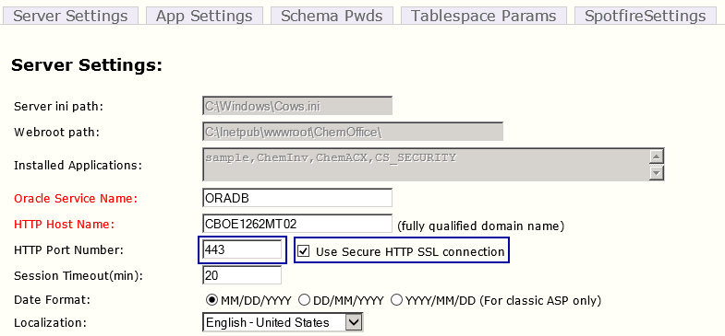

1. In the HTTP Port Number field, select the *Use Secure HTTP SSL Connection* check box. Make sure that the port number is 443.
2. Save and close the configuration tool.

### Updating SingleSignOnCom.dll.config File

To update the *SingleSignOnCom.dll.config* file:

1. Go to *C:\Program Files (x86)\CambridgeSoft\ChemOfficeEnterprise12.1.0.0\Common\dlls.*
2. Open *SingleSignOnCom.dll.config* for edit.
3. Change “*http*” to “*https*” as shown.

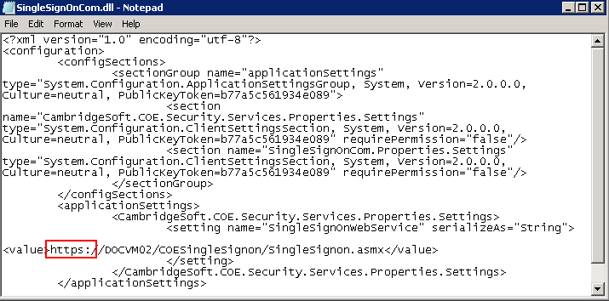

1. Save and close the file.
2. Application Server Installation

## Overview

This section describes the installation process for all components required to support the Web-based applications that are part of ChemBioOffice Enterprise 12.6.3. The installer for all components is provided with the ChemBioOffice Enterprise 12.6.3 distribution.

The installer controls the installation path for the programs and files that are getting installed. However, the destination location of some of the files such as asp, html, and gif are determined by the web root path of the IIS server and not by the installer target path. In case, if you want to avoid installing any files on the system volume (typically C:\), you need to first reconfigure the path of the Default Web Site web root as described in section Changing the Web Root Path.

The installers register services or IIS applications which must run under the credentials of an administrative user account. The installers will prompt for the user name and password of the windows account to be used. The installers can either create a new account or use an existing one. The account can be either a local account or a domain account, but in either case, it must belong to the local administrators group. It is strongly recommended that the chosen user be exempt from password expiration policies, otherwise the system will need to be reconfigured each time the password expires.

The installation process must be performed by a user who has administrative privileges on the server.

***Note****: The installer may warn you about the need to close some open applications. In most cases this warning can be safely ignored. It is typically not necessary to close those applications.*

***Note****: The CBOE 12.6.3 installer should be run using the actual administrator account.*

## Before Proceeding to Install

* Allow ISAPI and ASP.Net extensions

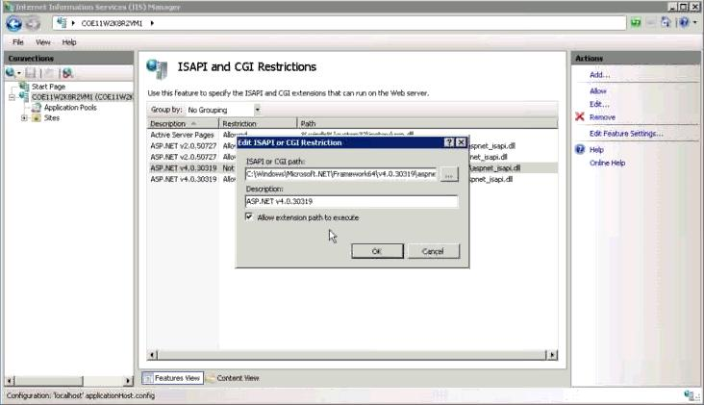

* Request filtering by removing the configuration file.

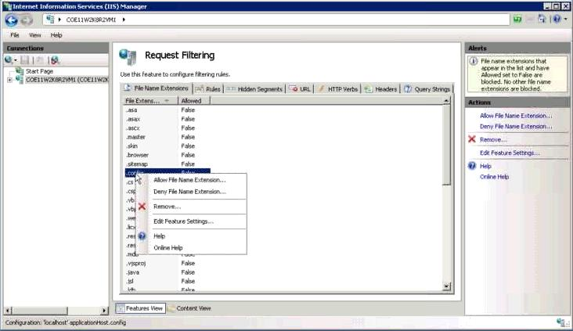

## Configuration Verification for Windows Server 2012

If you use Windows Server 2012, be sure to maintain the following recommended Server Manager Configuration settings.

### Accessing Server Manager Dashboard

1. Move the mouse pointer to the upper- right corner or lower-right corner of the screen, and click the **Start** icon from the Charms bar that appears.

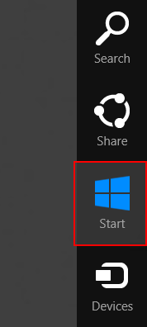

1. In the Windows Start screen that appears, click the **Server Manager** Icon.

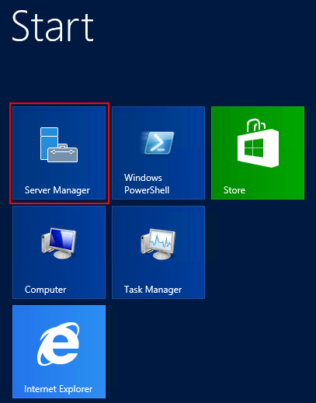

1. The Server Manager dashboard appears as shown below.

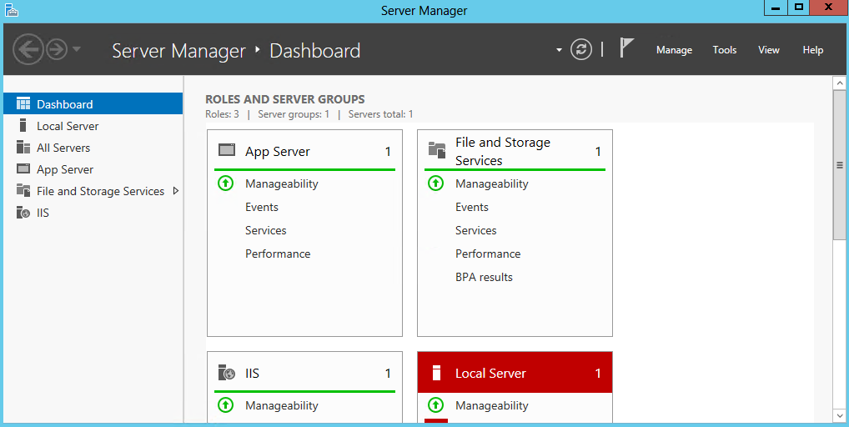

### Managing Roles and Features

1. In the Server Manager dashboard, click **Manage > Add Roles** **and Features**.

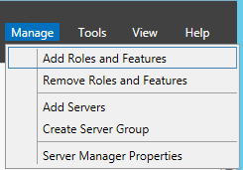

1. In the Add Roles and Features Wizard, click the **Server Roles** tab.
2. Expand **Application Server**.
3. Make sure that **Windows Process Activation Service Support** and all the options under it are selected as shown below.

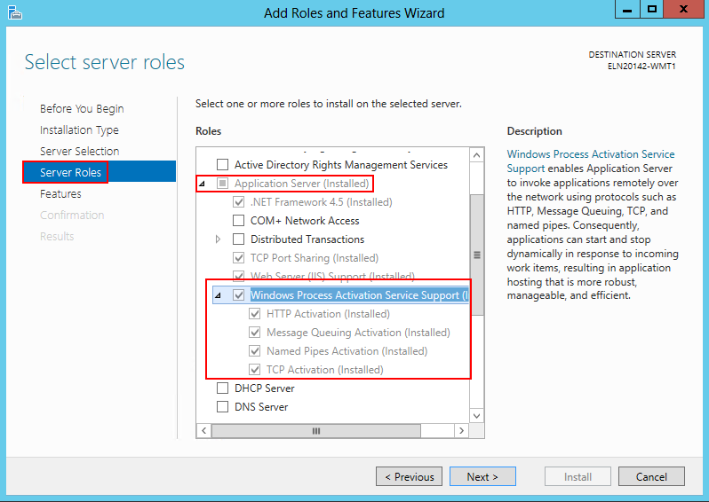

1. Expand **Web Server (IIS) > Web Server > Application Development**.
2. Verify that the options under Application Development are selected as shown below.

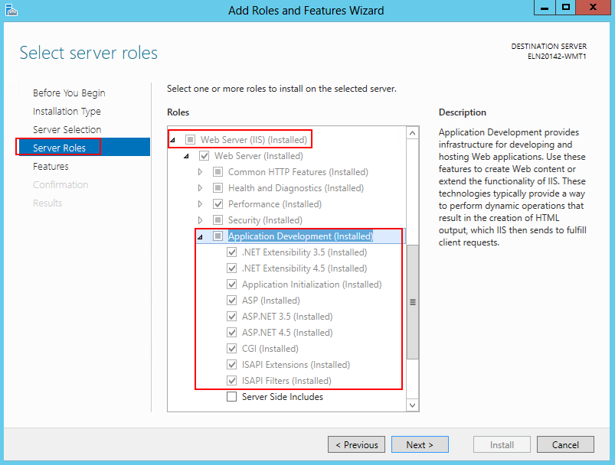

1. Click **Next** and click **Install** in the Confirmation window to install the selected features.

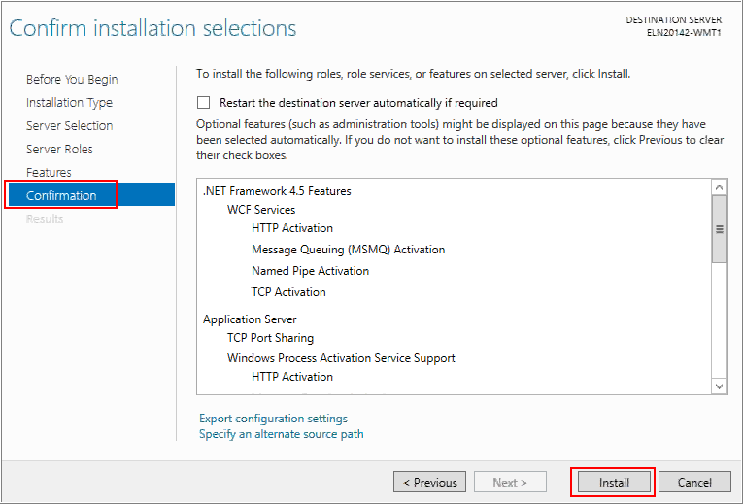

### Verifying the status of ASP.Net State Service

1. Open the Task Manager window and verify that the **ASP.Net State Service** is running as shown in the image below.

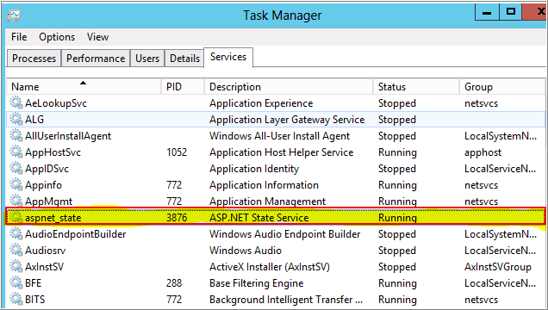

## Configuration Verification for IIS

If you are installing the CBOE server onto a middle tier system running IIS 7.x or IIS 8.x, make sure that the IIS installation on the middle tier server has been configured with both the IIS 6 Management Compatibility and IIS 6 WMI Compatibility features installed.

To install the IIS 6.0 Management Compatibility Components on Windows Server 2008 R2 or on Windows Server by using the Server Manager tool:

* 1. Click **Start > Administrative Tools > Server Manager**.
  2. In the navigation pane, expand Roles, right-click Web Server (IIS), and click Add Role Services. The Add Role Services wizard appears.
  3. In the Select Role Services pane, scroll down to IIS 6 Management Compatibility.
  4. Click to select the *IIS 6 Metabase Compatibility* and *IIS 6 Management Console* check boxes.
  5. In the Select Role Services pane, click Next, and click Install at the Confirm Installations Selections pane.
  6. Click Close to exit the Add Role Services wizard.

The screen shots below provide complete information on the IIS features that should be enabled for CBOE12.6.3:

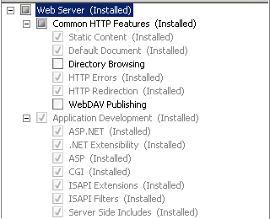

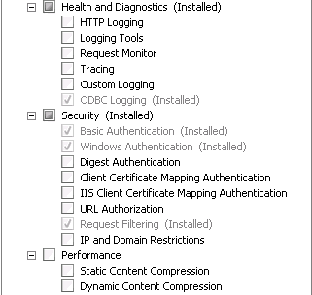

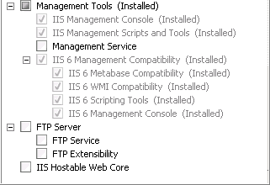

## Installing ChemBioOffice Enterprise 12.6.3

### Installation Prerequisites

To install CBOE 12.6.3, you must have .Net Framework 4.5.2 installed on your machine. If the installed version of .Net Framework is earlier than 4.5.2, it will automatically get upgraded to 4.5.2 while installing CBOE 12.6.3.

### Installing CBOE 12.6.3

Follow the steps below to install ChemBioOffice Enterprise Suite:

| **Step** | **User Input/Action** | **Expected Results** |
| --- | --- | --- |
| 1 | Launch the *CBOE 12.6.3.exe* installer. The CBOE installer wizard displays    Click **Install**.  **Note**: This installer wizard lists the prerequisites which are not installed on your machine. When you click Install, it begins installing the items listed. You may need to follow the on-screen instructions to complete the installation of the prerequisite items. | Installation begins and the welcome wizard appears. |
| 2 | Click **Next**. | CBOE 12.6.3 License Agreement window appears. |
| 3 | Read the license agreement, and select the “I accept the terms in the license agreement” option.    Click **Next**. | Website selection window appears |
| 4 | Select one of the following options:  Select existing Website    Create a new Website   * Website Description: Enter the name of the new Website. (ChemBioOfficeEnterprise12.0.1 by default) * IP Address: Select the IP Address from the dropdown list. * Port No: Enter the Port Number * Host Header: Optionally enter the host header     **Note**: Microsoft Internet Information Services (IIS) allows you to map multiple Web sites with the same port number to a single IP address by using a feature called Host Header Names. By assigning a unique host header name to each Web site, this feature allows you to map more than one Web site to an IP address.  The host header is the hostname that users will enter into their browser when trying to reach this server via HTTP. That is, the name of the server that user will enter into their web browser when trying to reach the ChemBioOffice Enterprise applications. It is the responsibility of the network administration to ensure that the host header resolves to the IP address bound to the Default Web Site. The same host header must not be used by any other web site sharing the same target IP address. | Website selection window dismisses, then the selection of CBOE installation destination folder window appears |
| 5 | If required, click **Change** to change the default destination location and to select a new destination folder.  Enter the Oracle Service Name and click **Next**. | The selection of CBOE installation destination folder window dismisses, then the user creation window appears |
| 6 | Enter the credentials for the Windows account used to run PerkinElmer services. This can be an existing local or domain administrative account. The installer can create a new account if desired.  The default is to create an account named camsoft_admin with password CambridgeS0ft!    **Note**: Depending on the password complexity policy in effect, this default password may not be acceptable. Please remember the user name and password chosen in this step for later use. | The user creation dialog dismisses, then the setup type selection dialog displays |
| 7 | Click Install. | Installation starts. |
| 8. | Once the installation is completed, click **Finish** to close the installer window. | Install shield wizard closes. |
| 9. | Click **Yes** in the confirmation window to restart the application server. |  |

## Installing ChemACX

The ChemACX application supports the use of Oracle based database. Please note that a free disk space of approximately 110GB is required for the ChemACX 16.16.3 installation in CBOE 12.6.3.

### ChemACX Oracle Based Database

The ChemACX Oracle requires that the contents of the ChemACX Oracle scripts as well as the dump file distributed on a separate CD, be extracted and copied to: <webroot>\ChemOffice\ChemACX\config\oracle_installation_scripts.

**Note**: After installing the ChemACX database, the chemacx.udl file should be updated. For detailed instructions please refer to the "*OracleSetup.hta*" file that can be found in the installation folder.

## Activate ChemDraw Professional

A copy of ChemDraw Professional 15.1 is installed on the Application Server in order for all other modules to function. You need to activate the ChemDraw Professional by providing user and serial number information:

| **Step** | **User Input/Action** | **Expected Results** |
| --- | --- | --- |
| 1 | Go to **Start > All Programs > ChemOffice 2015 > ChemDraw Professional 15.1** | The *PerkinElmer Software Activation* window appears. |
| 2 | Enter your Name, Organization, Email address and the Serial Number provided by PerkinElmer. |  |
| 3 | Enter the Activation Code provided by PerkinElmer or click the “Activate over Internet”. The activation code will be retrieved from PerkinElmer server via the Internet. If the server cannot gain access to the internet then you will need to obtain the activation code associated with your serial number from PerkinElmer technical support. |  |

## Activate ChemScript

ChemScript is installed on the Application Server in order for all other modules to function. You need to activate the ChemScript by providing user and serial number information:

| **Step** | **User Input/Action** | **Expected Results** |
| --- | --- | --- |
| 1 | Go to **Start > All Programs > ChemBioOffice 2014 > ChemScript 14.0 > ChemScript Demo**. |  |
| 2 | In the command window, follow the prompts until the PerkinElmer Software Activation window appears. |  |
| 3 | Enter your Name, Organization, Email address and the Serial Number provided by PerkinElmer |  |
| 4 | Enter the Activation Code provided by PerkinElmer or click the “Activate over Internet”. The activation code will be retrieved from PerkinElmer server via the Internet. |  |
| 5 | Close the ChemScript Demo command window. |  |

1. Database Schema Creation

## Overview

The Oracle schemas required by the ChemBioOffice WebServer application modules are created or updated by executing SQL scripts from the application server. If all software requirements have been met then the application server will be already properly configured to execute scripts against the database using the Oracle SqlPlus command line utility. The necessary SQL scripts are delivered to the application server as part of each application module installer. In addition, the Core ChemBioOffice Enterprise installer delivers Database Creation and Upgrade Guides which provide convenient hyperlinks from which to launch the SQL scripts. Clicking a hyperlink from the Upgrade or Creation Guide launches the corresponding script in SQLPlus. SQLPlus will prompt for the necessary input such as:

* Name of the target Oracle service
* Name of an account with Oracle DBA privileges (typically the “System” account)
* Password for the above account

**Note:** It is recommended that the database scripts be executed using the system account and that its password be temporarily changed to “manager2”. These are the default values used by most scripts. Doing this will minimize typing and expedite the installation process. The system password can be changed at the end of the database installation process and the final password used during the configuration steps detailed below.

Each SQL script will produce a detailed log file of the actions taken while creating or updating the target database, as well as a summary log file which contains a count of errors, ignorable errors, and actions performed. The summary log file is automatically open upon completion of the SQL script execution.

A copy of each summary and detailed log files is stored at:

*C:\Program Files (x86)\CambridgeSoft\ChemOfficeEnterprise12.1.0.0\Configuration and DB Tools\SetupLogs*

While executing the scripts, you may get the following ignorable errors. It is absolutely safe to ignore the errors.

* PLS-00302: component must be declared
* ORA-00955: name is already used by an existing object
* ORA-12003: materialized view or zonemap does not exist
* ORA-00942: table or view does not exist
* ORA-00001: unique constraint violated
* ORA-12002: there is no materialized view log on table
* ORA-01418: specified index does not exist

Most creation and upgrade scripts will yield a zero error count in the summary log. However, depending on the order in which the scripts are executed or on the previous database upgrade history, it is possible that some scripts will yield a non-zero error count. In this event, the “ignorable” error counts provided in the summary log should be inspected. If the sum of ignorable errors matches the total error count, then the script execution can be considered successful. If the error count is higher than the sum of ignorable errors, then the script execution should be considered unsuccessful. The cause of the unexpected errors should be investigated and resolved before continuing with the execution of other SQL scripts. The detailed log often contains the necessary information to pinpoint the cause of unexpected errors.

## Database Schema Creation

***Note:*** *If CBOE is installed with Oracle 11g or 12c, then CBOE classical applications (inventory, ChemACX) should have the udl username/password in CAPITAL. For more information on how to make the password case-insensitive please refer to the section* *13.5 Oracle 11g or 12c Related Issues**.*

The ChemBioOffice Enterprise 12.6.3 Database Creation Guide provides hyperlinks to launch each of the database creation scripts.

To launch the Database Creation Guide, click Start > ChemBioOffice Enterprise > Database Creation Scripts

The following page appears:

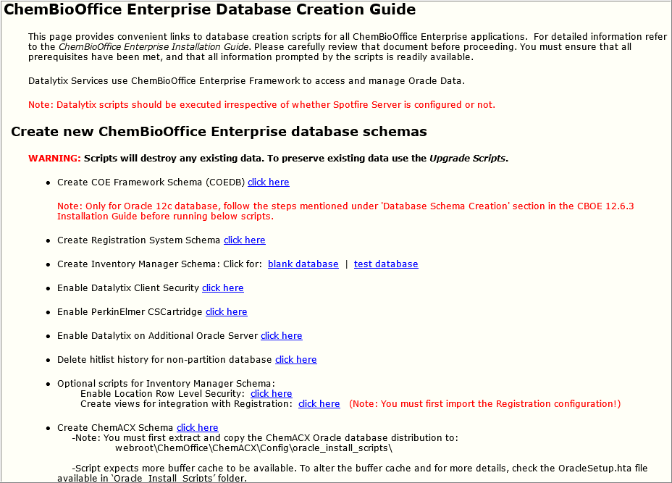

Click each of the links to create the corresponding database. The COE Framework Schema script is the only one required for all installations. The other creation scripts should be executed (in the order in which they appear on the page) if the corresponding application module was previously installed. Clicking a hyperlink to launch a script for an application that has not been installed will result in an error.

Unexpected errors found while executing any update script should be resolved before executing additional scripts. A copy of all log files in the SetupLogs folder should be submitted to PerkinElmer support for troubleshooting of the database creation errors.

***Note****: Scripts related to Datalytix (Enabling Datalytix Client Security, Enabling PerkinElmer CSCartridge, and Enabling Datalytix on Additional Oracle Server) are mandatory even if you are NOT using Datalytix integration. In CBOE 12.6.3, CBOE framework is integrated with Datalytix functionalities. As part of this integration, the framework requires more privileges to be set for the COE user (COEUSER). These required privileges are being set when the Datalytix scripts are run. Hence, it is mandatory that the database scripts related to Datalytix need to be run irrespective of whether Spotfire Server is configured or not.*

### COE Framework Schema

The COE Framework Schema script is the only one required for all installations.

|  |  |
| --- | --- |
| **Script Prompt** | **Description** |
| Enter the target Oracle service name: | Enter the name of the target Oracle service. This is the same name that should have been tested in section TNS Names Configuration. |
| Enter the name of an Oracle account with system privileges (system): | If your oracle account with system privileges is ***system****,* click Enter. For another one, enter the name of the oracle account. |
| Enter the above oracle account password (manager2): | If system password has been temporarily changed to “manager2”, click Enter. For another one, enter the system password. |

After the execution of this script, the summary log appears. Be sure Errors is equal to zero. If not, open and inspect the following log file *LOG_CREATE_COEDB_ORA.TXT* using the shortcut at Start > ChemBioOffice Enterprise > Setup Logs.

### Steps to be done in Oracle 12c Fresh Environment

1. After creating the COEDB schema through DB creation scripts, open a separate command prompt and login to sqlplus as SYS user:  
   e.g.  
   Enter user-name: sys@<oracle service Id> as sysdba  
   Enter password: <password for SYS user>
2. Once connected successfully, execute: alter system set "_projection_pushdown" = false scope=both;
3. Execute : grant select on sys.user$ to COEDB;
4. If its granted successfully, connect the sqlplus as COEDB user:  
   eg: connect coedb/<coedb schema password>@<oracle service id>
5. Once connected successfully, run the below statement:  
   @"C:\Program Files (x86)\CambridgeSoft\ChemOfficeEnterprise12.1.0.0\Framework\DBInstallScripts\COEDB\Oracle_Install_Scripts\sql\Patches\Patch 12.6.3\Function\fn_CreateUser.sql";
6. Make sure the function is created without any compilation errors.
7. Continue creating the rest of the CBOE schemas through DB creation scripts.

### Registration System Schema

Registration System is a powerful, web-based registration solution included in the ChemOffice Enterprise suite. The system includes a robust data model for pure compounds, mixtures, batches, salt management, automatic duplicate checking, and unique ID assignments.

To create the Registration System schema click the *Click Here* hyperlink from the Create Registration System Schema and respond to the script prompts:

|  |  |
| --- | --- |
| **Script Prompt** | **Description** |
| Enter the target Oracle service name: | Enter the name of the target Oracle service. This is the same name that should have been tested in section TNS Names Configuration. |
| Enter the name of an Oracle account with system privileges (system): | If your oracle account with system privileges is ***system****,* click Enter. For another one, enter the name of the oracle account. |
| Enter the above oracle account password (manager2): | If system password has been temporarily changed to “manager2”, click Enter. For another one, enter the system password. |

After the execution of this script, the summary log appears. Be sure Errors is equal to zero. If not, open and inspect the following log file *LOG_CREATE_CHEMREG_ORA.TXT* using the shortcut at Start > ChemBioOffice Enterprise > Setup Logs.

***Note****: While creating REGDB schema for a fresh installation, you may encounter ignorable errors in the log file as shown in the image. This is because of the performance improvement conducted on InvLoader, wherein some of the indexes were created under the system user and not under the regdb user. To fix this, we dropped the indexes created under the system user and recreated those under regdb user. This change is integrated into both 12.5.3 and 12.6. Since these scripts are included in both 12.5.3 and 12.6, you may get these errors. You can ignore these errors***.**

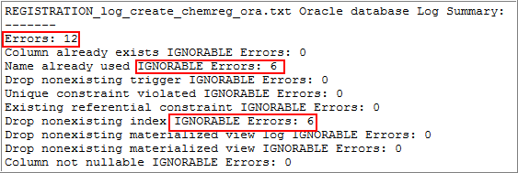

### Inventory Manager Schema

Inventory Enterprise is a ChemBioOffice Enterprise application that allows you to track the data associated with the reagents procured or produced by chemical and pharmaceutical research centers. It keeps track of all the data from the procurement or initial production of the reagents to the depletion or disposal of the reagents.

You can create a blank Inventory database with no data inside or a test Inventory database which load automatically a test database for test purpose.

***Note****: Before running the Inventory Manager schema, it is mandatory that you need to execute the Registration System schema to avoid any Oracle errors even though you are not using Registration.*

If you want to create a blank database click the *Blank Database* hyperlink, otherwise click *Test Database* from the Inventory Manager Schema section and respond to the script prompts:

***Note****: For* ***Test Database****, make sure that you have already installed both ODAC and Oracle client on the middle tier machine to avoid any ORA errors while executing the script.*

|  |  |
| --- | --- |
| **Script Prompt** | **Description** |
| Blank Database | |
| Enter the target Oracle service name: | Enter the name of the target Oracle service. This is the same name that should have been tested in section TNS Names Configuration. |
| Enter the name of an Oracle account with system privileges (system): | If your oracle account with system privileges is ***system****,* click Enter. For another one, enter the name of the oracle account. |
| Enter the above oracle account password (manager2): | If system password has been temporarily changed to “manager2”, click Enter. For another one, enter the system password. |
| Test Database | |
| Enter the target Oracle service name: | Enter the name of the target Oracle service. This is the same name that should have been tested in section TNS Names Configuration. |
| Enter the name of an Oracle account with system privileges (system): | If your oracle account with system privileges is ***system****,* click Enter. For another one, enter the name of the oracle account. |
| Enter the above oracle account password (manager2): | If system password has been temporarily changed to “manager2”, click Enter. For another one, enter the system password. |

After the execution of this script, the summary log appears. Be sure Errors is equal to zero. If not, open and inspect the following log file *LOG_CREATE_BLANK_CHEMINVDB.TXT or LOG_CREATE_TEST_CHEMINVDB.TXT* using the shortcut at Start > ChemBioOffice Enterprise > Setup Logs.

Additional, Inventory Manager optionally supports the use of Oracle Row Level Security to prevent users or groups from accessing protected inventory locations. This feature is enabled by executing a database script that defines the Oracle Fine Grained Access Control policies. Click the Enable Location Row Level security hyperlink option, to execute this database script:

|  |  |
| --- | --- |
| **Script Prompt** | **Description** |
| Enter the target Oracle service name: | Enter the name of the target Oracle service. This is the same name that should have been tested in section TNS Names Configuration. |
| Enter the name of an Oracle account with system privileges (system): | If your oracle account with system privileges is ***system****,* click Enter. For another one, enter the name of the oracle account. |
| Enter the above oracle account password (manager2): | If system password has been temporarily changed to “manager2”, click Enter. For another one, enter the system password. |

After the execution of this script, the summary log appears. Be sure Errors is equal to zero. If not, open and inspect the following log file LOG_ADDRLS.TXT using the shortcut at Start > ChemBioOffice Enterprise > Setup Logs.

**Note**: If location-based security is enabled, reporting in Inventory may not work correctly.

The Inventory Manager optionally supports integration with PerkinElmer’s Registration Enterprise system. This is a by-directional integration where the Inventory System can search and display registered compounds and the Registration system can create Inventory containers to track registered substances.

The Inventory Manager accesses the Compound and Batch data stored in the Registration System via a set of Oracle views created in the Inventory database schema. A SQL script is provided to create the views. The views can be modified under the direction of PerkinElmer Service Engineers to expose registration data from other sources.

To execute the default Registry Integration scripts, click the *Create views for integration with Registration* hyperlink.

|  |  |
| --- | --- |
| **Script Prompt** | **Description** |
| Enter the target Oracle service name: | Enter the name of the target Oracle service. This is the same name that should have been tested in section TNS Names Configuration. |
| Enter the name of an Oracle account with system privileges (system): | If your oracle account with system privileges is ***system****,* click Enter. For another one, enter the name of the oracle account. |
| Enter the above oracle account password (manager2): | If system password has been temporarily changed to “manager2”, click Enter. For another one, enter the system password. |

After the execution of this script, the summary log appears. Be sure Errors is equal to zero. If not, open and inspect the following log file LOG_REGISTRATIONINTEGRATION.TXT using the shortcut at Start > ChemBioOffice Enterprise > Setup Logs.

### Enabling Datalytix Security Schema

To create the Datalytix security schema, click the click here hyperlink corresponds to **Enable Datalytix Client Security** in the ChemBioOffice Enterprise Database Creation Guide page, and respond to the script prompts:

|  |  |
| --- | --- |
| **Script Prompt** | **Description** |
| Enter the target Oracle service name: | Enter the name of the target Oracle service. This is the same name that should have been tested in section TNS Names Configuration. |
| Enter the name of an Oracle account with system privileges (system): | If your oracle account with system privileges is ***system****,* click **Enter**. For another one, enter the name of the oracle account. |
| Enter the above oracle account password (manager2): | If system password has been temporarily changed to “manager2”, click **Enter**. For another one, enter the system password. |

After the execution of this script, the summary log appears. Be sure Errors is equal to zero. If not, open and inspect the following log file LOG_CREATE_DATALYTIX.TXT using the shortcut at Start > ChemBioOffice Enterprise > Setup Logs

### Enabling PerkinElmer CSCartridge

To enable the PerkinElmer CSCartridge, click the *click here* hyperlink corresponds to ***Enable PerkinElmer CSCartridge*** in the ChemBioOffice Enterprise Database Creation Guide page, and respond to the script prompts:

|  |  |
| --- | --- |
| **Script Prompt** | **Description** |
| Enter the target Oracle service name:: | Enter the name of the target Oracle service. |
| PerkinElmer CSCartridge schema name: | Enter the CSCartridge schema name. The default value is CSCARTRIDGE. |

After the execution of this script, the summary log appears. Be sure Errors is equal to zero. If not, open and inspect the following log file *SummaryLog_Datalytix_log_enablecscartridge.txt* using the shortcut at Start > ChemBioOffice Enterprise > Setup Logs.

### Enabling Datalytix on Additional Oracle Server

Click the click here hyperlink corresponds to **Enable Datalytix on Additional Oracle Server** in the ChemBioOffice Enterprise Database Creation Guide page to enable Datalytix on Additional Oracle Server. This allows you to create the global database owner, grant the required permissions and create the tables which will store the temporary query results.

***Note****: Enabling the Datalytix on Additional Oracle Server is required before publishing the data source to Spotfire. If not enabled, you may encounter permission issues.*

To enable the data source, click the click here hyperlink corresponds to **Enable Datalytix on Additional Oracle Server** in the ChemBioOffice Enterprise Database Creation Guide page and respond to the script prompts:

|  |  |
| --- | --- |
| **Script Prompt** | **Description** |
| Oracle service name: | The oracle service name for which you will create the global user. The service name should be added in Oracle tnsnames.ora |
| Oracle account with system privileges | The oracle user name which has system privileges. The tool will use this account to create the global user and grant required permissions. By default, the value is set to system. |
| Oracle account password | The password for the Oracle account defined above (Oracle account with system privileges). |

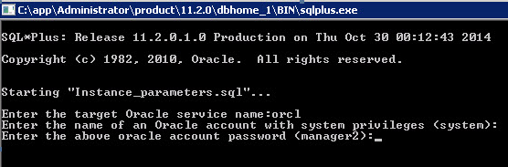

A global user will be created and the required permissions granted. The COE hit list tables will automatically be created as shown in the example below.

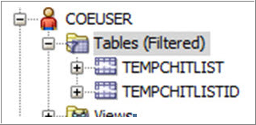

### Delete Hitlist History for Non-partition Database

The hitlist tables are used to store the identifiers of hit rows for Datalytix queries. Over time, the hitlist tables will become larger and will impact the search performance. On a partitioned system Datalytix automatically drops the older hitlist partitions by DBMS job. It is highly recommended to enable partitioning feature.

For non-partition system, please follow the steps below to delete the hitlist history manually:

Click the *click here* link corresponding to **Delete hitlist history for non-partition database** and respond to the script prompts:

|  |  |
| --- | --- |
| **Script Prompt** | **Description** |
| Enter the target Oracle service name: | Enter the name of the target Oracle service. If a different TNS alias was configured here, you should input the TNS alias. |
| Enter the name of an Oracle account with system privileges (system): | If your Oracle account with system privileges is ***system****,* click Enter. For another one, enter the name of the oracle account. |
| Enter the above Oracle account password (manager2): | Enter the Oracle account password. |
| Enter the record number to keep <10000>: | The hitlist of how many queries you want to keep. |

After the execution of this script, the summary log appears. The detailed execution result can be found in the log file “*log_cleanhitlisttables.txt*” located at Start > ChemBioOffice Enterprise > Setup Logs.

### ChemACX Schema

ChemACX (Available Chemicals Exchange) is a large database of chemical products that are currently available from chemical manufacturers and distributors. Before launching ChemACX scripts, be sure scripts and dump file are copied as described in *ChemACX Oracle based database* chapter*.*

*ChemACX scripts require that 4k and 16K buffer cache be available on the target database instance. The ChemACX schema hyperlink should not be used unless these requirements have been met.*

***Note****: The buffer cache size and minimum disk size required varies based on the ChemACX Database version you are installing. For more information, refer the OracleSetup.hta file available under <webRoot>wwwroot\ChemOffice\ChemACX\config\Oracle_Install_Scripts.*

***Note****: To increase the cache size please follow the below steps:*

* *Connect sys/<syspwd>@<schema> as sysdba*
* *Alter system set db_4k_cache_size=64M scope=spfile;*
* *Alter system set db_16k_cache_size=16M scope=spfile;*
* *Shutdown the system*
* *Startup*

To create the ChemACX schema click the *click here* hyperlink and respond to the script prompts:

|  |  |
| --- | --- |
| **Script Prompt** | **Description** |
| Enter the target Oracle service name: | Enter the name of the target Oracle service. This is the same name that should have been tested in section TNS Names Configuration. |
| Enter the name of an Oracle account with system privileges (system): | If your Oracle account with system privileges is ***system****,* click Enter. For another one, enter the name of the oracle account. |
| Enter the above Oracle account password (manager2): | If system password has been temporarily changed to “manager2”, click Enter. For another one, enter the system password. |

After the execution of this script, the summary log appears. Be sure Errors is equal to zero. If not, open and inspect the following log file log_create_chemacx.txt using the shortcut at Start > ChemBioOffice Enterprise > Setup Logs.

1. Application Server Configuration

## Overview

ChemOffice WebServer applications are highly configurable. Configuration settings are managed via initialization files (.ini) and database link files (.udl). There are some common configuration steps which are required for all application modules, such as providing the target database information or connection credentials. There are many other, application specific, optional configuration steps which control the behavior of detailed aspects of each module. All configuration files are human readable and can be edited using a simple text editor. However, the most common configuration tasks can be most easily accomplished using the ChemBioOffice Enterprise 12.6.3 Configuration Tool. This section provides an overview of the various configuration files. The next section provides details on the use of the Server Configuration Tool.

## Configuration Files

### COEFrameworkConfig.xml

This file is located in the C:\ProgramData\CambridgeSoft\ChemOfficeEnterprise12.1.0.0 folder. It is created by the core ChemBioOffice Enterprise installer and records configuration information required by the COE Framework services, including database connection details, SingleSignOn URL and authentication configuration. This file is automatically updated by the installer and the server configuration tool. It does not need to be manually edited for most common installation scenarios.

### COWS.ini

This file is located in the windows folder (typically C:\Windows or C:\WinNT). It is created by the core ChemBioOffice Enterprise installer and records the physical path to the ChemOffice folder under which all other modules are located. This file does not need to be modified unless the location of the ChemOffice folder needs to be changed after the initial installation. Relocating the ChemOffice folder requires adjusting many other configuration settings so is strongly recommended that this task only be performed under the direction of an experienced PerkinElmer service engineer.

### ChemOffice.ini

This file is located is located under the ChemOffice root (typically *C:\Inetpub\wwwroot\ChemOffice\Config*). It contains server level settings such as the list of installed application modules, the authentication method in effect, the version of ChemOffice desktop components present on the server, and the version of the ChemBioOffice Enterprise core. This file is created by the ChemBioOffice Enterprise installer and it is updated by each of the application modules installers. The configuration tool described below interacts with this file to setup the version of desktop components to be used. This file does not typically need to be manually edited.

### Cfserver.ini

This file is located in each application’s configuration folder (typically *C:\Inetpub\wwwroot\ChemOffice\<appName>\config*). It contains application level configuration information. There are three main sections in the cfserver.ini file. The [GLOBALS] and [CS_SECURITY] sections contain configuration settings that are available in all application modules. A third section typically named after the specific application (Ex. [CHEMINV]) contains configuration settings for application specific features. The mandatory and most commonly used settings in this file are managed by the configuration tool. Further customizations must be performed using a text editor under the supervision of a PerkinElmer service engineer.

### <AppName>.in

This file is located in each application’s configuration folder (typically *C:\Inetpub\wwwroot\ChemOffice\<appName>\config*), and is named after the application or database name. It contains information about the application database such as the names of database tables and fields, the relationships between tables, the data types of the fields, the expected behavior of data fields during query operations, and the database connection information. This file contains all the metadata required for ChemBioOffice Enterprise to dynamically generate the SQL required to interact with the database. These files do not typically need to be modified during deployment. They are authored and managed by the application developers as new objects are introduced into the database or as new query functionalities are added to the application. The only scenario under which this file may be modified on a deployed system would be the modification of the query behavior of an existing field. This task should be performed under the direction of a PerkinElmer service engineer.

### Custom Configuration Files

The ChemACX and Inventory Manager Application modules contain additional custom configuration files which extend the configurability afforded by the cfserver and application ini files. These files are also located in the application’s configuration folder.

ChemACXConfig.ini and InvConfig.ini are extensions of the corresponding application cfserver.ini files. Some of their most typically commonly used entries are managed by the Configuration tool. For more advanced settings they must be manually edited.

Other custom files such as invReg.ini, invAcx.ini and ChemACX2.ini are database metadata files similar to the <AppName>.ini. They contain the necessary information for more advanced global search features available in some applications. These files are also managed by the development teams and are not expected to be modified on the field.

### Database Link Files

ChemBioOffice Enterprise application modules use Microsoft OLEDB database link files to determine the database provider and service name used to establish the database connection. These files are located in each application configuration folder (typically *C:\Inetpub\wwwroot\ChemOffice\<appName>\config*). Udl files can be manually edited by double-clicking from the Windows Explorer. The operating system automatically provides a custom editor dialog that allows the selection of the provider and target service. Each application contains one of more udl files, but in most common scenarios, all applications will connect to the same back-end database. The ChemBioOffice Enterprise configuration tools will automatically set the service name for all of the installed module’s udl files, eliminating the need to repetitive manual configuration.

## Configuration Tool

While all configuration of the files described above may be performed by directly editing the files with a simple text editor, ChemBioOffice Enterprise 12.6.3 provides a configuration tool that can greatly simplify the most common configuration tasks.

The configuration tool detects the installed application modules and edits their configuration files. It is therefore important that the tool be run only after all desired modules have been installed. Application modules installed after the configuration tool has been run will not be affected by the configuration choices.

***Note:*** *Before launching the Server Configuration Tool make sure the Inventory system data sources (DSNs) is configured.*

### Launching the Configuration Tool

To launch the configuration tool go to Start > **All** Programs > ChemBioOffice Enterprise > Server Configuration Tool. The following page appears.

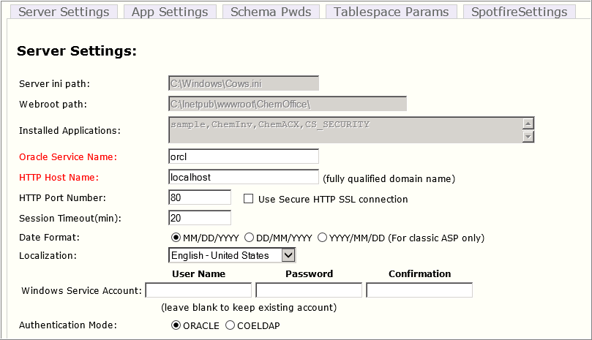

There are five tabs separating the major areas of configuration supported by the tool. Each tab is detailed in the following sections:

### Server Settings

Upon startup, the configuration tool detects the Cows.ini file path, ChemOffice webroot, and the list of installed applications. This information is presented in the tool, but it is not editable. Only application modules which appear in the list will be affected by the configuration tool. Before proceeding with any configuration choices please ensure that all desired modules have been installed.

The tool also checks for the presence of the ODBC DSNs that should have been setup as described in section ODBC Client Configuration. A warning will be issued if a connection cannot be established to the database.

The following configuration options appear on this section:

| **Fields** | **Description** |
| --- | --- |
| Oracle Service Name (required) | The name of the target Oracle service must be provided. This is the same name that should have been tested in section TNS Names Configuration. The tool will attempt to connect to the server before saving the configuration so the database must be available. |
| HTTP Host Name (required) | The application server host name or IP address must be entered here. The tool auto-detects the server name, however, it is recommended that this name be replaced with the DNS managed host name that will be used by the end users when accessing the application server. The recommended practice would be to setup a DNS entry pointing the application server using a fully qualified descriptive name such as ChemBioOfficeEnterprise12.6.3.YourDomain.com. |
| HTTP Port Number | Set the HTTP Port number and HTTPS port number as shown in the figures below to enable the secured Internet services for the server.   * For HTTP, Port Number should be 80 * For HTTPS, the Port Number should be 443   Click on the check box “Use Secure HTTP SSL Connection” which shown in the figure for SSL certification. |
| Date Format | Select the desired date format. The chosen format will be used whenever dates are displayed or entered into the system. This setting affects all Oracle based ChemOffice WebServer applications which provides finer control of data formats on a per field level. If different formats are desired for different application modules then the applicable DATE_FORMAT entry in cfserver.ini file would need to be modified. |
| **Localization** | Localization is used to select the region option that should be consistent with the regional language setting of the Operating System, supporting the local characters, number |
| Service Account | The service account was determined during installation of the ChemBioOffice Enterprise core. If you wish to reconfigure all application modules to use a different service account, a user name and password should be provided here. The credentials are validated by the tool upon entry. The user account can be a local windows account or a domain account (EX. myDomain\myUser). Leave this section blank to preserve the service account defined during installation. |
| Authentication Mode | ORACLE User credentials are authenticated against Oracle. User must have a valid Oracle account and know its password. No additional configuration is required in this case.  COELDAP User credentials are authenticated against the ChemOffice Enterprise SingleSignOn Service. The service is typically configured to connect to a Microsoft Active Directory or LDAP server for authentication. An Oracle account also exists for the user but its password is internally managed by the application and not known to the end-user. |

When COELDAP option is chosen, a valid COELDAP configuration xml file fragment must be provided. An example is given below together with the explanation of the parameters that typically need to be adjusted to the local LDAP environment.

|  |
| --- |
| C:\temp\New Text Document.xml - # <COELDAPConfiguration>  C:\temp\New Text Document.xml - # <COELDAP>  C:\temp\New Text Document.xml - # <addUser>  C:\temp\New Text Document.xml - #<process>  C:\temp\New Text Document.xml - # <bind pwdRequired="true" authenticationType="secure">  <basedn> LDAP SERVER: LDAP PORT/dc=DOMAIN,dc=com</basedn>  <error>Failed to bind to domain</error>  </bind>  C:\temp\New Text Document.xml - # <query timeOut="2" scope="subTree" pageSize="5">  <filter>(sAMAccountName=%username%)</filter>  <attr>cn</attr>  <error>The username %username% was not found in the domain</error>  </query>  <unbind />  </process>  </addUser>  C:\temp\New Text Document.xml - # <authenticate>  C:\temp\New Text Document.xml - # <process>  C:\temp\New Text Document.xml - # <bind pwdRequired="true" authenticationType="secure">  <basedn>LDAP SERVER: LDAP PORT/dc=DOMAIN,dc=com</basedn>  <error>Failed to bind to domain</error>  </bind>  C:\temp\New Text Document.xml - # <query timeOut="2" scope="subTree" pageSize="5">  <filter>(sAMAccountName=%username%)</filter>  <attr>dn</attr>  <error>The username %username% was not found in the domain</error>  </query>  C:\temp\New Text Document.xml - # <bind pwdRequired="true" authenticationType="fastbind">  <basedn>boron2.camsoft.com</basedn>  <dn> DOMAIN\%username%</dn>  <error>Authentication Failed, process two</error>  </bind>  </process>  </authenticate>  C:\temp\New Text Document.xml - # <getUserInfo>  C:\temp\New Text Document.xml - # <process>  C:\temp\New Text Document.xml - # <bind pwdRequired="true" authenticationType="secure">  <basedn> LDAP SERVER: LDAP PORT/dc=DOMAIN,dc=com</basedn>  <error>Failed to bind to domain</error>  </bind>  C:\temp\New Text Document.xml - # <query timeOut="2" scope="subTree" pageSize="5">  <filter>(sAMAccountName=%username%)</filter>  <attr>SAMAccountName</attr>  <attr>givenName</attr>  <attr>initials</attr>  <attr>sn</attr>  <attr>mail</attr>  <error>The username %username% was not found in the domain</error>  </query>  <unbind />  </process>  </getUserInfo>  <ldapUserDN>cn=SERVICE ACCOUNT,cn=users,dc=DOMAIN,dc=com</ldapUserDN>  <ldapPass>ACCOUNTPASSWORD</ldapPass>  C:\temp\New Text Document.xml - #<GetUserReturnInfo>  <add ldapCode="SAMAccountName" displayName="Username" mapTo="username" nodeName="username" />  <add ldapCode="givenName" displayName="First Name" mapTo="FirstName" />  <add ldapCode="initials" displayName="Middle Name" mapTo="MiddleName" />  <add ldapCode="sn" displayName="Last Name" mapTo="LastName" />  <add ldapCode="mail" displayName="Email" mapTo="Email" />  </GetUserReturnInfo>  </COELDAP>  </COELDAPConfiguration> |

LDAP Server  
The name or IP address of the target LDAP or Active Directory Server. (Ex. myLDAP.myDomain.com)

LDAP Port

The TCP/IP port used by the LDAP server. Default value is typically 389.

Domain  
The Domain hosting the Active Directory.

Service Account  
The account used to connect to the Active Directory in order to authenticate the end users.

Account Password  
The password for the above account.

The expressions inside the <filter> tags can also be adjusted to fit the requirements of the local LDAP environment. The filter expression within the <adduser> section is applied to determine which LDAP users are valid to add to the system. The expression within the <authenticate> provides the filter to reach the desired user to be authenticated.

### Application Settings

This section allows for the configuration of the most commonly used options for each of the application modules:

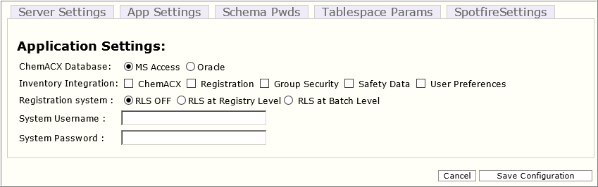

| **Fields** | **Description** |
| --- | --- |
| ChemACX Database | Select the oracle as the format for the ChemACX database. This setting affects the ChemACX and Inventory Manager Configuration files preparing them for ChemACX Oracle database connectivity. This step can be performed ahead of the actual database installation. It is not necessary that the database be copied or created ahead of this step.  The ChemACX application supports exporting the shopping cart contents to either MS Word or MS Excel documents. This functionality acts as simple integration point with procurement workflows that do not make use of more sophisticated electronic ordering systems. These export capabilities can be enabled via simple configuration ini settings, but also require some additional manual setup of the MS Office applications within the application server. |
| Inventory Integration | Enables the integration of the Inventory Manager application with other modules such as ChemACX, and Registration.  ChemACX Integration  The Inventory Manager optionally supports integration with the ChemACX procurement database. This integration allows the Inventory system to search the data in the ChemACX database. This integration can be enabled using the Configuration tool by checking the ChemACX box under the Inventory integration section. This option should not be enabled if the ChemACX module has not been installed.  Each distribution of the ChemACX database includes a SQL script that updates the Inventory Manager database with new vendor and package size information added to the ChemACX database. The following process should be followed to synchronize the Inventory database for use with ChemACX:   1. Insert the latest ChemACX database distribution CD. 2. Extract Oracle database distribution package by executing the appropriate self-extracting executable 3. Run the batch file update_inventory_for_chemacx.cmd   Registration Integration  The Inventory Manager optionally supports integration with PerkinElmer’s Registration Enterprise system. This is a by-directional integration where the Inventory System can search and display registered compounds and the Registration system can create Inventory containers to track registered substances.  User Preference  ***Note****: CBOE 12.6.3 does not support* ***User Preferences*** *feature. Hence ensure that the* ***User Preferences*** *option is un-checked.* |
| Enable Row Level Security | The Registration system can be optionally configured to implement project based virtual databases. This option is referred to as “Row Level Security” because it prevents certain users from accessing individual database rows based on their security clearance. Row level security is applied based on associations between users, projects, and registered compounds. A user will only see those registered compounds that are associated with projects to which he or she has been granted permissions. The Row Level security feature can be enabled/disabled using the configuration tool dialog. For more details about the Row Level Security feature please refer to the Registration System Admin Guide.  ***Note****: To make use of RLS feature, you need to have a valid Oracle Enterprise license. RLS feature will not work effectively with Oracle Standard.* |

### Schema Passwords

Most of the connections between the applications and the database are established using the credentials provided by the end-user during login. However, the application modules must sometimes connect to the database using the credentials of the schema owner. The system and schema passwords are stored on in the cfserver.ini files on the server. The password can optionally be encrypted for additional security.

This section of the configuration tool collects the schema passwords to be written to the cfserver.ini files. Note that the tool does not set or change the schema password in Oracle database. It simply writes the provided password to the appropriate ini files. The tool does, however, verify that the provided passwords are valid before proceeding. It is therefore required that target schemas exist and that their password be known ahead of using this tool to set the ini files.

Typically the configuration tool is first executed prior to the existence of the database schemas. It is therefore expected that this section of the tool will not be used until the initial configuration settings have been applied and the database scripts created. This section should be used to update the passwords in the ini configuration files if they were changed from their default values either during initial schema creation or at a later time. Validation of the schema passwords will fail if changes are made in this section prior to the existence of the schemas.

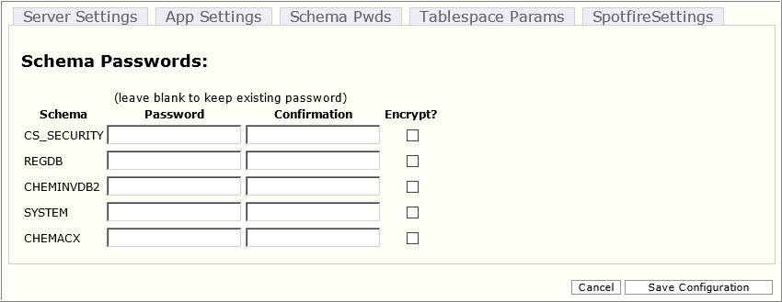

The default schema password for all ChemOffice WebServer databases is “ORACLE”. The default password for the system account is “manager2”. If the default values were used during the database schema creation then it will not be necessary to reset any of the ini files. In this case, this section can be left blank. If a password has been modified, then enter the new password into the corresponding Password and Confirmation text boxes. To encrypt the new password, select the Encrypt? Check-box.

To decrypt an existing password, enter the password in the corresponding Password and Confirmation text boxes and deselect the Encrypt? Check-box.

### Tablespace Parameters

The Oracle sql scripts used to create the application database schemas contain parameters that determine the size and file system path of tablespace data files. This section of the configuration allows modification of some of the entries in parameter.sql files. While each application schema has its own parameterized default paths, the configuration tool allows for only one default path per file-type to be set. For example, the entry under Table Data will be applied as the default table data file path for all application schemas. The values displayed in this section at start up are read from the first schema that uses this setting. Clicking the thumb icon under the “check” column will show the paths currently set for all other schemas that use the settings. A green “thumbs-up” icon indicates that all schemas that used the setting are currently set to use the same path. A red “thumbs-down” icon indicates that some paths may have been manually edited outside of this tool and are therefore not consistent with the setting about to be applied. This is mean to be a warning to the user that manually modified parameter entries will be modified when the new settings are saved.

The table on the bottom half of this section allows viewing and setting the data file size for all tablespaces. The sizes can be expressed in Kb, Mb, or Gb by using K, M, or G suffixes.

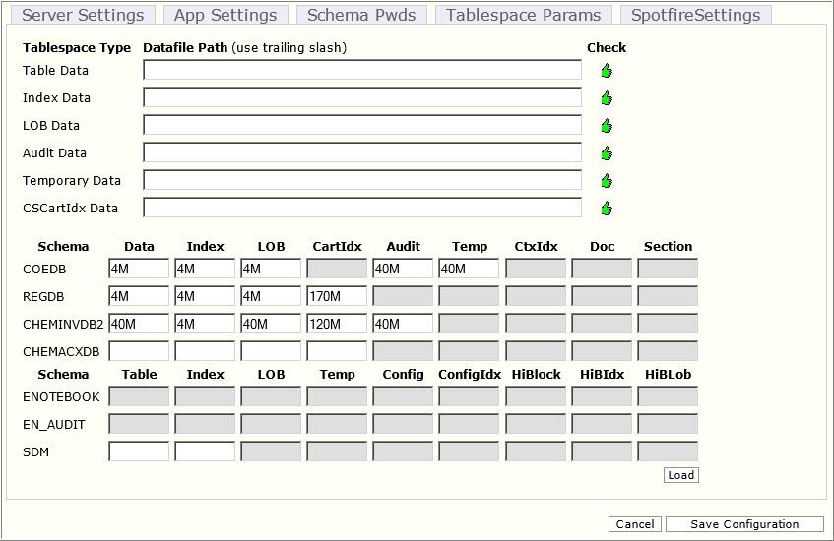

### Spotfire Settings

The Spotfire settings information is required to allow Datalytix to publish the data sources and data views to Spotfire.

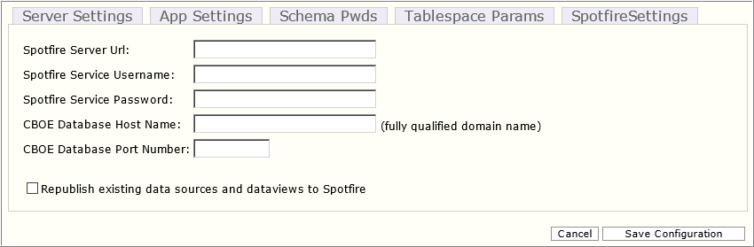

The following configuration options appear on this section:

| **Fields** | **Description** |
| --- | --- |
| **Spotfire Service URL** | Enter the Spotfire server connection URL. This Spotfire Service connection information is required to allow Datalytix to publish the data sources and data views to Spotfire. The Spotfire Server URL also accepts HTTPS settings.  ***Note****: Requires only if you use Datalytix. Otherwise leave this field empty.* |
| **Spotfire Service Username** | Enter the Spotfire service administrator username who has permission to operate the information link.  ***Note****: Requires only if you use Datalytix. Otherwise leave this field empty.* |
| **Spotfire Service Password** | Enter the password of the Spotfire Service user.  ***Note****: Requires only if you use Datalytix. Otherwise leave this field empty.* |
| **CBOE Database Host Name** | Enter the CBOE Database host name.  ***Note****: Requires only if you use Datalytix. Otherwise leave this field empty.* |
| **CBOE Database Port Number** | Enter the CBOE Database port number.  ***Note****: Requires only if you use Datalytix. Otherwise leave this field empty.* |

For the server settings related to Datalytix Data Source Publishing Tool, refer to section 8.3.8 Datalytix Data Source Publishing Tool.

### Loading Tablespace Parameters from ini file

The decisions regarding tablespace path and size require significant planning and cooperation between PerkinElmer service engineers and the customer DBA. The decisions of specific file paths and individual data file sizes must be reached well before the configuration tool is used. To simply the process of gathering and applying this complex tablespace parameter information, the configuration tool supports “loading” an initialization file instead of having to type the desired configuration values. All the entries presented in the “Tablespace Parameters” section of the configuration tool are also available in a simple text ini file named “CBOETableSpaceParameters.ini”. This file can be reviewed and populated ahead of time and its information loaded into this section of the configuration tool using the “Load” button. Entries loaded from the .ini file will appear in blue colored font until they are saved to the server.

The .ini file contains separate entries for the default path of each type of tablespace file:

* defaultTableTSPath: The path to the tablespace files.
* defaultIndexTSPath: The path to the index tablespace files.
* defaultLobTSPath: The path to the lob tablespace files.
* defaultAuditTSPath: The path to the audit tablespace files.
* defaultcscartTSPath: The path to the chemical index (cscartridge) tablespace files.
* defaultTempTSPath: The path to the temporary tablespace files.
* defaultSecurityTSPath: The path to the security tablespace files.
* defaultctxTSPath: The path to the ctx (Oracle Text index) tablespace files.
* defaultdocTSPath: The path to the tablespace used to store document BLOBs

In order to modify the destination path of the tablespaces created, follow the steps below:

1. Open the *CBOETableSpaceParameters.ini* file and go to [DEFAULT_TSPATHS] section
2. Enter the desired path for each tablespace file in between the single quotes
3. All paths must end with a slash and the path must be valid.

***Note:*** *The above example would be valid for a Windows based Oracle host. For a Unix based Oracle installation a valid Unix path should be provided (Ex. ‘space01/oradata/orcl/’). In either case, the path should contain the trailing slash.*

*If TSPath entries are left unedited, then the tablespaces will be created in the location of the System tablespace data file.*

The CBOETableSpaceParameters.ini files also control the initial size of each of the tablespace files. By default, the sizes are appropriate for a small test installation. It is therefore required that for production installations the settings be modify to set tablespace sizes that are commensurate with the expected size and growth pattern of the database.

To change tablespaces sizes, open the *CBOETableSpaceParameters.ini* file, locate the bracketed section associated with the desired schema, and enter the tablespace sizes using K, M, or G to designate Kb, Mb, or Gb.

The estimated file size should be based on the number of records that are expected for the given application module multiplied by the average expected record size. These two factors vary drastically depending on the application module and the data storage needs of each customer. Typically, the record size is driven by the size and number of chemical structures associated with each record and/or by the size of other large documents stored in the database. Another factor that can drastically affect the size of the tablespace files is the chosen database block size.

Given the complexity and unpredictability of the factors involved in the size calculation, an empirical, rather than predictive approach is recommended. An initial (rough) guess of the file size should be used during the setup of the test environment. After all legacy data has been loaded, an analysis can be performed of the resulting data file sizes. The sizes of the test system tablespace files can then be used as a starting point to estimate the production system file sizes by taking into account the expected growth patterns.

***Note****: All tablespaces are created with autoextend enabled. Not setting the "autoextend on" option places a responsibility on the DBA to ensure that there is always room within a data file for object (table and index) growth.*

### Datalytix Data Source Publishing Tool

In order to allow Datalytix to publish the data sources and data views to Spotfire, the Spotfire Service connection information must be provided when running the Server Configuration Tool.

The following information must be provided:

* **Spotfire Service URL**: The Spotfire server connection URL. The Spotfire Server Url also accepts HTTPS settings.
* **Spotfire Service Username:** The Spotfire service administrator username who has permission to operate the information link.
* **Spotfire Service Password:** The password of the Spotfire Service user.
* **CBOE Database Host Name**: The CBOE Database host name.
* **CBOE Database Port Number**: The CBOE Database port number.

***Note:*** *Any loopback address (localhost, 127.0.0.1) is not accepted by the* ***Spotfire Server URL*** *settings. Only the machine name or IP address is allowed.*

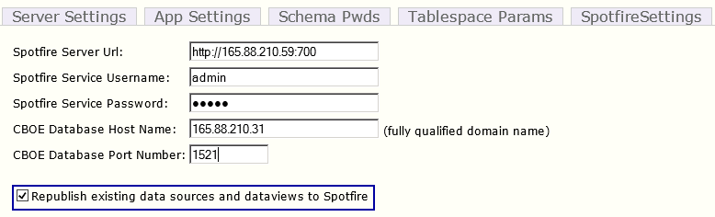

The **“Republish existing data sources and dataviews to Spotfire”** checkbox will be auto checked if the Spotfire settings entered here differ from those in the configuration file.

After updating the Spotfire Server settings, click on the **Save Configuration** button. A message will be displayed prompting you to save the changes.

If the **“Republish the existing data sources and dataviews to Spotfire”** checkbox is enabled**,** the **Datalytix Data Source Publishing Tool** will be launched automatically.

This publishing tool is used to publish the data sources to Spotfire. Its main functionalities include the creation of a primary data source, the modification of existing data sources and their publication to Spotfire and the publication of existing dataviews to Spotfire.

8. 3. 7. 1. Publishing Primary Data Source

Typically, the Primary Data Source details are configured in the “*COEFrameworkConfig.xml*” file, and while running Server Configuration Tool, it will invoke the Datalytix Data Source Publishing Tool, and this tool will help you to publish the primary data source.

Enter the following details when prompted:

* *Would you like to republish the existing data sources? (Yes/No):* Enter “**Y”**

***Note****: It is mandatory that you must enter ‘Y’ for the first time.*

* *Please choose an option to publish the data source. <Modify/Publish/Skip>*: Enter “P” to publish data source

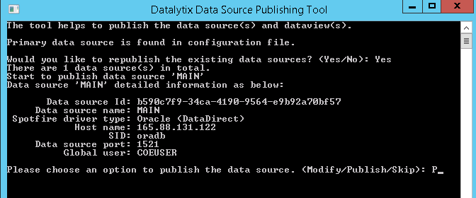

***Notes:***

* *Currently it only supports Oracle, Oracle (DataDirect) types. Prior to this step, the driver type should be enabled in Spotfire and related driver package should be deployed into Spotfire server location, otherwise it will return the validation error and the publication will fail.*
* *The required permissions should be granted to Global user by running the database creation script.*
  + - 1. Modifying Existing Data Sources

In the case where the Spotfire Service URL has changed, or the data source global user has changed, the data sources should be republished. You can run the Datalytix Data Source Publication tool to republish them.

The following information is displayed, some of which requires user input:

**Would you like to republish the existing data sources? (Yes/No)**. For subsequent run of Datalytix Data Source Publication tool, you may enter ‘y’ if you want to republish the existing data sources, otherwise enter ‘n’.

The existing data source information will be displayed in the console.

A console confirmation message will be displayed prompting you to choose an option to publish the data source (Modify/Publish/Skip) to confirm shown to confirm what you want to do, modification and publishing, publishing without modification, and skip. Enter one of the following characters to signify your choice:

* **M** – Modify and then publish
* **P** – Publish the data source
* **S** – Skip the data source publishing

***Note****: If a parameter is not modified, clicking the Enter key will retain the current value. For example, when prompted for the host name, clicking the Enter key will retain the old value and you will not need to enter the host name.*

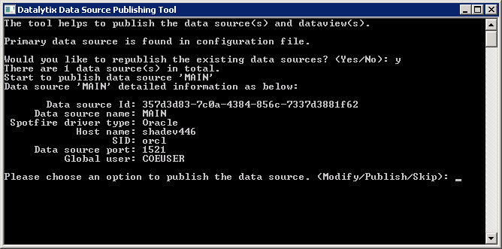

* + - 1. Publishing Existing Dataviews

The Datalytix Data Source Publishing Tool also provides the ability to publish the existing dataviews to the Spotfire Server.

Entering ‘y’ for the ‘**Would you like to republish the existing data views?**’ prompt will result in the tool retrieving all data views from DataView Manager, and subsequently publishing them one to one to the Spotfire Server.

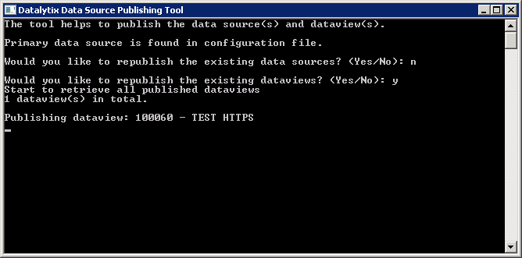

## Additional Configuration

This section details additional optional configuration and installation steps which are not automatically handled by either the installer or the configuration tools.

### Inventory Manager

Install T-Barcode ActiveX Component

A third party ActiveX control is required for Inventory reports that include barcodes. The T-Barcode ActiveX installer is delivered to the server during the installation of the Inventory module and can be found at the following location:

*<webroot>\ChemOffice\ChemInv\Installation\Tbarcode\TBarCode_x64_Setup.exe*

To install T-Barcode:

* Launch *TBarCode_x64_Setup.exe*
* Click Yes to install.
* Click Yes in the license agreement window.
* Browse to the destination folder and click Next.
* Click OK.

Location Based Security (optional)

The Inventory Manager optionally supports the use of Oracle Row Level Security to prevent users or groups from accessing protected inventory locations. This feature is enabled by executing a database script that defines the Oracle Fine Grained Access Control policies. A hyperlink to execute this database script can be found in the Database Creation Guide. Further details on executing the database script to enable location based security are provided in the Database Creation section below.

Integration with Registration Enterprise (optional)

The Inventory Manager optionally supports integration with PerkinElmer’s Registration Enterprise system. This is a by-directional integration where the Inventory System can search and display registered compounds and the Registration system can create Inventory containers to track registered substances. The steps required to enable this integration are:

* Set the REG_SERVER_NAME entry in the <webRoot>\ChemOffice\ChemInv\config\invconfig.ini file to the fully qualified name of the HTTP server hosting the Registration module. (Note: This task is automatically performed by the Configuration Tool if the Registration integration box is checked)
* Set the data source in the <webRoot>\ChemOffice\ChemInv\config\chemreg.udl to the name of the Oracle service name where the Registration data is hosted.

**Note:** *This task is automatically performed by the Configuration Tool based on the Service Name value provided*

The Inventory Manager accesses the Compound and Batch data stored in the Registration System via a set of Oracle views created in the Inventory database schema. A SQL script is provided to create the views. The views can be modified under the direction of PerkinElmer Service Engineers to expose registration data from other sources. Details on executing the script that create the Registration integration views are provided in the Database Creation section below.

Installing InvLoder (optional)

The Inventory Manager includes InvLoader, an optional stand-alone application that can be used for bulk loading containers and plates into the Inventory database.

The InvLoader installer is delivered to the server during the installation of the Inventory module and can be found at the following location:

*<webroot>\ChemOffice\ChemInv\Installation\InvLoader\InvLoaderSetup.exe*

To install InvLoader:

1. Navigate to the above path and launch the installer.
2. Choose the destination folder for the application files.
3. Choose the Start Menu location where the installer will create a **shortcut** to the InvLoader application.
4. Choose whether the installer should create a **desktop icon** to the application.
5. Review the installation settings and click Install
6. Click **Finish**.

Disabling Plate Features (optional)

The Inventory Manager optionally supports plate handling features which allow tracking inventoried compounds in plates and racks, rather than in independent containers. Refer to the Inventory Manager Users’ Guide for details. The plate features are enabled by default, but can be disabled by setting the ENABLE_PLATE_MANAGEMENT entry in the *<webRoot>\ChemOffice\ChemInv\config\invconfig.ini* to “False”.

IIS needs to be restarted before the configuration changes take effect.

Zebra Label Printing

To enable users to print labels, the LPR definition and label printer itself must be configured. For information see the Inventory Enterprise User Guide and Administrator Guide.

### ChemACX Oracle

MS Office Integration

The ChemACX application supports exporting the shopping cart contents to either MS Word or MS Excel documents. This functionality acts as simple integration point with procurement workflows that do not make use of more sophisticated electronic ordering systems. These export capabilities can be enabled via configuration ini settings, but also require some additional setup of the MS Office applications within the application server.

Additional Configuration

Additional optional features of the ChemACX application can be enabled by setting entries in either the cfserver.ini or the acxconfig.ini files. Changes to those files should be performed under the direction of PerkinElmer support personnel.

### Registration Enterprise

Enable Row Level Security

The Registration system can be optionally configured to implement project based virtual databases. This option is referred to as “Row Level Security” because it prevents certain users from accessing individual database rows based on their security clearance. Row level security is applied based on associations between users, projects, and registered compounds. A user will only see those registered compounds that are associated with projects to which he or she has been granted permissions. The Row Level security feature can be initially enabled during the Registration system database setup by answering the appropriate prompt. It can later me enabled/disabled using the Registration system’s configuration dialog. For details, refer to the Registration System Admin Guide.

ChemScript Integration

The Registration system can be optionally configured to integrate with ChemScript. ChemScript is used to normalize chemical structures submitted to the temporary table. These types of chemical modifications are accomplished via PerkinElmer’s ChemScript, which extends the standard Python scripting environment with chemically intelligent functions. All the components required for integration between ChemScript and Registration, including ChemScript, Python, and PyEngine are installed and configured by the server installer. Enabling/disabling the structure normalization features is controlled from the Registration system’s configuration dialog. For details consult the Registration System Admin Guide.

1. Importing Application Configuration

## Importing Chemical Registration Configuration

To Import the Chemical Registration configuration, follow the steps below:

| **Step** | **User Input/Action** | **Expected Results** |
| --- | --- | --- |
| 1 | Type the following address in the address bar of your Web browser:  *http:// YourHttpHostName/COEManager* |  |
| 2 | The ChemBioOffice Enterprise User Login page appears |  |
| 3 | Login in to the ChemBioOffice WebServer using the following username and password: T5_85/T5_85 |  |
| 4 | From the main menu, click the Customize Registration button |  |
| 5 | The Registration Admin page is opened:    Click the **Import / Export Configuration** link. |  |
| 6 | In the *Import from server side local directory* section, enter the server path (typical location is: …*.\CambridgeSoft\ChemOfficeEnterprise12.1.0.0\Registration\Config*).    Select the “Force Import” checkbox to replace the existing configuration with the configuration from the configuration files imported.  Click **Import**. | A new message will appear when the import is completed. |
| 7 | Logout from ChemBioOffice. |  |
| 8 | After importing the configuration, it is now possible to create views for integration with Registration.  To do that go to **Start > ChemBioOffice Enterprise > Database Creation Scripts** and then click on the "click here" link corresponding the "Create views for integration with Registration" option. |  |
| 9 | Enter the target Oracle service name:  Enter the name of the target Oracle service.  This is the same name that should have been tested in section TNS Names Configuration. |  |
| 10 | Enter the name of an Oracle account with system privileges (system): If your oracle account with system privileges is system, click Enter. For another one, enter the name of the oracle account. |  |
| 11 | Enter the above oracle account password (manager2): If system password has been temporarily changed to “manager2”, click Enter. Otherwise, enter the system password. |  |
| 12 | Run Server Configuration Tool with preferred settings. Refer to section 8.3. Configuration Tool |  |

## Updating invconfig.ini file for non C-Drive Installation

If you are installing CBOE 12.6.3 on a drive other than C drive, you must update the REPORT_DB_PATH in the *invconfig.ini* file.

**Updating the *invconfig.ini* file**

1. Open *<webroot>\ChemOffice\ChemInv\config\invconfig.ini* file.
2. Go to [REPORTS] section.
3. Make sure that the *REPORT_DB_PATH* path is correct as shown in the image.

***Note****: Even if you install CBOE on a drive other than C-drive, the mdb files are saved in C drive (C:\ChemOffice_Data\cheminv)*

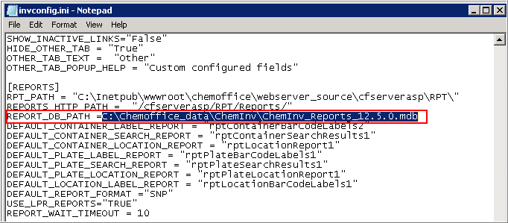

1. Save and close the file.
2. Client Workstation Installation

## Installing ChemDraw ActiveX (CDAX) Enterprise Constant NA 15.1

ChemDraw ActiveX 15.1 Plugin can be downloaded from the ChemBioOffice Enterprise home page.

### Installation Prerequisites – Installing Microsoft Visual C++ 2010 Runtime Libraries

As a pre-requisite, you need to install Microsoft visual C++ 2010 runtime libraries as shown below.

1. Browse to *Distribution Package\Installer\Dependencies\CDAX15.1\Prerequisite\.*
2. Double-click **vcredist_x86.exe**.

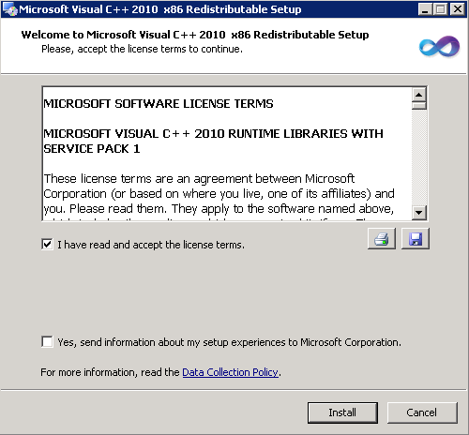

1. Read and accept the license agreement, and click **Install**.

### Installation Prerequisites – Enabling .NET Framework 3.5 in Windows 8.1 (Optional)

***Note****: If any previous version of CDAX is currently installed on your machine, you may need to uninstall the current version of CDAX before installing CDAX 15.1.*

**Enabling .NET Framework 3.5 in Windows 8.1 (Optional)**

If you use Windows 8.1 client, you may need to enable .NET Framework 3.5 in the Control Panel for the proper functioning of CDAX 15.1.

**To enable .NET Framework 3.5 in Windows 8.1:**

1. Move the mouse pointer to the upper- right corner or lower-right corner of the screen, and click the **Settings** icon from the Charms bar that appears.
2. Click **Control Panel**.
3. Click **Programs > Turn Windows features on or off**.
4. Select the **.NET Framework 3.5 (includes .NET 2.0 and 3.0)** check box.

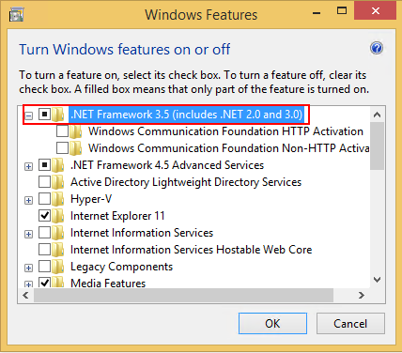

1. Click **OK**.

### Installing CDAX 15.1

To install ChemDraw ActiveX 15 Plugin, please follow these steps:

| **Step** | **User Input/ Action** | **Expected Results** |
| --- | --- | --- |
| 1 | Open your Web browser, and enter the following URL:  *https://servername/COEManager*  *<servername>* is the name of the server where ChemBioOffice Enterprise is installed. | The User Login page of ChemBioOffice Enterprise appears. |
| 2 | Enter a valid username and password. |  |
| 3 | Click the Log in button to display the home page of ChemBioOffice Enterprise. |  |
| 4 | Click on **CDAX15 Plugin** icon under "Applications & Utilities" section.    Click **Run** to download the installer. |  |
| 5 | The following window appears, click **Next.** | License Agreement window appears. |
| 6. | Read the license agreement and if you agree to the license agreement, select **I accept the terms in the license agreement**.    Click **Next**. | Destination Folder window appears. |
| 7. | To install in a different folder, other than the default folder, click **Change** and select a new destination folder.    Click **Next**. | Ready to Install the Program window appears |
| 8. | Click **Install** to initiate the installation. |  |
| 9. | Click **Finish** to complete the installation. | InstallShield wizard closes. |

## InvLoader Installation

To install InvLoader on your client machine, perform the steps below:

| **Step** | **User Input/ Action** | **Expected Results** |
| --- | --- | --- |
| 1 | Logon to the CBOE web server and copy the InvLoader folder from the following directory:  C:\inetpub\wwwroot\ChemOffice\ChemInv\Installation\InvLoader. | Logon successful |
| 2 | Paste the folder copied in step 1, anywhere on your client machine and browse to the “InvLoaderSetup.exe” file. | File found |
| 3 | Initiate the installation by double clicking on the “InvLoaderSetup.exe” file.    Click **Next**. | Windows installer initiates the installation from the setup program. Destination Location selection window appears. |
| 4 | The default destination folder is displayed. To install in a different location, click Browse and select a new location.    Click **Next**. | Start Menu Folder selection window appears |
| 5 | Click **Next**. | Additional Tasks selection window appears. |
| 6 | Select the check box to ceate a desktop icon.    Click **Next**. | Ready to Install window appears. |
| 7 | Click **Install** to start the installation. |  |
| 8 | Click **Finish** when the installation is done. |  |

## Configuration Settings for Inventory Reporting

### Installing Tbarcode

***Note****: If you upgrade your CBOE application, you may need to first uninstall the old Tbarcode, and then follow the steps mentioned below to install the new 64-bit Tbarcode.*

To install the new 64-bit Tbarcode, follow the steps:

| **Step** | **User Input/ Action** | **Expected Results** |
| --- | --- | --- |
| 1 | Go to *<webroot>\ChemOffice\ChemInv\Installation\Tbarcode\.* |  |
| 2 | Double-click *TBarCode_x64_Setup.msi*. | Welcome dialog box appears. |
| 3 | Click **Next**. | End-user license agreement dialog box appears. |
| 4 | Read the license agreement and select “*I accept the terms in the License Agreement”.*    Click **Next**. | Custom Setup dialog box appears. |
| 5 | Select the features you want to install and click **Next**. | Ready to Install dialog box appears. |
| 6. | Click **Install**. | Get Free Support dialog box appears. |
| 7. | Click **Next**. |  |
| 8. | Click **Finish**. |  |

### Inventory Reporting Prerequisites

***Note****: For Inventory reports to work, cheminvdb2 password should be in small case or password case sensitivity should be set to false as the queries in the MDB has a hard coded connection string set to small case oracle.*

The following prerequisites must be satisfied for the proper functioning of the Inventory reporting service.

1. Tbarcode needs to be installed.
2. WIN2PDF needs to be installed and it should be configured as the default printer.

***Note****: If Tbarcode is not installed, it can be installed from <webroot>\ChemOffice\ChemInv\Installation\Tbarcode*

*Also, if Win2PDF is not installed, it can be installed from <webroot>\ChemOffice\ChemInv\Installation\win2pdf.*

*It is important to make sure that Win2PDF is the default printer on the server machine.*

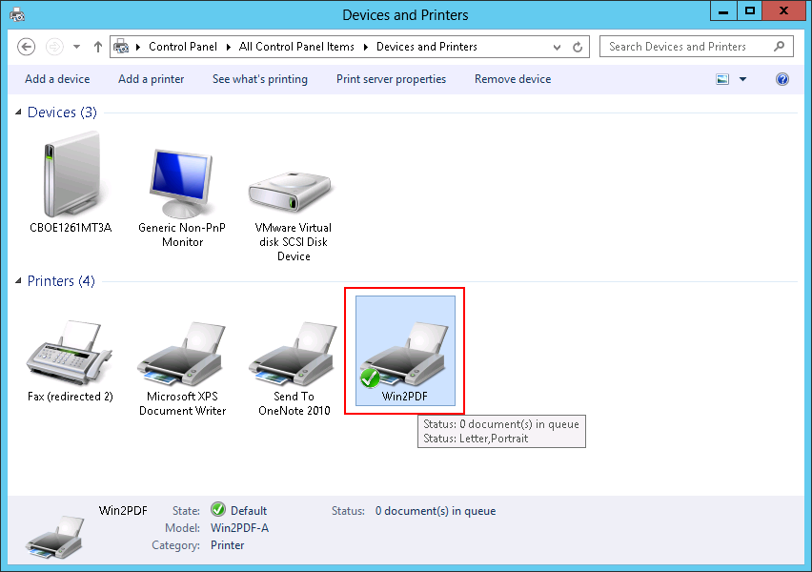

1. In the MS Access application, the following configurations need to be performed:

* Macro level should be set to "*Enable All Macros*"
* ActiveX settings should be configured as *“Enable all controls without restrictions and without prompting*”.

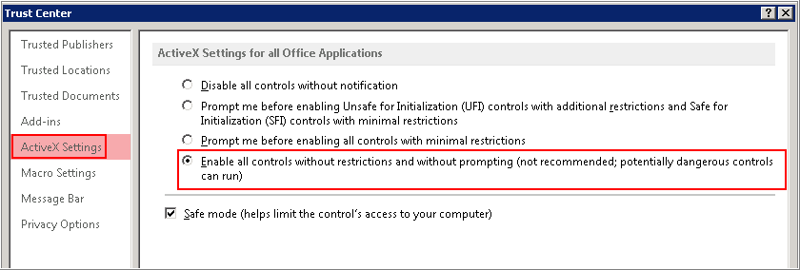

1. On your Web browser, the following configurations need to be performed.

* Open your Web browser, and add the CBOE url to the trusted sites.
* Set the Security level slider to the lowest.

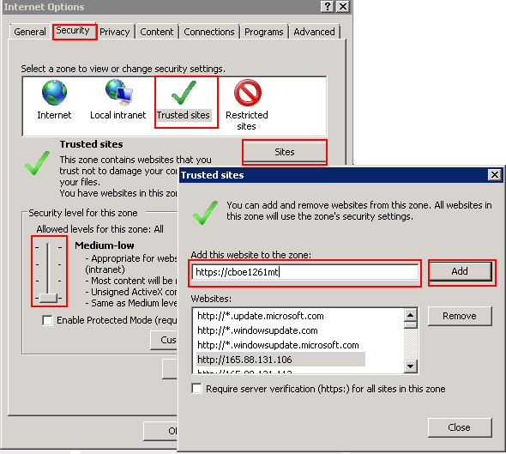

### Configuration Settings

To generate Inventory reports using “Inventory Reporting service (RPTService)”, you need to do following configuration.

**To configure RPTService settings:**

1. Go to Start > Run.
2. Type *services.msc*, and press <Enter>.
3. In the Services window, select RPTService.
4. Right-click RPTService, and click Properties.

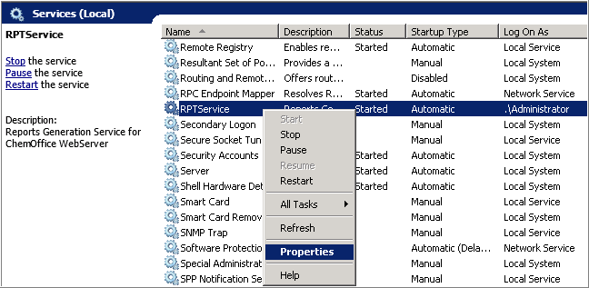

1. In the RPTService Properties window, click **Log On** tab.
2. Make sure that the RPTService is running as the logged in user. If you have logged in as administrator, then the RPTService needs to be run as administrator as shown in the image.

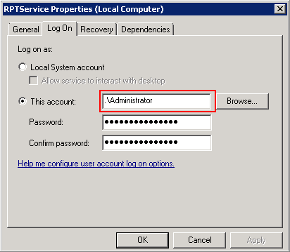

1. Click **OK**.

**To configure REPORTQ COM+ settings**

1. Go to **Start > Administrative Tools > Component Services** and press **Enter**.
2. Navigate to **Component Services > Computers > My Computer > COM+ Applications > REPORTQ**.

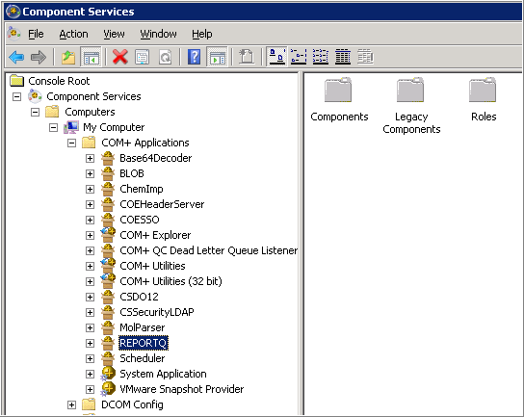

1. Right-click REPORTQ, and click **Properties**.
2. In the Properties window, click **Identity** tab.
3. Make sure that REPORTQ COM+ is running as the logged in user. If you have logged in as administrator, then the RPTService needs to be run as administrator as shown in the image.

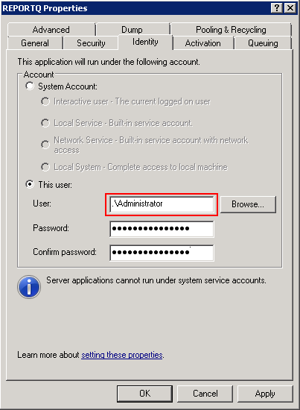

1. Click **OK**.
2. Installing Datalytix 6.3.1

DatalytixTM enables self-service import of relevant data into TIBCO Spotfire® software from scientifically significant data sources such as compound registries, biological assay repositories, LIMS systems, and other corporate information systems. This empowers scientists to ask questions of their data as soon as they are realized, accelerating time to insight/decision. Datalytix 6.3.1 has been qualified with Spotfire 7.6.

**Key Benefits include:**

1. User defined querying without requiring knowledge of data modeling or SQL
2. Search by text, numbers, date, and chemical structure
3. Import, merge, and link disparate data originating in one or more Oracle databases
4. Import and manipulate complex data relationships through hierarchical tables
5. Save and share previously run queries
6. A Card Visualization enabling browsing data in a form layout
7. Search and retrieve data from multiple Oracle instances
8. Ability to work with tables with non-numeric and missing primary keys

## Installation Pre-requisites

This section explains the steps required to deploy and set up Datalytix, based on the assumption that you have previously performed the following tasks:

1. Installed the Spotfire Server at your site.
2. Deployed the core Distribution Package and Installation Documentation to the Spotfire Server.

***Tip****: Tasks 1 and 2 are explained in detail in the TIBCO Spotfire® Installation and Configuration Manuals and TIBCO Spotfire® Deployment and Administration Manual.*

***Note****: Datalytix requires a CBOE 12.6.3 Server from which to retrieve its data. If you already have a Server, you need to point to it from the Datalytix logon dialog box.*

## Datalytix Installation

This section explains the installation procedures for installing Datalytix 6.3.1. The actual features and functionality of Datalytix are implemented in software packages. These packages are bundled into a distribution which must be deployed on the TIBCO Spotfire Server.

When the end users start Spotfire on their computers, they will log into the Spotfire Server and download the deployment locally, automatically downloading any newer or added packages. Depending on the licenses that are enabled for each user, varying features may appear in each user's application.

### Deploying the Datalytix Package

**To deploy the Datalytix package:**

1. Open the Administration Console located at http://*spotserver*/spotfire/administration (where *spotserver* is the name of one of your Spotfire servers) in a web browser.
2. Log in as a Spotfire Admin. (E.g. User: Administrator, Password: Administrator).
3. Select the **Deployment** tab.
4. Select the Environment to which you want to deploy Datalytix (e.g. Test).

***Note****: The Environment you select must have a functioning TIBCO Spotfire deployment.*

1. Click **Add** in the Software Packages section. The Add to Deployment dialog box appears.
2. Click **Browse**. The File Upload dialog box appears.
3. Browse to the *Datalytix_6.3.1.60.spk* file you want to include in the deployment.

***Note****: This spk file is typically located in the general location* *\\AMERCMBDEVFS01.perkinelmer.net\General_Release\Products\Spotfire\Lead Discovery\Lead Discovery\Lead Discovery 7.3\PKI_LeadDiscovery_7.3_win\Lead Discovery 7.3\Distribution). You may need to copy this spk file onto your machine.*

1. Click **OK** in the Add to Deployment dialog box to upload and add the file to the distribution. The list of packages is updated with the contents of the file
2. Click **Validate** in the lower left corner to make sure the deployment is not damaged or corrupted in any way.
3. Click **OK** in the Validation dialog box.
4. Click Save in the lower left corner to save and publish the deployment. The Save Deployment dialog box appears.
5. The Force Update checkbox is NOT checked. This is the default state.
6. Enter a version number and a description for the deployment, for instance, 6.3.1 and Spotfire with Datalytix and click **OK**.

## Deploying the Lead Discovery Package

Lead Discovery 7.3.0.xxxx.spk is required for performing structure searches and rendering structures in Datalytix.

**To deploy the Lead Discovery package:**

1. Open the **Administration Console** located at http://spotserver/spotfire/administration (where spotserver is the name of one of your Spotfire servers) in a web browser.
2. Log in as a Spotfire Admin. (E.g. User; Administrator, Password; Pa$$w0rd).
3. Select the **Deployment** tab.,
4. Select the Environment to which you want to deploy Datalytix (e.g. Test).

***Note****: The Environment you select must have a functioning TIBCO Spotfire deployment.*

1. Click **Add** in the **Software Packages** section**.** The **Add to Deployment** dialog box appears.
2. Click **Browse**. The File Upload dialog box appears.
3. Browse to the *LeadDiscovery_7.3.0.168.spk* file you want to include in the deployment.

***Note****: This spk file is typically located in the general location \\AMERCMBDEVFS01.perkinelmer.net\General_Release\Products\Spotfire\Lead Discovery\Lead Discovery\Lead Discovery 7.3\PKI_LeadDiscovery_7.3_win\Lead Discovery 7.3\Distribution). You may need to copy this spk file onto your machine.*

1. Click **OK** in the Add to Deployment dialog box to upload and add the file to the distribution. The list of packages is updated with the contents of the file.
2. Click **Validate** in the lower left corner to make sure the deployment is not damaged or corrupted in any way.
3. Click **OK** on the Validation dialog box.
4. Click **Save** in the lower left corner to save and publish the deployment. The Save Deployment dialog box appears.
5. The Force Update check box is NOT checked, this is the default state.
6. Enter a version number and a description for the deployment, for instance, 7.3 and Spotfire with Datalytix and click **OK**.

## Launching Datalytix from Spotfire

Datalytix is accessed from the main Spotfire Client interface.

**To open the Datalytix interface:**

1. Double click the TIBCO Spotfire icon on the desk top. Alternatively, select **Start > All Programs > TIBCO > TIBCOSpotfire**.
2. The Log in dialog box is displayed.
3. Log in as Administrator (e.g. Administrator/Pa$$w0rd). Datalytix is accessible only when working online.
4. In the **Server** drop down list, ensure the Server is correct.
5. Click **Login**.
6. The TIBCO Spotfire screen is displayed.
7. Select **Tools> Import Data with Datalytix.**
8. In the **Login** dialog box, log in as administrator (e.g. User:cssadmin, password:cssadmin).
9. In the **Server** drop down list, select an existing CBOE Server, or enter the URL of a new CBOE Server.
10. Click **OK**.
11. Datalytix for TIBCO Spotfire screen is displayed.

***Note****: For further details, refer to the PerkinElmer Datalytix User Guide.*

### Enabling Client Side Logging

To enable client side logging in Datalytix, perform the following steps:

1. Navigate to the Datalytix Configuration file (DLLogConfig.xml) under the Datalytix module folder on your system.Dependent on the Spotfire installation, this file can be located in one of the following locations:

* *"C:\Program Files (x86)\TIBCO\Spotfire\7.60.0\Modules\Datalytix_2514.110.1.xxx"*
* *"%LOCALAPPDATA%\TIBCO\Spotfire\7.60.0\Modules\Datalytix_2514.110.10.xxx"*

***Notes:***

* 7.6 is the version of the Spotfire Client. Use the correct version of the installation.
* Datalytix_ 25.11.0.xxx is the Datalytix plugin deploy folder. The appended suffix is the version of the plugin. Use the correct version for the plugin.

1. To modify the configuration file to enable client side logging, open the DLLogConfig.xml file using a text editing tool such as Notepad.

The configuration file is similar to the following:

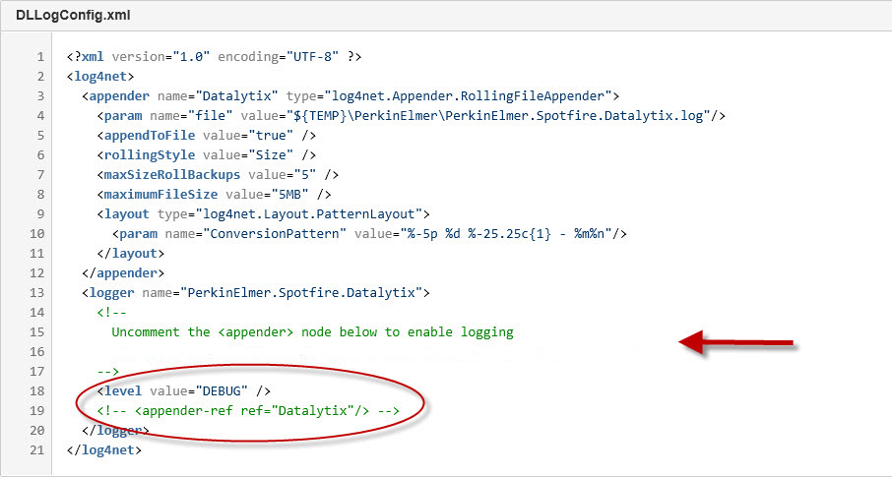

1. Uncomment the <appender> node to enable logging as shown here:

Before: <!-- <appender-ref ref="Datalytix"/> -->

After: <appender-ref ref="Datalytix"/>

The value in <level> will decide how to output the log information. The following log levels are supported:

**DEBUG** – Outputs detailed log information. This information is useful for troubleshooting.

**INFO** – Outputs summary log information only. This information is useful for performance testing.

Once client side logging has been enabled, Datalytix will log the operations to a log file.

The log file is located in the folder:

${TEMP}\PerkinElmer\PerkinElmer.Spotfire.Datalytix.log

The TEMP folder may vary from system to system.

This path may be changed by modifying the <param name=”file”> tag in the configuration file.

1. Upgrading CBOE 12.6.x to CBOE 12.6.3

CBOE 12.6.3 installer is designed for upgrading your old version of CBOE (CBOE12.6.x) to the most recent version, CBOE 12.6.3.

This section of the guide describes the steps and procedures to upgrade your CBOE to its most recent version.

## Upgrading ChemBioOffice Enterprise Server

Follow the steps below to upgrade ChemBioOffice Enterprise server:

| **Step** | **User Input/Action** | **Expected Results** |
| --- | --- | --- |
| 1 | Launch the *CBOE 12.6.3.exe* installer. The CBOE installer wizard displays.    Click **Next**. | CBOE 12.6.3 License Agreement window appears. |
| 2 | Read the license agreement, and select the “I accept the terms in the license agreement” option.    Click **Next**. | Ready to Install the Program window appears |
| 3 | Click Install.    Once the installation is completed, click **Finish** to close the installer window. | Installation starts. |

## Activate ChemDraw and ChemScript

Refer to section 6.7 Activate ChemDraw Professional and section 6.8 Activate ChemScript for detailed description on activating ChemDraw and ChemScript.

## Upgrading CBOE Database Schemas

The ChemBioOffice Enterprise 12.6.3 Database Upgrade Guide provides hyperlinks to launch each of the database update scripts.

To launch the Database Upgrade Guide: go to **Start > ChemBioOffice Enterprise > Database Update Scripts**. The following page appears:

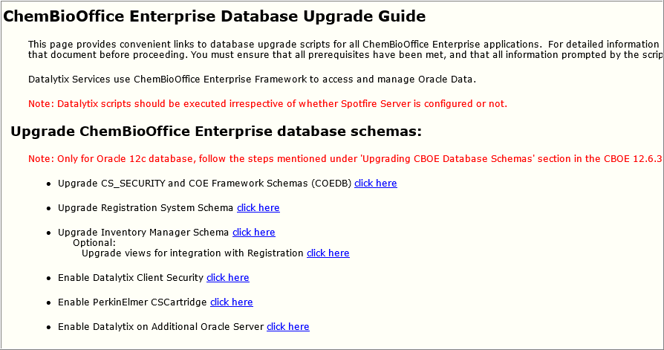

Click each of the links to update the corresponding database. The COE Framework Schema script is the only one required for all installations. The other upgrade scripts should be executed (in the order in which they appear on the page) if the corresponding application module was previously installed. Clicking a hyperlink to launch a script for an application that has not been installed will result in an error.

While executing the scripts, you may get the following ignorable errors. It is absolutely safe to ignore the errors.

* PLS-00302: component must be declared
* ORA-00955: name is already used by an existing object
* ORA-12003: materialized view or zonemap does not exist
* ORA-00942: table or view does not exist
* ORA-00001: unique constraint violated
* ORA-12002: there is no materialized view log on table
* ORA-01418: specified index does not exist

***Note****: Scripts related to Datalytix (Enabling Datalytix Client Security, Enabling PerkinElmer CSCartridge, and Enabling Datalytix on Additional Oracle Server) are mandatory even if you are NOT using Datalytix integration. In CBOE 12.6.3, CBOE framework is integrated with Datalytix functionalities. As part of this integration, the framework requires more privileges to be set for the COE user (COEUSER). These required privileges are being set when the Datalytix scripts are run. Hence, it is mandatory that the database scripts related to Datalytix need to be run irrespective of whether Spotfire Server is configured or not.*

### Updating Customized CBOE Schema Passwords

If the customer has set password for COEDB/REGDB/CHEMINVDB2 other than the default password "oracle", you need to perform the steps mentioned below before you start upgrading your CBOE.

1. Open Server Configuration Tool.
2. Click the **Schema Pwds** tab and add customized passwords of CS_SECURITY, REGDB and CHEMINVDB2
3. Save the configuration.
4. Open the *parameters.sql* files available in the following locations and update the mentioned passwords manually:

* *<InstallationDirectory>\inetpub\wwwroot\ChemOffice\ChemInv\config\oracle_install_scripts\Create_blank_ChemInv_DB\sql*
  + DEFINE schemaName = CHEMINVDB2
  + DEFINE schemaPass = "Custom Password"
  + DEFINE securitySchemaName = COEDB
  + DEFINE securitySchemaPass = "Custom Password"
  + DEFINE regSchemaName = REGDB
  + DEFINE regSchemaPass = "Custom Password"
* *<Installation Directory>\Program Files (x86)\CambridgeSoft\ChemOfficeEnterprise12.1.0.0\Framework\DBInstallScripts\COEDB\Oracle_Install_Scripts\sql*
  + DEFINE schemaName = COEDB
  + DEFINE schemaPass = "Custom Password"
  + DEFINE securitySchemaName = COEDB
  + DEFINE securitySchemaNameOld = CS_SECURITY --Temporary
  + DEFINE securitySchemaPass = "Custom Password"
* *<Installation Directory>:\Program Files (x86)\CambridgeSoft\ChemOfficeEnterprise12.1.0.0\Framework\DBInstallScripts\Datalytix\sql*
  + DEFINE schemaName = COEDB
  + DEFINE schemaPass = "Custom Password"
  + DEFINE securitySchemaName = COEDB
  + DEFINE securitySchemaPass = "Custom Password"

### Steps to be done in Oracle 12c Upgrade Environment

1. Before upgrading the COEDB schema through DB upgrade scripts, open a separate command prompt and login to sqlplus as SYS user:  
   e.g.  
   Enter user-name: sys@<oracle service Id> as sysdba  
   Enter password: <password for SYS user>
2. Once connected successfully, execute: alter system set "_projection_pushdown" = false scope=both;
3. Execute: grant select on sys.user$ to COEDB;
4. Now upgrade the COEDB schema and rest of the schemas through DB upgrade scripts.

### COE Framework Schema

To upgrade the CS_SECURITY and COE Framework schemas, follow the steps below:

1. Click the *click here* link corresponding to *Upgrade CS_SECURITY and COE Framework Schemas (COEDB).*
2. In the command window, enter the following details when prompted.

* Target Oracle service name:
* Name of the Oracle account with system privileges:
* Oracle account password:
* Which version do you want to upgrade to:

***Note****: 12.6.3 is the default value. You may press <Enter> to accept the default value.*

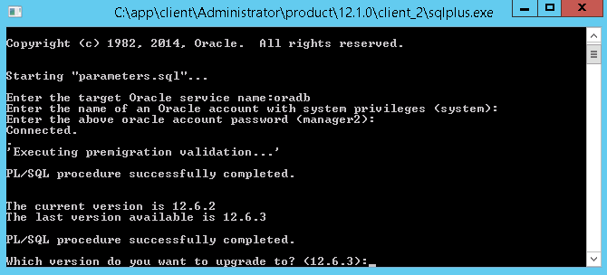

After the execution of this script, the summary log appears. Be sure Errors is equal to zero. If not, open and inspect the following log file *COEDB_LOG_PATCHES_COEDB_ORA.TXT* using the shortcut at Start > ChemBioOffice Enterprise > Setup Logs.

### Registration System Schema

To upgrade the Registration system schema, follow the steps below:

1. Click the *click here* link corresponding to *Upgrade Registration System Schema.*
2. In the command window, enter the following details when prompted.

* Target Oracle service name:
* Name of the Oracle account with system privileges:
* Oracle account password:
* Name of the target schema owner:
* Oracle account password:
* Which version do you want to upgrade to:

***Note****: 12.6.3 is the default value. You may press <Enter> to accept the default value.*

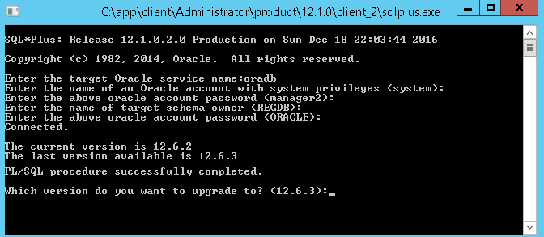

After the execution of this script, the summary log appears. Be sure Errors is equal to zero. If not, open and inspect the following log file *REGISTRATION_LOG_PATCHES_CHEMREG_ORA.TXT* using the shortcut at Start > ChemBioOffice Enterprise > Setup Logs.

### Inventory Manager Schema

***Caution****: If you have created any customized reports, you must take a backup of the .mdb file (C:\ChemOffice_Data\ChemInv\) before you perform an upgrade. Otherwise, your custom reports will be lost after upgrade. Refer to* *section 12.6.1 Inventory Reporting – Custom Reports* *for more details.*

***Note****: Before running the Inventory Manager schema, it is mandatory that you need to execute the Registration System schema to avoid any Oracle errors even though you are not using Registration.*

To upgrade the Inventory manager schema, follow the steps below:

1. Click the *click here* link corresponding to *Upgrade Inventory Manager Schema.*
2. In the command window, enter the following details when prompted.

* Target Oracle service name:
* Name of the Oracle account with system privileges:
* Oracle account password:
* Name of the target schema owner:
* Oracle account password:
* E-Notebook schema name:
* Which version do you want to upgrade to:

***Note****: 12.6.3 is the default value. You may press <Enter> to accept the default value.*

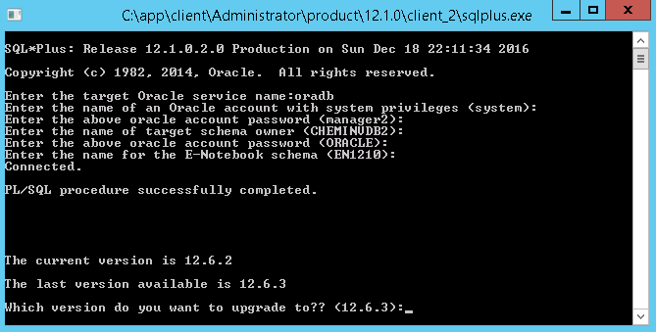

After the execution of this script, the summary log appears. Be sure Errors is equal to zero. If not, open and inspect the following log file *CHEMINV_LOG_PATCHES_CHEMINVDB2.TXT* using the shortcut at Start > ChemBioOffice Enterprise > Setup Logs.

### Enabling Datalytix Security Schema

To enable the Datalytix security schema, follow the steps below:

1. Click the *click here* link corresponding to *Enable Datalytix Client Security.*
2. In the command window, enter the following details when prompted.

* Target Oracle service name:
* Name of the Oracle account with system privileges:
* Oracle account password:

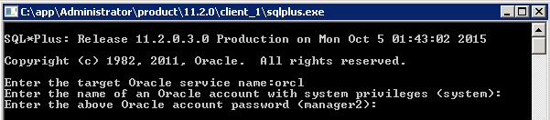

After the execution of this script, the summary log appears. Be sure Errors is equal to zero. If not, open and inspect the following log file LOG_CREATE_DATALYTIX.TXT using the shortcut at Start > ChemBioOffice Enterprise > Setup Logs

### Enabling PerkinElmer CSCartridge

To enable PerkinElmer CSCartridge, follow the steps below:

1. Click the *click here* link corresponding to *Enable PerkinElmer CSCartridge.*
2. In the command window, enter the following details when prompted.

* Target Oracle service name:
* PerkinElmer CSCartridge schema name:

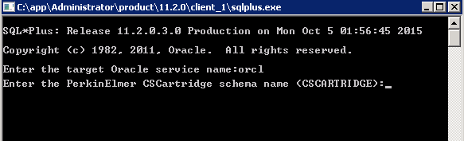

After the execution of this script, the summary log appears. Be sure Errors is equal to zero. If not, open and inspect the following log file *SummaryLog_Datalytix_log_enablecscartridge.txt* using the shortcut at Start > ChemBioOffice Enterprise > Setup Logs.

### Enabling Datalytix on Additional Oracle Server

***Note****: Enabling the Datalytix on Additional Oracle Server is required before publishing the data source to Spotfire. If not enabled, you may encounter permission issues.*

To enable Datalytix data source, follow the steps below:

1. Click the *click here* link corresponding to *Enable Datalytix on Additional Oracle Server.*
2. In the command window, enter the following details when prompted.

* Oracle service name:
* Name of the Oracle account with system privileges:
* Oracle account password:

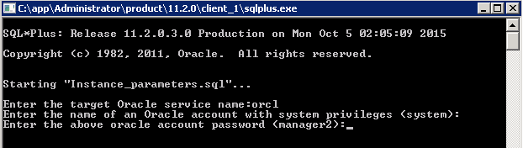

### Importing Registration Configuration

***Note****: Before logging into the CBOE application for the first time after running upgrade scripts, make sure that you run the server configuration tool. Refer to* *section 12.4. Running the Server Configuration Tool* *for more details*

***Note****: Run the Server Configuration Tool by giving only ‘Oracle Service Name’ and ‘HTTP Host Name’*

To Import the Chemical Registration configuration, follow the steps below:

| **Step** | **User Input/Action** | **Expected Results** |
| --- | --- | --- |
| 1 | Type the following address in the address bar of your Web browser:  http://YourHttpHostName/COEManager | The ChemBioOffice Enterprise User Login page appears |
| 2 | Login in to the ChemBioOffice WebServer using the following username and password: T5_85/T5_85 |  |
| 3 | From the main menu, click the *Customize Registration* icon. |  |
| 4 | The Registration Admin page is opened:    Click the **Import / Export Configuration** link. |  |
| 5 | In the *Import from server side local directory* section, enter the server path (typical location is: …*.\CambridgeSoft\ChemOfficeEnterprise12.1.0.0\Registration\Config*).    Click **Import**.  ***Note****: Make sure that the* ***Force import*** *check-box is not selected. For upgrade installation, it is mandatory that you do not select this* ***Force import*** *check-box.* | A new message will appear when the import is completed. |
| 6 | Logout from ChemBioOffice. |  |
| 7 | After importing the configuration, it is now possible to create views for integration with Registration.  To do that go to **Start > ChemBioOffice Enterprise > Database Update Scripts.**  **Click** the "click here" link corresponding the "Upgrade views for integration with Registration" option. |  |
| 8 | In the command window, enter the following details when prompted:   * Target Oracle service name: * Name of the Oracle account with system privileges: * Oracle account password: |  |

### COE Patching Tool

Follow the steps mentioned below to run the COE patching tool:

1. Navigate to *…..\CambridgeSoft\ChemOfficeEnterprise12.1.0.0\Framework\COEPatchingTool.*
2. Execute the *COEPatcher.exe* file.
3. Enter the following details when prompted:

* Oracle instance name:
* Oracle user:
* Oracle password:
* The version you are upgrading from:

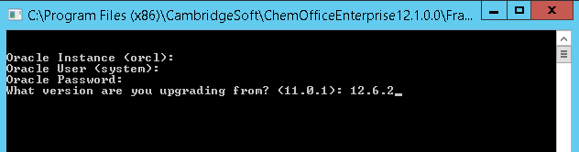

### Oracle Cartridge Upgrade

For an upgrade of Oracle Cartridge version over an already existing cartridge all the existing Cartridge indexes have to be recreated. Those indexes still exist, but orphaned, without any data supporting them. They have to be first dropped with the command DROP INDEX indexname (where indexname is the name of the index that was used when the index was created), and then re-created with the appropriate CREATE INDEX command

1. To Uninstall Oracle Cartridge manually:
   1. Connect to sqldeveloper as system user and executed below

Drop user cscartridge cascade;

Drop tablespace T_CSCartridge including contents and datafiles cascade constraints;

* 1. Manually delete CsCartridge folder from oracle db path (ex. C:\app\Administrator\product\12.1.0\dbhome_2\BIN)

1. To Uninstall Oracle Cartridge using setup.exe

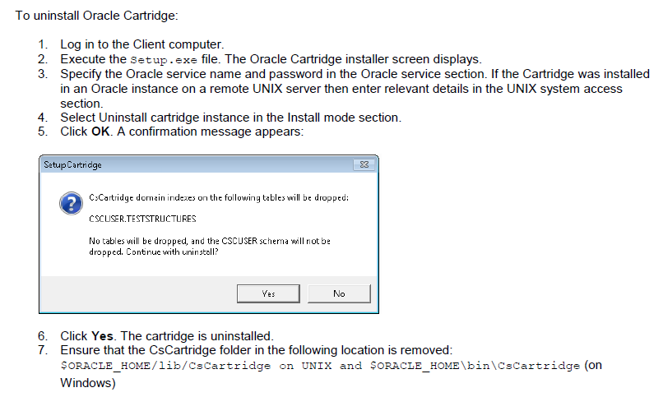

1. After uninstallation, connect sql developer by system user and execute following for dropping existing indexes if any
   * 1. drop index REGDB.MX;
     2. drop index REGDB.MX2;
     3. drop index REGDB.MX3;
     4. drop index CHEMINVDB2.MX;
     5. drop index CHEMINVDB2.VW_MX
     6. drop index CHEMACXDB.MX;Cartridge
2. Installation and manual changes post installation
   1. Install CSCartridge by double-clicking the *Setup.exe* file icon by following the steps mentioned in Fresh installation
   2. After Installation, connect sql developer by system user and execute following for giving permission.
      * ALTER USER CSCARTRIDGE QUOTA UNLIMITED ON T_REGDB_CSCART;
      * ALTER USER CSCARTRIDGE QUOTA UNLIMITED ON T_CHEMINVDB2_CSCART;
      * ALTER USER CSCARTRIDGE QUOTA UNLIMITED ON T_CHEMACXDB_CSCART;
   3. Connect sqlplus by REGDB and execute following to recreate index
      * Create index MX on STRUCTURES(BASE64_CDX) indextype is cscartridge.moleculeindextype parameters ('TABLESPACE=T_REGDB_CSCART,FULLEXACT=INDEX');
      * Create index MX2 on TEMPORARY_COMPOUND(BASE64_CDX) indextype is cscartridge.moleculeindextype parameters ('TABLESPACE=T_REGDB_CSCART,FULLEXACT=INDEX');
      * Create index MX3 on MIXTURES(STRUCTUREAGGREGATION) indextype is cscartridge.moleculeindextype parameters ('TABLESPACE=T_REGDB_CSCART,FULLEXACT=INDEX');
   4. Connect sqlplus by CHEMINVDB2 and execute following to recreate index
      * Create index MX on INV_COMPOUNDS(BASE64_CDX) indextype is cscartridge.moleculeindextype parameters ('TABLESPACE=T_CHEMINVDB2_CSCART');
      * Create index VW_MX on INV_VW_COMPOUNDS(BASE64_CDX) indextype is cscartridge.moleculeindextype parameters ('TABLESPACE=T_CHEMINVDB2_CSCART');
   5. Connect sqlplus by CHEMACXDB and execute following to recreate index
      * Create index CHEMACXDB.MX on CHEMACXDB.SUBSTANCE(BASE64_CDX) indextype is cscartridge.moleculeindextype parameters ('TABLESPACE=T_CHEMACXDB_CSCART');

## Running the Server Configuration Tool

You must run the server configuration tool after upgrading your current CBOE server to CBOE 12.6.3 and after running Database upgrade scripts. The configuration tool detects the installed application modules and edits their configuration files. It is therefore important that the tool be run only after all desired modules have been installed.

To launch the server configuration tool, go to **Start > All Programs > ChemBioOffice Enterprise > Server Configuration Tool**. Make necessary configuration changes in the required fields and save the changes.

Refer to section 8.3 Configuration Tool for detailed description and configuration of the server configuration tool.

## Installing Datalytix 6.3.1

Refer to section 11 Installing Datalytix 6.3.1 for detailed instructions to install Datalytix 6.3.1.

## Upgrading Client

After you successfully upgrade your server and database, you need to upgrade your client by installing its latest version.

The steps for upgrading the client are the same as that of fresh installation of the client applications mentioned in section 10 Client Workstation Installation.

* Refer to section 10.1 Installing ChemDraw ActiveX (CDAX) Enterprise Constant NA 15.1 to install CDAX 15.1
* Refer to section 10.2 InvLoader Installation to install InvLoader application
* Refer to section 10.3 Configuration Settings for Inventory Reporting to configure Inventory reporting.

### Inventory Reporting - Custom Reports

If you have created any customized reports before you perform an upgrade, you need to perform the following steps to make the customized reports available in the upgraded system.

1. Before you perform an upgrade, take a backup of the existing .mdb file from the location *C:\ChemOffice_Data\ChemInv*
2. After you perform the upgrade, open the new access file and click on **File > Get External Data > Import** and browse to the backup .mdb file and import any custom reports/queries. This will import the custom report\queries to the new .mdb file.
3. Troubleshooting

This section describes few issues/errors that you may encounter while installing CBOE 12.6.3 and the steps to resolve those issues. For more information on any issues/errors not discussed in this section, refer to the knowledgebase at: <http://www.cambridgesoft.com/support/EnterpriseSupport/KnowledgeBase/FAQ/>.

Select ‘**ChemBioOffice Enterprise**’ under Products and ‘**Installation**’ under Topics as shown below to list the installation related issues.

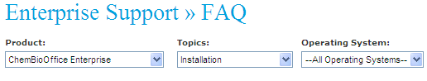

## ‘Could not load file or assembly Oracle.DataAccess’ Error

After successful installation of CBOE 12.6.3, you may encounter the following error when accessing COE Manager through Internet Explorer-

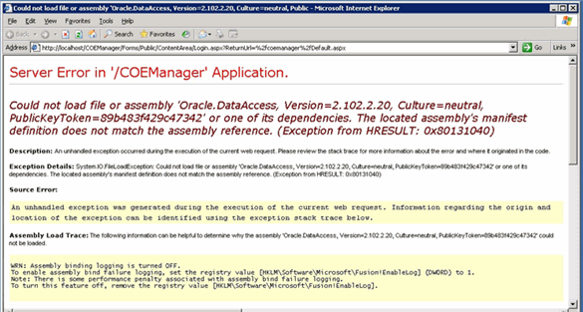

To resolve this error, ensure that the following is installed:

* Compatible version of Oracle Data Access Components (ODAC) which includes OLEDB Provider and Oracle Data Provider for .Net.

## ORA-00600 Error While Accessing Registration

You may encounter the following error while accessing Registration application if you use Oracle 11g 11.2.0.3.

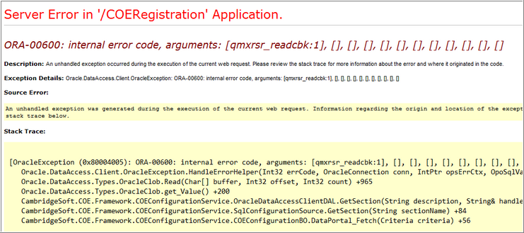

To resolve this error, you must download and apply the Oracle bug fix (Bug 12708641 Doc ID 1508711.1). Note that this bug fix is applicable only for Oracle 11.2.0.3.

## Registering ASP.Net in IIS

If ASP.NET has not been registered to IIS, register it with the ASP.NET registration utility, which is located in the .NET Framework installation by executing the following command from the Windows command prompt:

<WindowsPath>\Microsoft.NET\Framework\v2.0.50727\aspnet_regiiis.exe -i

## .Net Framework Security

**Issue**: The following error appears while trying to search the TEMP area:

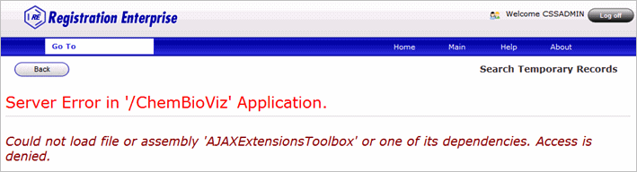

**Remedy:** The default access for the .NET framework folders should be updated manually, by giving the default Windows "Everyone" user group "Modify" privileges on the "C:\WINDOWS\Microsoft.NET\Framework" folder and all subfolders.

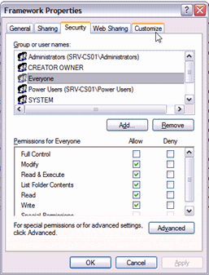

## Oracle 11g or 12c Related Issues

If CBOE is installed with Oracle 11g or 12c, then CBOE classical applications (Inventory, and ChemACX) should have the udl username/password in CAPITAL.

**Example:**

For Inventory:

* Go to C:\Inetpub\wwwroot\ChemOffice\ChemInv\config
* Double-click on ChemInv.udl and provide required details as
  + DataSource: orcl
  + Username: CHEMINVDB2
  + Password: ORACLE

Click on Test Connection button to verify. In order to make the password case-insensitive in Oracle 11g, please execute the query below:

alter system set sec_case_sensitive_logon=false;

## Error in RLS Log File 'log_runRLSConfigurationTool.txt

**Issue**:

You may receive errors in the RLS log file after performing the following steps:

1. Open the Server Configuration Tool.
2. Choose RLS at Registry level or Batch level.
3. Save the configuration.

After saving the server configuration settings successfully, verify the 'log_runRLSConfigurationTool.txt' file located at the setup log location. You may encounter errors in the log file.

**Remedy**:

You have to restart all the running oracle services in the DB server before running server configuration tool.

## Inventory Reporting Errors

If you encounter any difficulty in generating Inventory reports, perform the following checks:

1. Open the r*eportqueue.mdb* file from *<webroot>\ChemOffice\WebServer_Source\cfserverasp\RPT*.
2. Open the table tblReportQueue in the *reportqueue.mdb* file.
3. See the message in the ErrorMessage field to find the cause of report failed.

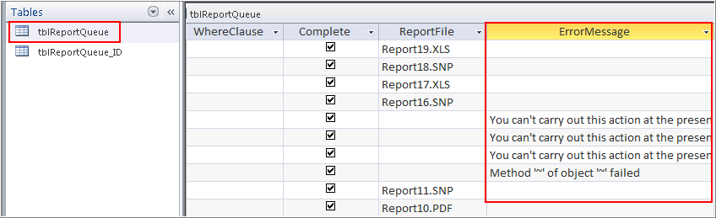

1. Open task manager and make sure that:

* Only one instance of *dllhost.exe* is running by the system user.
* Only one instance of *report.exe* is running.
* Only one instance of *msaccess* is running.

## ChemDraw for Excel Errors

You must install MS Office application before you install/upgrade CBOE 12.6.3. If you install MS Office application after you install CBOE 12.6.3, the ChemDraw for Excel application may not work properly.

If the ChemDraw for Excel is not working properly, follow the link and perform the workaround as mentioned.

<http://cspartnernet.camsoft.com/Desktop/Excel/TechDoc/troubleshooting_cdxl.htm>

## Invalid Character Error in Japanese Environment while Importing Configuration

**Issue**:

You may receive an “invalid character” error message in Japanese environment in the following scenarios:

* While importing the SSO Authenticator configuration files to work with the CBOE-ELN integration feature.
* While importing the Registry configuration file

**Remedy**:

The issue is because of the presence of some invalid or junk characters in the xml file. You may need to manually remove the junk characters from the xml file to resolve this issue.

* If you receive the error while importing SSO Authenticator configuration files, open the *GlobalAddin.xml* file which is typically located at: *<InstallDirectory>\Std\COEIntegrationConfig\SSOAuthenticatorConfig\Commands* and remove the junk characters.
* If you receive the error while importing the Registry configuration file, open the *GlobalAddins_SetupFragmentsConfiguration.xml* file which is typically located at: *<InstallDirectory>\Std\COEIntegrationConfig\RegistryConfig\Commands* and remove the junk characters.

## Error: ChemDraw Control Version is Not Supported in Server Side

**Issue:**

The following error appears when performing a submission to registration with a user featuring SUPERVISING_CHEMICAL_ADMIN role (the same for a SUBMITTER).

|  |
| --- |
| ChemDraw control version not supported in server side. Server version: ChemDraw Viewer ActiveX Control 15.1.0.144 (required a registered Professional version). |

**Remedy**:

To fix the issue, follow the steps mentioned below:

* Connect to the machine as the domain administrator (instead of local machine admin)
* Repair the ChemDraw Ultra 15.1 installation
* Make sure that the application was licensed/activated (opening ChemDraw)
* Make sure that the application was licensed/activated (opening Registration form > right click on structure field > Activate ChemDraw)
* Make sure that ChemScript was activated/licensed
* Run iisreset

## Inventory Application Stops Working After Configuring Inventory Reporting

Issue:

The following errors appear in the following scenario:

CBOE 12.6.3 is installed on an Application Server which does not have MS Office installed. After CBOE 12.6.3 installation, MS Office 2013 is installed, and configured all the pre-requisites for inventory reporting. After this configuration, log into the Inventory application as invadmin and click any of the inventory buttons.

**Error 1:**

|  |
| --- |
| Server object error 'ASP 0177 : 80004005'  Server.CreateObject Failed  /cfserverasp/source/cs_security/cs_security_login_utils_vbs.asp, line 18  80004005 |

**Error 2:**

|  |
| --- |
| error '80004005'  /LM/W3SVC/1/ROOT/CHEMINV/global.asa, line 211 |

**Remedy**:

To fix the issue, you need to restart the Application Server.

## Strange Characters are Displayed When Logging into CBOE Manager

**Issue**:

After a fresh installation or a migration of CBOE, when trying to open CBOE Manager main page, it only displays strange characters as shown.

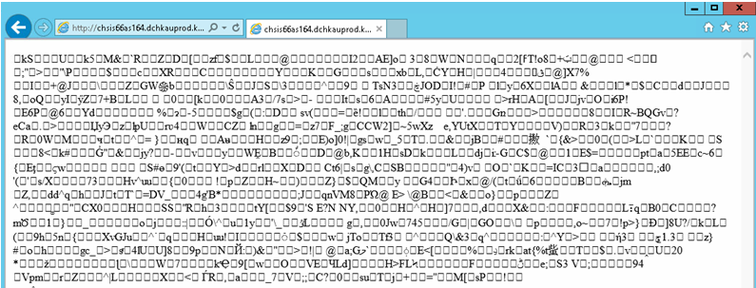

**Remedy**:

To fix this issue, try the following workaround steps:

* Connect to Oracle using COEUSER/ORACLE account (Oracle passwords may have expired)
* Ensure that SID entered in the server configuration tool is correct
* Ensure that fully qualified server name is entered in the server configuration tool
* Try to use the full path: http://servename/COEManager/Forms/Public/ContentArea/Login.aspx?ReturnUrl=%2fcoemanager%2f
* Re-run server configuration tool.
* Before running CBOE installation, disable the following Windows features:
  + user account control:
    - Go to Start > Control Panel
    - Click 'Control Panel' and choose User Accounts
    - Click 'Turn User Account Control on or off' link
    - Uncheck the *Use User Account Control (UAC)* *to help protect your computer* checkbox, and then click **OK**
    - Restart the machine
  + Admin approval mode:
    - Press ''Ctrl' + R ' or go to Start > Run
    - Type *secpol.msc* and click **OK**
    - In Security Settings > Local Policies, click **Security Options**
    - Find 'User Account Control: Run all administrators in Admin Approval Mode' and double-click it
    - Select the Disabled option, and then click **OK**
    - Restart the server
  + Configure Data Execution Prevention:
    - Go to Control Panel
    - Select System
    - Click the Advanced System Settings
    - Under Performance section, click the **Settings** button
    - Select the Data Execution Prevention tab
    - Select the "Turn on DEP for essential Windows programs and services only" option
* Verify if COE user password is not expired.
* Make sure that the password of COEUSER in the file *COEFrameworkConfig.xml* is correct
* Disable Oracle password case sensitivity and check.
* Edit "*C:\ProgramData\CambridgeSoft\ChemOfficeEnterprise12.1.0.0\COEFrameworkConfig.xml*". Look for line 19 and 27. Make sure sid and data source have a value.

Line 19:

<add id="b590c7f9-34ca-4190-9564-e9b92a70bf57" name="MAIN" dbmsType="ORACLE" databaseGlobalUser="COEUSER" useProxy="True" hostName="" port="" sid="oradb" isCBOEInstance="True" dataSource="oradb" driverType="OracleDataDirect">

Line 27:

<add name="ORACLE" dataSource="oradb" useProxy="true" databaseGlobalUser="COEUSER">.

* Save the file and do an IISRESET.

## Receive Orders Window in Inventory Expiries after 20 Minutes despite the Session Timeout Settings of the System

**Issue:**

The Inventory ‘Receive Orders’ window expires after 20 minutes regardless of the session and script timeout set in the system.

**Remedy**:

Follow the workaround steps shown below to increase the session timeout in CBOE:

1. Run *Server Configuration Tool* and set the value for **Session Timeout (min)** to a new value of **120 minutes** (more/less value depending on your needs), and save the configuration.

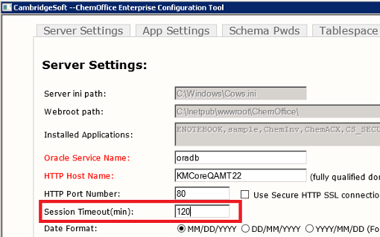

1. Go to **Start > Administrative Tools > Internet Information Services Manager** > Select **Application Pools**.
   1. Right-click **DefaultAppPool,** select **Advanced Properties** and in the **Process Model** section change the **Idle Time-out** to a new value of **120 minutes** or more depending on your needs. Click **OK**.

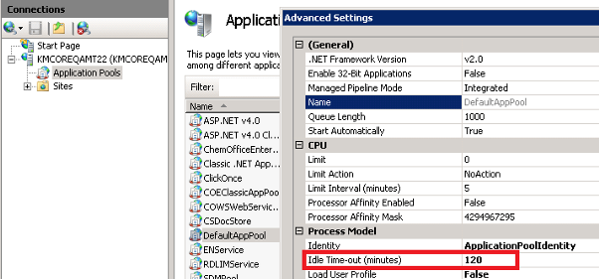

* 1. Right-click **ChemOfficeEnterprise**, select **Advanced Properties**, and in the **Process Model** section change the ‘**Idle Time-out’** to a new value of **120 minutes** or more depending on your needs.Click **OK**.

1. Expand the **Sites** tree > Select ‘**Default Web Site,** and double-click **ASP** under IIS.

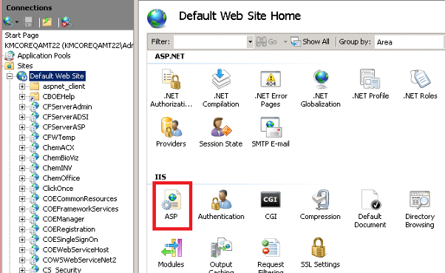

* 1. Expand the **‘Limits Properties’** group and set the ‘**Script Time-out’** property to **02:00:00**.
  2. Expand the ‘Session Properties’ group, and set the ‘**Time-out’** property to **02:00:00**.
  3. Click **Apply**.

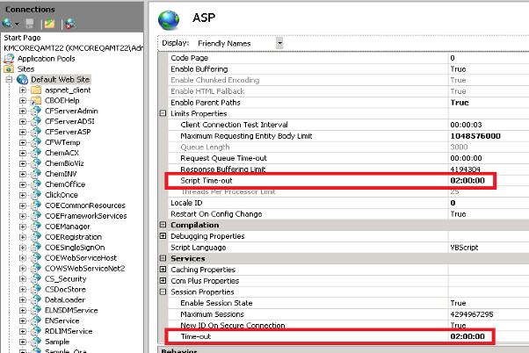

1. Under ‘Default Web Site’ look for the following web sites:

* CFServerAdmin
* CFServerADSI
* CFServerASP
* ChemACX
* ChemINV
* ChemOffice
* Cs_Security
  1. Select the web sites one at a time which is mentioned above, double-click the ‘ASP property’, expand the ‘Limits Properties’ group, and set the ‘**Script Time-out’** property to **02:00:00**.
  2. Expand the ‘*Session Properties’* group, and set the ‘**Time-out’** property to **02:00:00.**
  3. Click **Apply**.

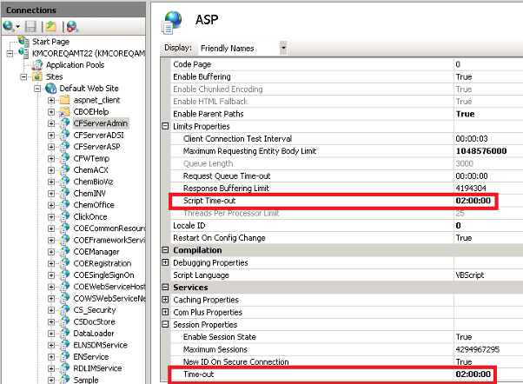

1. Find the file 'Cfserver.ini' in the following locations:

* C:\inetpub\wwwroot\ChemOffice\ChemACX\config
* C:\inetpub\wwwroot\ChemOffice\ChemInv\config
* C:\inetpub\wwwroot\ChemOffice\CS_Security\config

**Note:** You need to **c**reate a backup of the files before proceeding.

* 1. Open each files and search for 'COOKIE_EXPIRES_MINUTES' keyword, and change the value to 120 (For E.g. COOKIE_EXPIRES_MINUTES=120).
  2. Save and close the file.

1. Perform an IISReset.

## Registration and Inventory Loading CDAX14 instead of CDAX15.1 when ChemBioDraw Ultra 14 is installed in the Client Machine

**Issue:**

In a client machine which has ChemBioDraw Ultra 14.0 installed, and after CDAX15.1 is installed from CBOE 12.6.3 home page, the CDAX version is showing as v14 instead of v15.1

**Remedy**:

To fix this issue, you need to disable the CS ChemDraw Control 14.0 in the web browser as shown below.

1. In the Internet Explorer, go to Tools > Manage add-ons.
2. Select CS ChemDraw Control14.0, and click the Disable button at the bottom pane.

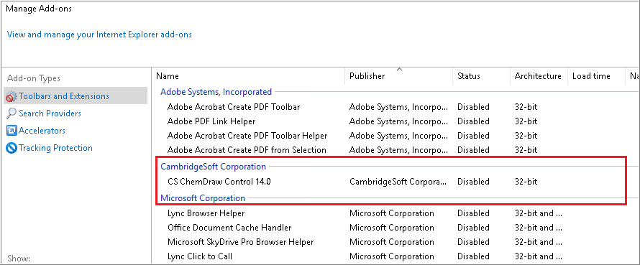

1. Now the CBOE will only use CDAX 15.1 version add-on as it is enabled in the manage add-ons.

## Degree and Period Symbols in S Sentences and P Precaution Sentence are not Displaying Properly

**Issue:**

Degree and period symbols in S Sentences & P Precaution Sentences are not displaying properly - (¿)

**Remedy**:

To fix this issue, follow the steps mentioned below:

Connect to the database (CHEMINVDB2/ORACLE) using the sql developer and reinsert the data to the INV_CUSTOM_FIELDS table.

1. DELETE INV_CUSTOM_FIELDS.

Note: If you get any integrity constraint error while deleting the fields, perform the steps below

* Identify the constraint name from the error message
* Identify the table which contains the constraint by using the query "select * from user_constraints where constraint_name = 'constraintname';
* Disable the constant by using the command ALTER TABLE table_name disable constraint 'constraintname';
* DELETE INV_CUSTOM_FIELDS

1. Go to the following location and open **GHS_Hazards.sql** for edit: *C:\inetpub\wwwroot\ChemOffice\ChemInv\config\oracle_install_scripts\Create_blank_ChemInv_DB\sql\Patches\Patch 12.5.0\Data*
2. Copy the whole content starting from “insert into inv_custom_fields values”
3. Paste it in the sql developer and run using Run Script command.
4. Go to the following location and open **Hazards.sql** for edit: *C:\inetpub\wwwroot\ChemOffice\ChemInv\config\oracle_install_scripts\Create_blank_ChemInv_DB\sql\Patches\Patch 12.5.0\Data*
5. Copy the whole content starting from “insert into inv_custom_fields values”
6. Paste it in the sql developer and run using Run Script command.
7. Enable the constraint using the command "ALTER TABLE table_name enable constraint 'constraintname'; "
8. Commit the changes.

If the customer has any customized data in this table then you need to manually update the row which has invalid data. Check the below example for reference.  
Update INV_CUSTOM_FIELDS set custom_field_name = 'S7/47: Keep container tightly closed and at a temperature not exceeding ... °C (to be specified by the manufacturer).' where custom_field_id = 435

## Unable to Browse Inventory Content after Changed Authentication from ORACLE to LDAP or vice versa Once the CBOE System is Setup

In case of Oracle authentication, CBOE authenticates the user directly against the credentials stored in Oracle. In case of LDAP authentication, CBOE uses two level authentication step; One it authenticates with the LDAP using the LDAP credentials and then to start a connectivity with Oracle. It authenticates with Oracle also using a CBOE system generated password (it is by reversing the username and prefixing the reversed username with "7" and suffixing with "11C" e.g. if the username is "abcd" then the generated password is "7dcba11C").

**Oracle to LDAP conversion:**

To resolve this issue, we need to Alter this user in Oracle and setup the password manually to the generate password mentioned above by prefixing and suffixing the additional characters to the reversed username.

e.g. ALTER USER <username> IDENTIFIED BY "7<reversed_username>11C";

So if you need to do this for all the CBOE users in the system we may need to write a database script. Please follow the script given below as an example.

|  |
| --- |
| DECLARE  TYPE CURSOR_TYPE IS REF CURSOR;  dba_username dba_users.username%type;  dba_generate_pass dba_users.password%type;  PEOPLE_RS CURSOR_TYPE;  BEGIN  OPEN PEOPLE_RS FOR  SELECT dba_users.username, '"7' || Upper(reverse(dba_users.username)) || '11C"' FROM dba_users, people  WHERE Upper(dba_users.username) = Upper(people.user_id)  AND Upper(dba_users.profile) = 'CSUSERPROFILE'  AND Upper(dba_users.username) NOT IN  ('CSCARTRIDGE', 'SCOTT', 'BIOSARDB', 'CHEMINVDB2', 'REGDB', 'CHEMACXDB',  'CS_SECURITY', 'CSCUSER', 'CTXSYS', 'D3DATA', 'DBSNMP', 'DMSYS', 'DOCMGR',  'DRUGDEG', 'ORDSYS', 'EXFSYS', 'MDSYS', 'OLAPSYS', 'ORDPLUGINS', 'OUTLN',  'SI_INFORMTN_SCHEMA', 'TSMSYS', 'WMSYS', 'XDB');  LOOP  FETCH PEOPLE_RS INTO dba_username, dba_generate_pass;  EXIT WHEN PEOPLE_RS%NOTFOUND;  execute immediate 'ALTER USER ' || dba_username || ' IDENTIFIED BY ' || dba_generate_pass;  END LOOP;  CLOSE PEOPLE_RS;  END;  / |

***Note****: You may need to skip the CBOE schema users from the update and listed in the "NOT IN clause" of the SQL.*

**LDAP to Oracle conversion:**

In case of changing from LDAP to Oracle authentication, once the CBOE system is setup, we need to do the similar step as mentioned above. Here instead of altering the password of the user to a generated one, we can set it to same as username, so that the user can login to CBOE and change his password to his desired one.

E.g. ALTER USER <username> IDENTIFIED BY "<username>";

For e.g. please follow the script given below as an example.

|  |
| --- |
| DECLARE  TYPE CURSOR_TYPE IS REF CURSOR;  dba_username dba_users.username%type;  dba_generate_pass dba_users.password%type;  PEOPLE_RS CURSOR_TYPE;  BEGIN  OPEN PEOPLE_RS FOR  SELECT dba_users.username, dba_users.username FROM dba_users, people  WHERE Upper(dba_users.username) = Upper(people.user_id)  AND Upper(dba_users.profile) = 'CSUSERPROFILE'  AND Upper(dba_users.username) NOT IN  ('CSCARTRIDGE', 'SCOTT', 'BIOSARDB', 'CHEMINVDB2', 'REGDB', 'CHEMACXDB',  'CS_SECURITY', 'CSCUSER', 'CTXSYS', 'D3DATA', 'DBSNMP', 'DMSYS', 'DOCMGR',  'DRUGDEG', 'ORDSYS', 'EXFSYS', 'MDSYS', 'OLAPSYS', 'ORDPLUGINS', 'OUTLN',  'SI_INFORMTN_SCHEMA', 'TSMSYS', 'WMSYS', 'XDB');  LOOP  FETCH PEOPLE_RS INTO dba_username, dba_generate_pass;  EXIT WHEN PEOPLE_RS%NOTFOUND;  execute immediate 'ALTER USER ' || dba_username || ' IDENTIFIED BY ' || dba_generate_pass;  END LOOP;  CLOSE PEOPLE_RS;  END;  / |

***Note****: You may need to skip the CBOE schema users from the update and listed in the "NOT IN clause" of the SQL.*

## Unknown Error Displays when Trying to Search for a Query While Adding a New Component to a Mixture

**Issue**: The following error appears while trying to search for a query when adding a new component to a mixture.

*"An unknown error has occurred.  
Please go back and try again.  
Failed to load viewstate. The control tree into which viewstate is being loaded must match the control tree that was used to save viewstate during the previous request. For example, when adding controls dynamically, the controls added during a post-back must match the type and position of the controls added during the initial request. "*

**Remedy:**

Follow the workaround steps mentioned below to resolve this issue:

1. Log into the Middle Tier where CBOE application is installed.
2. Go to C:\ProgramData\CambridgeSoft\ChemOfficeEnterprise12.1.0.0
3. Open 'COEFrameworkConfig.xml' for edit.
4. Set: "returnPartialHitlist=NO"
5. Save and close the file.
6. Perform IISRESET.

## Errors While Creating New User and Submitting Record to Registration Temp Table in an Oracle 12c Upgraded Machine

**Issue**: The following error appears while creating a new user and submitting record to Registration Temp Table after upgrading Oracle from Oracle 11g to Oracle 12c in an upgraded machine.

ORA-06550: line 1, column 21: PLS-00905: object COEDB.CREATEUSER is invalid ORA-06550: line 1, column 7: PL/SQL: Statement ignored.

**Remedy**:

To fix the issue, connect to database as sys user and execute the following scripts:  
alter system set "_projection_pushdown" = false scope=both

grant select on SYS.USER$ to COEDB;  
*grant insert on sys.user$ to coedb,  
grant update on sys.user$ to coedb.*And compile the schema by using exec dbms_utility.compile_schema('COEDB')

## Fail to Publish Data Source and DataView to Spotfire 7.6

**Issue**: Invalid username or password error appears while publishing data source and DataView to Spotfire application.

**Remedy**:

To fix the issue you need to enable the Spotfire web service and add the Spotfire account into API User group as described below:

**To add Spotfire user or administrator group into API User group:**

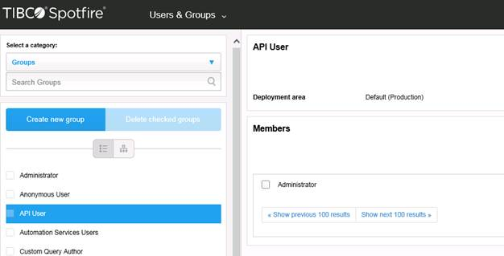

**To enable Spotfire web service**

1. Open configure tool of Spotfire.

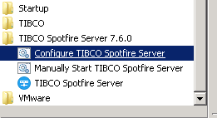

1. Export the configure file from database.

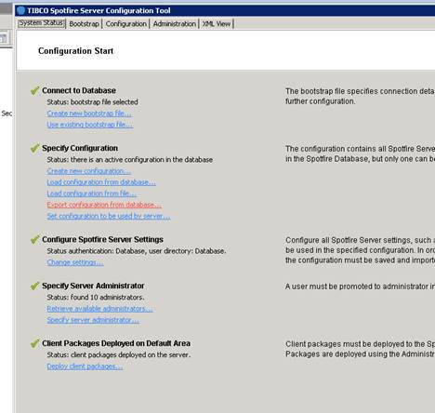

1. Modify the configure file to enable the web-services.

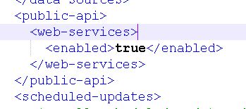

1. Load the configure file into database.

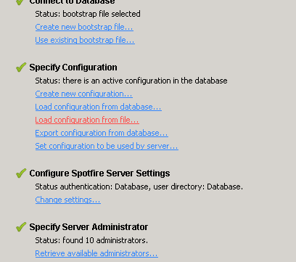

1. Restart Spotfire server service.

## Invalid Objects in CBOE12.6.3 fresh Database

**Issue**: Invalid objects are shown while executing the script select * from dba_objects where status ='INVALID' on a CBOE 12.6.3 fresh database.

**Remedy**:

To fix the issue follow the steps mentioned below:

1. Connect to the database system as system/manager.
2. Execute the query shown below for compiling invalid objects.
3. Copy and paste the results one by one and run it.
4. Check all the objects are in valid state.

|  |
| --- |
| select ' alter '||decode(object_type, 'PACKAGE BODY', 'PACKAGE',object_type) ||' '|| owner||'.'||object_name || ' compile ;' Compile_statement_invalid_obj  from dba_objects where status ='INVALID' and object_type <>'SYNONYM' union  select ' alter '||decode(owner, 'PUBLIC', 'PUBLIC ' ||object_type, object_type) ||' '|| object_name || ' compile ;' Compile_statement_invalid_obj  from dba_objects where status ='INVALID' and object_type ='SYNONYM'; |

1. Appendix A: Inventory Enterprise INI Configuration Files

This chapter describes the various *Invconfig.ini configuration files* used in Inventory Enterprise. The Inventory Enterprise INI configuration files fall into three categories:

* *CFServer.ini* Configuration File
* *ChemInv.ini* Configuration File
* *Invconfig.ini* Configuration File

The *Invconfig.ini configuration file*, found in *<webroot>/ChemOffice/ChemInv/Config* defines parameters that allow Inventory Enterprise to find necessary information and how to react in certain situations. When editing fields in this file, it is important to be sure what is going to change because many of these settings are necessary for the application to function properly. For more information about the *CFServer.ini* and *ChemInv.ini* configuration files, refer to *ChemBioOffice Enterprise Administrator Guide*.

## InvConfig.ini Configuration File

**APPLICATION**

**INV_SERVER_NAME**

Example: INV_SERVER_NAME = server1

Description: Indicates what server the inventory schema resides on.

Default: no default

Options: A valid server name on the network.

**CHEMREG**

**REG_SERVER_NAME**

Example: REG_SERVER_NAME = server1

Description: Indicates what server the Registration schema resides on.

Default: no default

Options: A valid server name on the network.

**USE_NOTEBOOK_TABLE**

Example: USE_NOTEBOOK_TABLE = 0

Description: Indicates if the notebook table is used in the Registration System. This MUST match the Registration Enterprise setting.

Default: 0

Options: 0 | 1

**REG_CONTAINERS_ONLY**

Example: REG_CONTAINERS_ONLY = false

Description: Indicates the status of the container of Registration Enterprise.

Default: false

Options: false | true

**USE_REGISTRATION_MAP**

Example: USE_REGISTRATION_MAP = False

Description: Indicates if the registration values need to be used while creating container from Registration enterprise

Default: false

Options: False | True

**DEFAULT_CONTAINER_STATUSID**

Example: DEFAULT_CONTAINER_STATUSID = 1

Description: Indicates the status of the container while creating container from Registration system.

Default: 1

Options: 1 | valid container status id from database

**CHEMACX**

**ACX_SERVER_NAME**

Example: ACX_SERVER_NAME = server1

Description: Indicates what server the ChemACX database resides on.

Default: NULL

Options: A valid server name on the network

**IMPORT_CONTAINER_PICKLIST_1_FIELD**

Example: IMPORT_CONTAINER_PICKLIST_1_FIELD = Field_1

Description: The name of a field which should be added to the Send Hits to Inventory Manager from ChemACX dialog box (default configuration of dialog box is pictured below). Adding the name of a field here makes an additional field present in the dialog box allowing the user to populate that field during the import. This setting is linked to IMPORT_CONTAINER_PICKLIST_1_TITLE and

IMPORT_CONTAINER_PICKLIST_1_SQL

Default: ""

Options: Any valid Field name

**IMPORT_CONTAINER_PICKLIST_1_SQL**

Example: IMPORT_CONTAINER_PICKLIST_1_SQL= "SELECT PickList_Display AS Value, substr(PickList_Display, 1 , 20) AS DisplayText FROM cheminvdb2.inv_picklists WHERE picklist_domain = 1 ORDER BY lower(DisplayText) ASC"

Description: The SQL used to populate the field (in the interface) for the of a field in

IMPORT_CONTAINER_PICKLIST_1_FIELD. This setting is linked to IMPORT_CONTAINER_PICKLIST_1_FIELD and

IMPORT_CONTAINER_PICKLIST_1_TITLE

Default: ""

Options: Any valid SQL statement.

**IMPORT_CONTAINER_PICKLIST_1_TITLE**

Example: IMPORT_CONTAINER_PICKLIST_1_TITLE = Category

Description: The label (in the interface) of a field in IMPORT_CONTAINER_PICKLIST_1_FIELD. This setting is linked to IMPORT_CONTAINER_PICKLIST_1_FIELD and IMPORT_CONTAINER_PICKLIST_1_SQL

Default: ""

Options: Any text

**IMPORT_CONTAINER_PICKLIST_2_FIELD**

Example: IMPORT_CONTAINER_PICKLIST_2_FIELD = Field_2

Description: The name of a field which should be added to the Send Hits to Inventory Manager from ChemACX dialog box (default configuration of dialog box is pictured below). Adding the name of a field here makes an additional field present in the dialog box allowing the user to populate that field during the import. This setting is linked to IMPORT_CONTAINER_PICKLIST_2_TITLE and IMPORT_CONTAINER_PICKLIST_2_SQL

Default: ""

Options: Any valid Field name

**IMPORT_CONTAINER_PICKLIST_2_SQL**

Example: IMPORT_CONTAINER_PICKLIST_2_SQL = "SELECT PickList_Display AS Value, substr(PickList_Display, 1 , 20) AS DisplayText FROM cheminvdb2.inv_picklists WHERE picklist_domain = 1 ORDER BY lower(DisplayText) ASC"

Description: The SQL used to populate the field (in the interface) of a field in IMPORT_CONTAINER_PICKLIST_2_FIELD. This setting is linked to IMPORT_CONTAINER_PICKLIST_2_FIELD and IMPORT_CONTAINER_PICKLIST_2_TITLE

Default: ""

Options: Any valid SQL statement

**IMPORT_CONTAINER_PICKLIST_2_TITLE**

Example: IMPORT_CONTAINER_PICKLIST_1_TITLE = Category

Description: The label (in the interface) of a field in IMPORT_CONTAINER_PICKLIST_2_FIELD. This setting is linked to IMPORT_CONTAINER_PICKLIST_2_FIELD and IMPORT_CONTAINER_PICKLIST_2_SQL

Default: ""

Options: Any text

**MSDX_LOOK_AHEAD**

Example: MSDX_LOOK_AHEAD = 1

Description: Indicates if the MSDX lookup link should appear greyed out if there is no MSDX data available. A value of 1 makes the application look ahead to see if data exists and greys out the link if it doesn’t. This can slow down the loading process in some cases.

Default: 0

Options: 0 | 1

**MSDS_LOOK_AHEAD**

Example: MSDS_LOOK_AHEAD = 1

Description: Indicates if the MSDS lookup link should appear greyed out if there is no MSDS data available. A value of 1 makes the application look ahead to see if data exists and greys out the link if it doesn’t. This can slow down the loading process in some cases.

Default: 0

Options: 0 | 1

**SHOW_ACX_LOOKUP_LINK**

Example: SHOW_ACX_LOOKUP_LINK = 1

Description: Indicates if the ACX lookup link should be visible to users. A value of 1 makes the link visible.

Default: 0

Options: 0 | 1

**SHOW_MSDX_LOOKUP_LINK**

Example: SHOW_MSDX_LOOKUP_LINK = 1

Description: Indicates if the MSDX lookup link should be visible to users. A value of 1 makes the link visible.

Default: 0

Options: 0 | 1

**SHOW_MSDS_LOOKUP_LINK**

Example: SHOW_MSDS_LOOKUP_LINK = 1

Description: Indicates if the MSDS lookup link should be visible to users. A value of 1 makes the link visible.

Default: 0

**SEARCH**

**LOG_SEARCHES**

Example: LOG_SEARCHES = "False"

Description: This setting is an internal setting which should not be changed.

Default: n/a

Options: n/a

**SEARCH_LOG_DB_CONNSTR**

Example: SEARCH_LOG_DB_CONNSTR = ""

Description: This setting is an internal setting which should not be changed.

Default: n/a

Options: n/a

**NP_SEARCH**

Example: NP_SEARCH = "True"

Description: Indicates if a no plugin search is available. After switching this flag, the no plugin search must also be implemented. If it isn’t implemented, changing this flag has no effect.

Default: True

Options: True | False

**SPECIAL_LOCATIONS**

Example: SPECIAL_LOCATIONS = "1,2,3"

Description: Indicates which locations will appear in the "Special Locations" window. The Special Locations window lists possible special locations. These locations are not recognized as special until a user selects the appropriate checkbox in the application.

Default: "1,2,3"

Options: Comma delimited list of valid location IDs

**DEFAULT_SEARCH_DATABASE**

Example: DEFAULT_SEARCH_DATABASE="invreg"

Description: Indicates the default database to be searched.

Default: None

Options: invreg|invacx|cheminv

**DEFAULT_SEARCH_TAB**

Example: DEFAULT_SEARCH_TAB = "Simple"

Description: Indicates the type of search is available for the user.

Default: Simple

Options: Simple|Advanced|Substructure|Batches|Global|Plate

**DEFAULT_EXCLUDE_SPECIAL_LOCATIONS**

Example: DEFAULT_EXCLUDE_SPECIAL_LOCATIONS = "False"

Description: Indicates which locations to be excluded while performing the search. False turns off the feature, true turns it on.

Default: False

Options: True | False

**DEFAULT_SEARCH_SUBLOCATIONS**

Example: DEAFULT_SEARCH_SUBLOCATIONS = "False"

Description: Indicates that sub locations will be included in performing the search.

Default: False

Options: True | False

**DISPLAY_SUBSTANCE_RESULT_AS_LIST**

Example: DISPLAY_SUBSTANCE_RESULT_AS_LIST= "False"

Description: Shows the substance result in a list form.False turns off the feature, true turns it on.

Default: False

Options: True | False

**DISPLAY_STRUCTURE**

Description: Shows the substance Structure in result list form of substructure search. False turns off substance Structure, true turns it on.

Default: True

Options: True | False

**DISPLAY_SUBSTANCE_NAME**

Description: Shows the substance Name in result list form of substructure search. False turns off substance Name, true turns it on.

Default: True

Options: True | False

**DISPLAY_COMPOUND_ID**

Description: Shows the Compound ID in result list form of substructure search. False turns off Compound ID, true turns it on.

Default: True

Options: True | False

**DISPLAY_CAS_NUMBER**

Description: Shows the CAS Number in result list form of the substructure search. False turns off CAS Number, true turns it on.

Default: True

Options: True | False

**DISPLAY_NUM_CONTAINERS**

Description: Shows the Display number of containers in result list form of the substructure search. False turns off Display number of containers, true turns it on.

Default: True

Options: True | False

**DISPLAY_RECORD_NUM**

Description: Shows the Display Record number in result list form of the substructure search. False turns off Display Record number , true turns it on.

Default: True

Options: True | False

**HIDE_BATCH_SEARCH_TAB**

Description: Shows the Display Batch Search Tab in Search mode. 1 turns off Display Batch Search Tab , 0 turns it on.

Default: 0

Options: 0 | 1

**CONTAINERS**

**DEFAULT_CONTAINER_STATUS**

Example: DEFAULT_CONTAINER_STATUS = 1

Description: Indicates what container status should appear as the default in the New Container dialog. The value must be a valid container status ID in the INV_CONTAINER_STATUS table.

Default:

Options: A valid container status ID.

**EXPIRATION_DATE_INCREMENT**

Example: EXPIRATION_DATE_INCREMENT = 1

Description: Indicates the default expiration date increment (in years). For example, a value of 1 would default the expiration date of a new container to 1 year from the current date.

Default:

Options: A positive number

**DISPLAY_CREATED_CONTAINERS_SUMMARY**

Example: DISPLAY_CREATED_CONTAINERS_SUMMARY = "True"

Description: Display summary of the new created containers. False turns off the feature, true turns it on.

Default: True

Options: True | False

**WARN_FOR_NO_COMPOUND**

Example: WARN_FOR_NO_COMPOUND= 0

Description: Displays a warning that no compound has been created for new container.

Default: 0

Options: 0|1

**CUSTOM_FIELDS**

Example: CUSTOM_FIELDS = FIELD_1: Custom Field 1;0,FIELD_2:Custom Field 2;0

Description: A comma delimted list of the optional customizable fields that are in use. If the field appears in this list, it will appear on all relevant forms. Names of field are in the following format:

<Field_Name>:<Field_Label>;<0|1> where Field_Name is the name of the configurable field (as shown in the INI file), Field Label is how the field should be labeled in the interface, and the last parameter indicates if the field is required (1) or not (0). NOTE: Putting spaces in field names may make the field display in a less then optimal way.

Default: ""

Options: A comma delimited list in the above format.

**DISPLAY_EHS_DATA**

Example: Display_ehs_data =”True”

Description: Shows EH&S tab in container details frame. False turns off the feature, true turns it on.

Default: True

Options: True|False

**MAX_UPDATEABLE_CONTAINERS**

Example: Max_updateable_containers = 400

Description: Allows to update number of containers in multi-select mode.

Default: 400

Options: a positive number

**AUTOGENERATE_FIRST_LABEL**

Example: Autogenerate_first_label =0

Description: Autogenerate the label on launching the print label dialog. 0 turns off the feature, 1 turns it on.

Default: 0

Options: 0|1

**AUTOLAUNCH_LABELPRINT_DIALOG**

Example: Autolaunch_labelprint_dialog =0

Description: Launch the Print dialog automatically. 0 turns off the feature, 1 turns it on.

Default: 0

Options: 0|1

**DEFAULT_CONTAINER_TYPE_ID**

Example: DEFAULT_CONTAINER_TYPE_ID= 1

Description: Indicates what Container Type should appear as the default in the New Container dialog. The value must be a valid Container Type in the INV_CONTAINER_TYPES table.

Default: 1

Options: A valid Container Type id.

**DEFAULT_SUPPLIER_ID**

Example: DEFAULT_SUPPLIER_ID = 1

Description: Indicates what supplier id should appear as the default in the New Container dialog. The value must be a valid supplier id in the INV_SUPPLIERS table.

Default: 1

Options: A valid supplier id.

**SHOW_USER_PREFERENCES_LINK**

Example: SHOW_USER_PREFERENCES_LINK = False

Description: Indicates if the User Preferences link needs to be displayed. This link appears when ELN - CBOE integration is on. Server Configuration tool set the value for this parameter. False turns off the feature, true turns it on.

Default: False

Options: True | False

**USERPREFERENCES_FIELDS**

Description: USERPREFERENCES_FIELDS contains the list of all fields for the User Preferences. This key should not be modified. Currently 61 fields are added by default.

**UP_FIELD1 - UP_FIELD61**

Example: UP_FIELD1 =Visible:Requred:Field Name:Display Name:Field Type:Control Type:SQL

Description: UP_FIELD<n> contains the properties of the User preferences fields.

The value of the ‘Visibility’ properties can be modified. 0 sets Visibility property to false, 1 set it on.

The value of the ‘Required’ properties can be modified. 0 sets Required property to false, 1 set it on.

The ‘field name’ is similar to the database field name in inv_containers table and this should not be modified.

The ‘display name’ can also be changed by the user.

‘Field Type’ should not be modified by the user.

‘Control Type’ should not be modified by the user.

‘SQL’ should not be modified by the user.

**PLATES**

**ENABLE_PLATE_MANAGEMENT**

Example: ENABLE_PLATE_MANAGEMENT = "True"

Description: Enables plate management if set to True.

Default: False

Options: True | False

**PLATE_DEFAULT_VOL_UNIT**

Example: PLATE_DEFAULT_VOL_UNIT = 4

Description: Indicates what the default volumetric units should be in the creation of a new plate. The value must be equal to a valid unit ID from the INV_UNITS table.

Default: 4

Options: A valid Unit ID

**PLATE_DEFAULT_CONC_UNIT**

Example: PLATE_DEFAULT_CONC_UNIT = 91

Description: Indicates what the default concentration units should be in the creation of a new plate. The value must be equal to a valid unit ID from the INV_UNITS table.

Default: 91

Options: A valid Unit ID

**PLATE_DEFAULT_MASS_UNIT**

Example: PLATE_DEFAULT_MASS_UNIT = 8

Description: Indicates what the default mass units should be in the creation of a new plate. The value must be equal to a valid unit ID from the INV_UNITS table.

Default: 8

Options: A valid Unit ID

**CUSTOM_PLATE_FIELDS**

Example: CUSTOM_PLATE_FIELDS = FIELD_1: Custom Checkin Field 1;0,FIELD_2:Custom Checkin Field 2;0

Description: A comma delimited list of the optional customizable fields that are in use. If the field appears in this list, it will appear on all plate details forms. Names of fields are in the following format:

<Field_Name>:<Field_Label>;<0|1> where Field_Name is the name of the configurable field (as shown in the INI file), Field Label is how the field should be labeled in the interface, and the last parameter indicates if the field is required (1) or not (0). NOTE: Putting spaces in field names may make the field display in a less then optimal way.

Default: ""

Options: A comma delimited list in the above format.

**CUSTOM_WELL_FIELDS**

Example: CUSTOM_WELL_FIELDS = FIELD_1:Custom Checkin Field 1;0,FIELD_2:Custom Checkin Field2;0

Description: A comma delimted list of the optional customizable fields that are in use. If the field appears in this list, it will appear on all well details forms. Names of fields are in the following format:

<Field_Name>:<Field_Label>;<0|1> where Field_Name is the name of the configurable field (as shown in the INI file), Field Label is how the field should be labeled in the interface, and the last parameter indicates if the field is required (1) or not (0). NOTE: Putting spaces in field names may make the field display in a less then optimal way.

Default: ""

Options: A comma delimited list in the above format.

**USE_DEFAULT_PLATEVIEWER_CELL_SIZE**

Example: USE_DEFAULT_PLATEVIEWER_CELL_SIZE = “True”

Description: Indicates that how Plate viewer tab will look like. True will show the plate viewer in a fixed size, False will show Plate viewer in variable size based on plate wells.

Default: True

Options: True | False

**SUBSTANCES**

**GET_CARTRIDGE_MW_FORMULA**

Example: GET_CARTRIDGE_MW_FORMULA = False

Description: Indicates how the molecular weight and molecular formula are searched.

Default: False

Options: True|False

**ALT_IDS**

Example: ALT_IDS = inv_compounds.ALT_ID_1:Substance ID 1;1-U,inv_compounds.ALT_ID_2:Substance ID 2;0

Description: A comma delimted list of the alternate compound IDs. Alt IDs are in the following format:

<Field_Name>:<Field_Label>;<0|1> where Field_Name is the name of the alt ID field (as shown in the INI file), Field Label is how the alt id should show up in the interface, and the last parameter indicates if the field is required (1) or not (0). Add a -U to the end of an alt ID’s definition to make the ID a unique identifier.

Default: inv_compounds.ALT_ID_1:Substance ID 1;1-U,inv_compounds.ALT_ID_2:Substance ID 2;0,inv_compounds.ALT_ID_3:Substance ID 3;0,inv_compounds.ALT_ID_4:Substance ID 4;0,inv_compounds.ALT_ID_5:Substance ID 5;0

Options: A comma delimited list in the above format.

**DISPLAY_SAFETY_DATA**

Example: DISPLAY_SAFETY_DATA =False

Description: Indicates that if the safety data will be displayed in with the substance information. . If set to True, the Safety data will be displayed.

Default: False

Options: True | False

**BARCODES**

**REQUIRE_BARCODE**

Example: REQUIRE_BARCODE = 1

Description: Indicates if the container barcode should be required in the New Container dialog. If set to 1, the container barcode will be required.

Default: 1

Options: 0 | 1

**RETIRE**

**DEFAULT_RETIRED_LOCATION**

Example: DEFAULT_RETIRED_LOCATION = 2

Description: Indicates where retired containers are put by default.

Default: 2

Options: Any location ID.

**DEFAULT_RETIRED_STATUS**

Example: DEFAULT_RETIRED_STATUS = 6

Description: Indicates what status is given to retired containers by default.

Default: 6

Options: Any valid status ID.

**PLATE_DEFAULT_RETIRED_LOCATION**

Example: PLATE_DEFAULT_RETIRED_LOCATION = 2

Description: The location ID of the location where retired containers should be placed by default.

Default: 2

Options: Location ID

**PLATE_DEFAULT_RETIRED_STATUS**

Example: PLATE_DEFAULT_RETIRED_STATUS = 6

Description: The status ID of the status which should be assigned to retired containers by default.

Default: 6

Options: Status ID

**RECTIFICATION**

**DISABLE_CHECKBOXES_DURING_RECTIFICATION**

Example: DISABLE_CHECKBOXES_DURING_RECTIFICATION = "False"

Description: Indicates if, while rectifying a location, checkboxes should be available to manually check off containers listed (instead of having to scan in barcodes). True indicates no checkboxes are available, False indicates checkboxes are available.

Default: False

Options: True | False

**SECURITY**

**PERSIST_AUTHENTICATION_COOKIES**

Example: Persist_authentication_cookies = “True”

Description: Save the cookie on the system for a specified time. If sets to False the cookie is not saved on the system.

Default: True

Options: True | False

**ENABLE_OWNERSHIP**

Example: ENABLE_OWNERSHIP = "False"

Description: Indicates for group Security is enable for containers/Locations/Plated

Default: False

Options: True | False

**CHECKIN_CHECKOUT**

**SHOW_CHECKIN_DETAILS**

Example: SHOW_CHECKIN_DETAILS = 1

Description: Indicates if the fields defined in the CUSTOM_CHECKIN_DETAILS setting should be displayed in the Check In dialog.

Default:

Options: 0 | 1

**CUSTOM_CHECKIN_FIELDS**

Example: CUSTOM_CHECKIN_FIELDS = FIELD_1:Custom Checkin Field 1;0,FIELD_2:Custom Checkin Field 2;0

Description: A comma delimted list of the optional customizable fields that are in use. If the field appears in this list, it will appear on the container checkin form. Names of fields are in the following format:

<Field_Name>:<Field_Label>;<0|1> where Field_Name is the name of the configurable field (as shown in the INI file), Field Label is how the field should be labeled in the interface, and the last parameter indicates if the field is required (1) or not (0). NOTE: Putting spaces in field names may make the field display in a less then optimal way.

Default: ""

Options: A comma delimited list in the above format.

**REQUESTS**

**ALLOW_REQUESTS**

Example: ALLOW_REQUESTS = "False"

Description: Indicates if users will be able to use the request feature of the software. False turns off the request feature, true turns it on.

Default: False

Options: True | False

**SHOW_REQUEST_SAMPLE**

Example: SHOW_REQUEST_SAMPLE = 1

Description: Indicates if the Request Sample feature should be turned on. The Request Sample feature allows you to request part of a container or batch of containers as opposed to the Request Container feature in which you request the whole container. In addition to the Request Sample feature, this setting also enables the Manage Sample Requests and Manage

Orders features, if set to 1.

Default:

Options: 0 | 1

**RETIRE_FULFILLED_CONTAINERS**

Example: RETIRE_FULFILLED_CONTAINERS="True"

Description: Indicates that containers whose requests are fulfilled gets retired.

Default: False

Options: True|False

**STATUS_REQUESTED_SAMPLES**

Example: DEFAULT_SAMPLE_UOC="26=mg/ml"

Description: Sets a default unit of concentration for a new sample.

Default: None.

Options: Any valid unit in which the concentration of the sample can be measured.

**DEFAULT_REQUEST_DELIVERY_LOCATION**

Example: DEFAULT_REQUEST_DELIVERY_LOCATION = 2

Description: Shows default delivery location id for samples which are part of a request.

Default: any valid location id

Options: any location id

**SHOW_CREATE_SAMPLE**

Example: SHOW_CREATE_SAMPLE="True"

Description: Indicates that the user can create a sample. False turns off the feature, true turns it on.

Default: True

Options: True|False

**SHOW_ADD_SAMPLE**

Example: SHOW_ADD_SAMPLE =”True”

Description: Indicates that the user can add a sample in Manage sample requests section. False turns off the feature, true turns it on.

Default: True

Options: True|False

**REQUEST_SAMPLE_BY_AMOUNT**

Example: REQUEST_SAMPLE_BY_AMOUNT

Description:

Default:

Options:

**CUSTOM_CREATEREQUEST_FIELDS**

Example: CUSTOM_CREATEREQUEST_FIELDS = FIELD_1: Custom Field

1;0,FIELD_2:Custom Field 2;0

Description: Displays fields when making a request on a container. For more details see custom fields.

Default: ""

Options: A comma delimited list in the above format.

**CUSTOM_FULFILLREQUEST_FIELDS**

Example: CUSTOM_FULFILLREQUEST_FIELDS = FIELD_1: Custom Field 1;0, FIELD_2:Custom Field 2;0

Description: Displays the fields when fulfilling a request. For more details see custom fields.

Default: ""

Options: A comma delimited list in the above format.

**BYPASS_REQUEST_APPROVAL**

Example: BYPASS_REQUEST_APPROVAL = “False”

Description: Indicates that the request approval is required. False turns off the feature, true turns it on.

Default: False

Options: True | False

**AUTOMATIC_RESERVATION**

Example: AUTOMATIC_RESERVATION =0

Description: Indicates that a new reservation will be created for newly created request. 0 turns off the feature, 1 turns it on.

Default: 0

Options: 0|1

**REQUIRE_APPROVAL_FOR_SAMPLES**

Example: REQUIRE_APPROVAL_FOR_SAMPLES =”False”

Description: Indicates that a request container link will be available after certifying a container. False turns off the feature, True turns it on.

Default: False

Options: True | False

**USE_REG_REQUEST_MAP**

Example: USE_REG_REQUEST_MAP

Description: Indicates that the Registration values to be used while placing request from Registration system.

Default:

Options: True | False

**BATCHES**

**CUSTOM_BATCH_PROPERTY_FIELDS**

Example: CUSTOM_BATCH_PROPERTY_FIELDS = FIELD_1:Custom Field 1;0,FIELD_2:Custom Field 2;0

Description: Displays fields associated with the batch of containers. For more details see custom fields.

Default: ""

Options: A comma delimited list in the above format.

**SAMPLES**

**SHOW_SAMPLE**

Example: SHOW_SAMPLE = "True"

Description: Enables the sample container function is set to True.

Default: True

Options: True | False

**DEFAULT_SAMPLE_UOM**

Example: DEFAULT_SAMPLE_UOM="1=ml"

Description: Sets a default unit of measurement for a new sample.

Default: None.

Options: Any valid unit in which the quantity of the sample can be measured.

**DEFAULT_SAMPLE_UOC**

Example: DEFAULT_SAMPLE_UOC="26=mg/ml"

Description: Sets a default unit of concentration for a new sample.

Default: None.

Options: Any valid unit in which the concentration of the sample can be measured.

**DEFAULT_SAMPLE_CONTAINER_TYPE_ID**

Example: DEFAULT_SAMPLE_CONTAINER_TYPE_ID="2"

Description: Sets default container type for a new sample.

Default: None.

Options: Any valid container type.

**DEFAULT_SAMPLE_REQUEST_CONC**

Example: DEFAULT_SAMPLE_REQUEST_CONC="6=mg"

Description: Sets a default unit of concentration for a sample that is requested from an already existing container.

Default: None.

Options: Any valid unit in which the concentration of the sample can be measured.

**SAMPLE_REQUIRE_CONCENTRATION**

Example: SAMPLE_REQUIRE_CONCENTRATION = True

Description: Indicates concentration requirement in the new sample screen. False turns off the feature, true turns it on.

Default: True

Options: True| False

**STATUS_ORDER_CONTAINERS**

Example: STATUS_ORDER_CONTAINERS = 16

Description: Indicates the status of the requested containers.

Default: 16

Options: Depends on the table INV_CONTAINER_STATUS

**DEFAULT_REALIQUOT_DISPOSED_LOC**

Example: DEFAULT_REALIQUOT_DISPOSED_LOC = 2

Description: Shows default location id for samples being aliquoted during sample fulfilment.

Default: any valid Location ID

Options: any valid Location ID

**SAMPLE_CREATE_LIMIT**

Example: SAMPLE_CREATE_LIMIT = 200

Description: Indicates a limit for a maximum number of samples created.

Default: 200

Options: any positive integer

**SPLITTING**

**SHOW_SPLIT**

Example: SHOW_SPLIT = "True"

Description: Enables the split container function is set to True.

Default: True

Options: True | False

**CERTIFICATION**

**SHOW_CERTIFY**

Example: SHOW_CERTIFY = TRUE

Description: Indicates if the Certify Container feature should be turned on. The Certify Container feature requires the INV_CERTIFY_CONTAINER privilege. In order to use this feature, the STATUS_CERTIFIED status must also be set.

Default: TRUE

Options: FALSE | TRUE

**STATUS_APPROVED**

Example: STATUS_APPROVED = 1001

Description: Indicates what state a container should be set to when approved through the Manage Approvals interface. The Manage Approvals interface is only available if SHOW_CERTIFY = 1 (the Certification workflow is turned on). The value must be a valid container status ID in the INV_CONTAINER_STATUS table.

Default:

Options: A valid container status ID

**STATUS_CERTIFIED**

Example: STATUS_CERTIFIED = 1001

Description: Indicates what state a container should be set to when certified through the Certify Container feature. The Certify Container feature is only available if SHOW_CERTIFY = 1 (the Certification workflow is turned on). The value must be a valid container status ID in the INV_CONTAINER_STATUS table.

Default:

Note: There is no default value for STATUS_CERTIFIED.

Options: A valid container status ID

**CONTAINER_ORDERING**

**BYPASS_ORDERING_SCREENS**

Example: BYPASS_ORDERING_SCREENS = 0

Description: Displays an ordering screen while ordering the containers from ChemACX to ChemInv.

Default: 0

Options: 0 | 1

**ALLOW_USER_TO_SET_DELIVERY_LOCATION**

Example: ALLOW_USER_TO_SET_DELIVERY_LOCATION= 0

Description: Indicates that a user can set the delivery location for the container.

Default: 0

Options: 0|1

**DEFAULT_CONTAINER_ORDER_PROJECT**

Example: DEFAULT_CONTAINER_ORDER_PROJECT = 1

Description: Indicates which project user wants to select by default while ordering the container.

Default: 1

Options: 0| 1

**DEFAULT_CONTAINER_ORDER_JOB**

Example: DEFAULT_CONTAINER_ORDER_JOB= 1

Description: Indicates which job user wants to select by default while ordering the container.

Default: 1

Options: 0 | 1

**DEFAULT_CONTAINER_ORDER_DELIVERY_LOCATION**

Example: DEFAULT_CONTAINER_ORDER_DELIVERY_LOCATION = 1

Description: Indicates by default which location user wants to set the container.

Default: 1

Options: depends on the location id.

**DEFAULT_CONTAINER_ORDER_STATUS**

Example: DEFAULT_CONTAINER_ORDER_STATUS = 3

Description: Indicates the status of the ordered container.

Default: any valid container status id

Options: depends on the container status id

**DEFAULT_CONTAINER_ORDER_OWNER**

Example: DEFAULT_CONTAINER_ORDER_OWNER = ""

Description: Indicates which owner user wants to set by default while ordering the container.

Default: ""

Options: depends on the user id

**DEFAULT_CONTAINER_ORDER_UNIT_OF_MEAS**

Example: DEFAULT_CONTAINER_ORDER_UNIT_OF_MEAS = 100

Description: Displays default unit of measure ID for containers.

Default: any valid unit id

Options: unit id

**DEFAULT_CONTAINER_ORDER_SIZE**

Example: DEFAULT_CONTAINER_ORDER_SIZE = 1

Description: Indicates the size of the ordered container.

Default: 1

Options: 0 | 1

**DEFAULT_CONTAINER_ORDER_REASON**

Example: DEFAULT_CONTAINER_ORDER_REASON= 1

Description: Indicates while ordering the container default selected reason.

Default: any valid reason id

Options: depends on container reason id.

**ORDER_WORKFLOW_OPTION**

Example: ORDER_WORKFLOW_OPTION= 1

Description: Indicates that which fields will be displayed while creating container from ACX.

Default: 1

Options: 1|2

**DEFAULT_CONTAINER_ORDER_DUE_DAYS**

Example: DEFAULT_CONTAINER_ORDER_DUE_DAYS= 2

Description: Indicates while ordering a container, how many days will be added for the due date field.

Default: 2

Options: Any positive number

**INTERFACE**

**USE_CUSTOM_BANNER_FRAME_LINKS**

Example: USE_CUSTOM_BANNER_FRAME_LINKS = "False"

Description: Indicates if the application should look for a custom file to define the links found in the Banner Frame (top frame in search mode). True indicates a custom file is used, False indicates the standard should be used.

Default: False

Options: True | False

**USE_CUSTOM_BROWSEBANNER_FRAME_LINKS**

Example: USE_CUSTOM_BROWSEBANNER_FRAME_LINKS = "False"

Description: Indicates if the application should look for a custom file to define the links found in the Browse Banner Frame (top frame in browse mode). True indicates a custom file is used, False indicates the standard should be used.

Default: False

Options: True | False

**USE_CUSTOM_LIST_FRAME_LINKS**

Example: USE_CUSTOM_LIST_FRAME_LINKS = "False"

Description: Indicates if the application should look for a custom file to define the links found in the Container List Frame (middle, right hand side). True indicates a custom file is used, False indicates the standard should be used.

Default: False

Options: True | False

**USE_CUSTOM_TAB_FRAME_LINKS**

Example: USE_CUSTOM_TAB_FRAME_LINKS = "False"

Description: Indicates if the application should look for a custom file to define the links found in the Container Tab Frame (lower right hand side). True indicates a custom file is used, False indicates the standard should be used.

Default: False

Options: True | False

**USE_CUSTOM_SEARCH_FORM_TABS**

Example: USE_CUSTOM_SEARCH_FORM_TABS = "False"

Description: Indicates if the application should look for a custom file to define new search forms (therefore new search form tabs). True indicates a custom file is used, False indicates the standard should be used.

Default: False

Options: True | False

**HIDE_OTHER_TAB**

Example: HIDE_OTHER_TAB = "True"

Description: If set to true, this entry hides the Custom Fields tab in the container details frame.

The tab should probably only be set to visible (false) if there are custom fields defined.

Default: True

Options: True | False

**OTHER_TAB_POPUP_HELP**

Example: OTHER_TAB_POPUP_HELP = "Custom configured fields"

Description: The text which appears when the customer fields tab is moused over. This is only relevant if the custom fields tab is visible (HIDE_OTHER_TAB = "False").

Default: Custom configured fields

Options: Text (any string)

**OTHER_TAB_TEXT**

Example: OTHER_TAB_TEXT = "Other"

Description: The label on the Custom Fields Tab, if the tab is visible (HIDE_OTHER_TAB = "False").

Default: Other

Options: Text (any string)

**REPORTS**

**DEFAULT_CONTAINER_SEARCH_REPORT**

Example: DEFAULT_CONTAINER_SEARCH_REPORT = "rptContainerSearchResults1"

Description: The name of the default search report in the report writer Access database.

Default: rptContainerSearchResults1

Options: Name of report in the database.

**DEFAULT_CONTAINER_LABEL_REPORT**

Example: DEFAULT_CONTAINER_LABEL_REPORT = "rptContainerBarCodeLabels2"

Description: The name of the default label report in the report writer Access database.

Default: rptContainerBarCodeLabels2

Options: Name of report in the database.

**DEFAULT_CONTAINER_LOCATION_REPORT**

Example: DEFAULT_CONTAINER_LOCATION_REPORT = "rptLocationReport1"

Description: The name of the default location report in the report writer Access database.

Default: rptLocationReport1

Options: Name of report in the database.

**DEFAULT_PLATE_SEARCH_REPORT**

Example: DEFAULT_PLATE_SEARCH_REPORT = "rptPlateSearchResults1"

Description: The name of the default search report in the report writer Access database.

Default: rptPlateSearchResults1

Options: Name of report in the database.

**DEFAULT_PLATE_LABEL_REPORT**

Example: DEFAULT_PLATE_LABEL_REPORT = "rptPlateBarCodeLabels1"

Description: The name of the default label report in the report writer Access database.

Default: rptPlateBarCodeLabels1

Options: Name of report in the database.

**DEFAULT_PLATE_LOCATION_REPORT**

Example: DEFAULT_PLATE_LOCATION_REPORT = "rptPlateLocationReport1"

Description: The name of the default location report in the report writer Access database.

Default: rptPlateLocationReport1

Options: Name of report in the database.

**DEFAULT_REPORT_FORMAT**

Example: DEFAULT_REPORT_FORMAT = "PDF"

Description: The default format for the report writer.

Default: PDF

Options: SNP | PDF (if installed)

**REPORT_DB_PATH**

Example: REPORT_DB_PATH = C:\Chemoffice_data\ChemInv\ChemInv_reports.mdb

Description: The path to the report writer Access database.

Default: C:\Chemoffice_data\ChemInv\ChemInv_reports.mdb

Options: Absolute or relative path to the report writer database.

**RPT_PATH**

Example: RPT_PATH = "C:\Inetpub\wwwroot\ChemOffice\webserver_source\cfserverasp\RPT\"

Description: The path to the necessary report writer files.

Default: "C:\Inetpub\wwwroot\ChemOffice\webserver_source\cfserverasp\RPT\"

Options: Absolute or relative path to the report writer files.

**REPORTS_HTTP_PATH**

Example: REPORTS_HTTP_PATH = "/cfserverasp/RPT/Reports/"

Description: The path used in a URL for the report writer.

Default: "/cfserverasp/RPT/Reports/"

Options: Absolute or relative path to the report writer files.

**USE_LPR_REPORTS**

Example: USE_LPR_REPORTS = " True"

Description: Indicates if the LPR reports to be used in the Inventory Label’s generation.

Default: True

Options: True | False

**DEFAULT_LOCATION_LABEL_REPORT**

Example: DEFAULT_LOCATION_LABEL_REPORT= "rptLocationBarCodeLabels1"

Description: Indicate which report will be selected while generating the report for a location.

Default: rptLocationBarCodeLabels1

Options: A valid report.

**MANAGE_TABLES**

**EDITABLE_TABLES**

Example: EDITABLE_TABLES = inv_grid_format:Grid Format,inv_location_types:Location Types

Description: A comma delimited list of tables that can be edited by the Edit Tables interface in the application. Names of tables are in the following format:

<Oracle_Table>:<Display Name> where Oracle_Table is the name of the table in Oracle and Display Name is how the table should be labeled in the interface.

Default: inv_container_status:Container Status,inv_container_types:Container

Types,inv_grid_format:Grid Format,inv_enumeration(eset_id_fk;3):Grid Format

Types,inv_location_types:Location Types,inv_enumeration(eset_id_fk;6):Plate Corners,

inv_enumeration(eset_id_fk;7):Plate Directions,inv_enumeration(eset_id_fk;4):Plate Inventory

Settings,inv_enumeration(eset_id_fk;5):Plate Libraries,inv_enumeration(eset_id_fk;2):Plate

Status,inv_plate_types:Plate Types,inv_reporttypes:Report Types,inv_reservation_types:Reservation

Types,inv_units:Units,inv_unit_types:Unit Types,inv_enumeration(eset_id_fk;1):Well Formats

Options: A comma delimited list in the above format.